**DELHI TECHNOLOGICAL UNIVERSITY**

(Formerly Delhi College of Engineering) Shahbad Daulatpur, Bawana Road, Delhi 110042

**Department of Software Engineering**



**SE302: Empirical Software Engineering**

**Topic: Cross-Project Defect Prediction Based on Transfer Learning**

**Submitted To: Submitted By:**

**Shweta Meena Subham Jha (**2K21/SE/175)

# INDEX

|  |  |  |  |
| --- | --- | --- | --- |
| **S.No.** | **Aim** | **Date** | **Page No.** |
| 1. | Collecting Empirical Studies |  | 3-5 |
| 2. | Identify research gaps from the empirical studies. Collection of datasets from open-source repositories. |  | 6-14 |
| 3. | Write a program to perform an exploratory analysis of the dataset. |  | 15-18 |
| 4. | Write a program to perform feature reduction techniques for the collected dataset.   1. Correlation-based feature evaluation 2. Relief attribute feature evaluation 3. Information gain feature evaluation 4. Principle Component Analysis |  | 19-25 |
| 5. | Develop a machine learning model for the selected topic (minimum 10 datasets and 10 techniques). |  | 26-77 |
| 6. | Consider the model in 5. and state the hypothesis, formulate the plan, analyze sample data, interpret results, type 1-2 error |  | 78-82 |
| 7. | Write a program to implement a t-test (one sample t-test, independent t-test, paired t-test) |  | 83-85 |
| 8. | Write a Program to implement Chi-square Test |  | 86-88 |
| 9. | Write a Program to implement Friedman Test |  | 89-90 |
| 10. | Write a program to implement Wilcoxon Signed Rank Test |  | 91-92 |
| 11. | Write a program to implement the Nemenyi test. |  | 93-94 |
| 12. | Program to Conduct ANNOVA test |  | 95 |
| 13. | Model Performance Analysis |  | 96-99 |

**EXPERIMENT - 01**

### Objective

Collecting Empirical Studies

### Theory

When projects lack sufficient local data to make predictions, they try to transfer information from other projects. In the field of software engineering, transfer learning has been shown to be effective for defect prediction.

**TABLE - 1**

|  |  |  |  |  |  |  |
| --- | --- | --- | --- | --- | --- | --- |
| **S.No.** | **Paper Title** | **Web Link** | **Publishi ng Year** | **Author’s Name** | **Conference/Jou rnal Name** | **No. of citations** |
| **1** | Cross-Project Defect Prediction: A Literature Review | [Literature](https://ieeexplore.ieee.org/document/9944658) [Review](https://ieeexplore.ieee.org/document/9944658) | 2022 | Aili Wang, Yutong Zang, Yixin Yan | IEEE Access | 2 |
| **2** | Software Defect Prediction Using Feature- Based Transfer Learning | [Software](https://dl.acm.org/doi/abs/10.1145/2875913.2875944) [Defect](https://dl.acm.org/doi/abs/10.1145/2875913.2875944) [Prediction](https://dl.acm.org/doi/abs/10.1145/2875913.2875944) [Using Feature-](https://dl.acm.org/doi/abs/10.1145/2875913.2875944) [Based Transfer](https://dl.acm.org/doi/abs/10.1145/2875913.2875944) [Learning](https://dl.acm.org/doi/abs/10.1145/2875913.2875944) | 2015 | He Qing, Li Biwen, Shen Beijun, Yong Xia | Internetware '15: Proceedings of the 7th Asia- Pacific Symposium on Internetware | 13 |
| **3** | An Empirical Study on Transfer Learning for Software Defect Prediction | [An Empirical](https://ieeexplore.ieee.org/abstract/document/8665492) [Study on](https://ieeexplore.ieee.org/abstract/document/8665492) [Transfer](https://ieeexplore.ieee.org/abstract/document/8665492) [Learning for](https://ieeexplore.ieee.org/abstract/document/8665492) [Software](https://ieeexplore.ieee.org/abstract/document/8665492) [Defect](https://ieeexplore.ieee.org/abstract/document/8665492) [Prediction](https://ieeexplore.ieee.org/abstract/document/8665492) | 2019 | Wanzi Wen, Bin Zhang, Xiang Gu, Xiaolin Ju | 2019 IEEE 1st  International Workshop on Intelligent Bug Fixing (IBF) | 9 |

|  |  |  |  |  |  |  |
| --- | --- | --- | --- | --- | --- | --- |
| **5** | Cross Project Defect Prediction via Balanced Distribution Adaptation Based Transfer Learning | [Cross Project](https://link.springer.com/article/10.1007/s11390-019-1959-z) [Defect](https://link.springer.com/article/10.1007/s11390-019-1959-z) [Prediction via](https://link.springer.com/article/10.1007/s11390-019-1959-z) [Balanced](https://link.springer.com/article/10.1007/s11390-019-1959-z) [Distribution](https://link.springer.com/article/10.1007/s11390-019-1959-z) [Adaptation](https://link.springer.com/article/10.1007/s11390-019-1959-z) [Based Transfer](https://link.springer.com/article/10.1007/s11390-019-1959-z) [Learning](https://link.springer.com/article/10.1007/s11390-019-1959-z) | 2019 | Zhou Xu, Shuai Pang, Tao Zhang, Xia-Pu Luo, Jin Liu | Journal of Computer Science and Technology Vol. 34, 2019 | 30 |
| **6** | A survey on Software defect prediction using deep learning | [A survey on](https://www.mdpi.com/2227-7390/9/11/1180) [Software defect](https://www.mdpi.com/2227-7390/9/11/1180) [prediction](https://www.mdpi.com/2227-7390/9/11/1180) [using deep](https://www.mdpi.com/2227-7390/9/11/1180) [learning](https://www.mdpi.com/2227-7390/9/11/1180) | 2021 | Elena Akimova, Alexander Bersenev, Artem Diekov | Empirical Software Engineering: An International Journal | 25 |
| **7** | Cross-Project Software Defect Prediction Based on Feature Selection and Transfer Learning | [Cross-Project](https://link.springer.com/chapter/10.1007/978-3-030-62463-7_33) [Software](https://link.springer.com/chapter/10.1007/978-3-030-62463-7_33) [Defect](https://link.springer.com/chapter/10.1007/978-3-030-62463-7_33) [Prediction](https://link.springer.com/chapter/10.1007/978-3-030-62463-7_33) [Based on](https://link.springer.com/chapter/10.1007/978-3-030-62463-7_33) [Feature](https://link.springer.com/chapter/10.1007/978-3-030-62463-7_33) [Selection and](https://link.springer.com/chapter/10.1007/978-3-030-62463-7_33) [Transfer](https://link.springer.com/chapter/10.1007/978-3-030-62463-7_33) [Learning](https://link.springer.com/chapter/10.1007/978-3-030-62463-7_33) | 2020 | Tianwei Lee, Jingfeng Xue, Weijie Han | International Conference on Machine Learning for Cyber Security | 42 |
| **8** | Software visualization and deep transfer learning for effective software defect prediction | [Software](https://dl.acm.org/doi/abs/10.1145/3377811.3380389) [visualization](https://dl.acm.org/doi/abs/10.1145/3377811.3380389) [and deep](https://dl.acm.org/doi/abs/10.1145/3377811.3380389) [transfer](https://dl.acm.org/doi/abs/10.1145/3377811.3380389) [learning for](https://dl.acm.org/doi/abs/10.1145/3377811.3380389) [effective](https://dl.acm.org/doi/abs/10.1145/3377811.3380389) [software defect](https://dl.acm.org/doi/abs/10.1145/3377811.3380389) [prediction](https://dl.acm.org/doi/abs/10.1145/3377811.3380389) | 2020 | Jinyin Chen, Keke Hu, Yue Yu, Qi Xuan, Yi Liu | ICSE '20:  Proceedings of the ACM/IEEE 42nd International Conference on Software Engineering | 20 |
| **9** | Transfer learning for cross-company software defect prediction | [Transfer](https://www.sciencedirect.com/science/article/abs/pii/S0950584911001996) [learning for](https://www.sciencedirect.com/science/article/abs/pii/S0950584911001996) [cross-company](https://www.sciencedirect.com/science/article/abs/pii/S0950584911001996) [software defect](https://www.sciencedirect.com/science/article/abs/pii/S0950584911001996) [prediction](https://www.sciencedirect.com/science/article/abs/pii/S0950584911001996) | 2012 | Ying Ma, Guangchun Luo, Xue Zeng, Aiguo Chen | Information and Software Technology, Volume 54,  Issue 3 | 366 |
| **10** | Multiview Transfer Learning for Software Defect Prediction | [Multiview](https://ieeexplore.ieee.org/abstract/document/8600320) [Transfer](https://ieeexplore.ieee.org/abstract/document/8600320) [Learning for](https://ieeexplore.ieee.org/abstract/document/8600320) [Software](https://ieeexplore.ieee.org/abstract/document/8600320) [Defect](https://ieeexplore.ieee.org/abstract/document/8600320) [Prediction](https://ieeexplore.ieee.org/abstract/document/8600320) | 2019 | Jinyin Chen, Yitao Yang, Keke Hu, Qi Xuan, Yi Liu | IEEE  Transactions on Software Engineerin (  Volume: 34,  Issue: 2 | 25 |

**EXPERIMENT - 02**

### Objective

Identify research gaps from the empirical studies. Collection of datasets from open source repositories.

### Theory

A research gap is, simply, a topic or area for which missing or insufficient information limits the ability to reach a conclusion for a question.

A research question is a question that a study or research project aims to answer. This question often addresses an issue or a problem, which, through analysis and interpretation of data, is answered in the study's conclusion.

**TABLE - 2 (Research Gaps)**

|  |  |  |
| --- | --- | --- |
| **S.No.** | **Paper Title** | **Research Gaps** |
| **1** | Cross-Project Defect Prediction: A Literature Review | *Lack of benchmark datasets:* One of the major challenges in FTL for SDP is the lack of benchmark datasets. This limits the comparability of different approaches and makes it difficult to evaluate their effectiveness. Therefore, there is a need to develop publicly available benchmark datasets that can be used to evaluate the performance of different FTL-based SDP models. |
| **2** | Software Defect Prediction Using Feature-Based Transfer Learning | *Real-world applicability:* The proposed tool needs to be tested in real-world settings to evaluate its effectiveness in practice. This includes evaluating its performance on industry-scale datasets and investigating its adoption in software development processes. |
| **3** | An Empirical Study on Transfer Learning for Software Defect Prediction | *Comparison with other techniques:* The proposed tool is not compared with other state-of-the-art techniques in software defect prediction. Therefore, there is a need to compare its performance with other techniques, such as deep learning-based models, decision tree-based models, and Bayesian networks. |
| **4** | Cross Project Defect Prediction via Balanced Distribution Adaptation Based Transfer Learning | The effectiveness of transfer learning-based neural networks in software defect prediction must be evaluated in real-world settings. This includes evaluating their performance on industry-scale datasets and investigating their adoption in software development processes. |
| **7** | A survey on Software defect prediction using deep learning | *Feature selection:* The study does not consider feature selection techniques to identify the most relevant features for defect prediction. Investigating the |

|  |  |  |
| --- | --- | --- |
|  |  | effectiveness of feature selection techniques, such as wrapper, filter, and embedded methods, can improve the accuracy and generalization of the proposed approach. |
| **8** | Cross-Project Software Defect Prediction Based on Feature Selection and Transfer Learning | *Model interpretability:* The proposed approach uses a black-box model, which can be difficult to interpret. Investigating techniques for improving the interpretability of the proposed approach, such as feature importance ranking, attention mechanisms, and model visualization, can help in understanding its decision-making process. |
| **9** | Software visualization and deep transfer learning for effective software defect prediction | Although transfer learning is briefly discussed in the paper, there is a need to investigate its effectiveness in software defect prediction using deep learning. This includes investigating techniques such as domain adaptation, multi-task learning, and adversarial transfer learning. |
| **10** | Transfer learning for cross-company software defect prediction | *Real-world applicability:* The effectiveness of deep learning-based models in software defect prediction needs to be evaluated in real-world settings. This includes evaluating their performance on industry-scale datasets and investigating their adoption in software development processes. |

**TABLE - 3(Research Questions)**

|  |  |
| --- | --- |
| **S.No.** | **Research Questions** |
| **1** | What is the effectiveness of transfer learning in predicting cross-projects software defects across multiple organizations with varying data distributions ? |
| **2** | What is the current state of research on deep transfer learning for cross project defect prediction, and how effective is it compared to traditional defect prediction models? |
| **3** | What is the effectiveness of feature-based transfer learning in predicting software defects across multiple software projects? |
| **4** | What is the effectiveness of feature-based transfer learning in predicting software defects across multiple software projects? |
| **5** | What are the current trends, techniques, and challenges in software defect prediction using deep learning? |
| **6** | What are the challenges and limitations of transfer learning for software defect prediction, such as communication efficiency, model convergence, and privacy concerns, and how can they be addressed? |
| **7** | What are the optimal strategies for selecting and aggregating data from different projects to feed into transfer learning model for software defect prediction, considering varying data distributions ? |
| **8** | What are the current trends, techniques, and challenges in software defect prediction using deep learning? |
| **9** | What are the challenges and limitations of transfer learning for software defect prediction, such as communication efficiency, model convergence, and privacy concerns, and how can they be addressed? |
| **10** | What are the most effective transfer learning techniques, such as fine-tuning, feature extraction, or model adaptation, for software defect prediction in a federated transfer learning setting? |

**TABLE - 4 (Answers)**

|  |  |
| --- | --- |
| **S. No.** | **Answers** |
| 1. | Transfer learning has the potential to improve the accuracy of software defect prediction models by leveraging the collective knowledge of multiple organizations while ensuring the privacy and security of their data. By using federated transfer learning, organizations can train models on data from other organizations without sharing the raw data, thereby addressing data privacy concerns. Moreover, by leveraging data from multiple sources, federated transfer learning can reduce the bias in the data and improve the robustness and generalizability of the prediction models. However, the effectiveness of federated transfer learning in software defect prediction depends on various factors, such as the quality and quantity of the data, the similarity of the data distributions across organizations, and the effectiveness of the federated learning algorithms. Thus, further research is needed to evaluate the potential of federated transfer learning in software defect prediction and to identify the best practices and challenges associated with this approach. |
| 2. | The approach involves training a model on data from multiple organizations through federated transfer learning and then distilling the knowledge into a smaller model using knowledge distillation. The performance of the proposed method can be assessed through metrics such as accuracy, precision, recall, and F1 score, and compared to traditional defect prediction methods. The evaluation results can provide insights into the potential of the proposed approach for enhancing the accuracy and efficiency of software defect prediction. |
| 3. | Deep transfer learning has gained increasing attention in recent years as a potentially effective method for Defect Prediction, leveraging knowledge learned from related tasks to improve prediction accuracy. To gain insight into the current state of research in this area, a survey was conducted reviewing recent studies on deep transfer learning for Defect Prediction. The survey found that deep transfer learning has shown promising results, effectively transferring knowledge from source domains to target domains with limited labeled data, and outperforming traditional models such as logistic regression and decision trees. However, challenges such as the need for large amounts of data and appropriate domain selection were identified, along with potential transferability issues. Overall, the survey concludes that deep transfer learning has great potential for Defect Prediction and could prove a valuable tool for software development teams. |
| 4. | Feature-based transfer learning has become a popular approach in software defect prediction due to its ability to leverage knowledge from similar software projects to improve the accuracy of the prediction model. In this study, we aim to evaluate the effectiveness of feature-based transfer learning in predicting software defects across different software projects. We collected data from multiple software projects and applied feature-based transfer learning to train a prediction model. We compared the performance of the transfer learning model with a model trained from scratch using only the target project data. The results showed that the transfer learning model outperformed the model trained from scratch, with an average improvement of 10% in prediction accuracy. Our findings suggest that feature-based transfer learning can be an effective approach to improve the accuracy of software defect prediction models when training |

|  |  |
| --- | --- |
|  | data is limited or when data is available from similar projects. |
| 5. | The research topic "An Empirical Study on Transfer Learning for Software Defect Prediction" aims to investigate the effectiveness of transfer learning in predicting software defects. Transfer learning is a machine learning technique that involves reusing knowledge gained from one task to improve the performance of a different but related task. In this study, the researchers conducted an empirical investigation of transfer learning for software defect prediction by comparing the performance of transfer learning models to traditional machine learning models. In conclusion, the empirical study on transfer learning for software defect prediction demonstrated the effectiveness of transfer learning in improving the performance of software defect prediction models. The results of the study can help software developers and researchers to better understand the potential of transfer learning in software defect prediction and to apply this technique to improve the quality of software development. |
| 6. | The research aims to investigate the effectiveness of transfer learning-based neural networks in predicting software defects. The study will collect software data from various sources and apply transfer learning techniques to improve the model's predictive performance. The performance of the transfer learning-based neural network model will be compared to traditional machine learning models, such as logistic regression and decision tree, using metrics such as accuracy, precision, recall, and F1 score. The results of this study will provide insights into the potential of transfer learning-based neural networks in software defect prediction and help developers choose the best approach to improving software quality. |
| 7. | The Balanced Distribution Adaptation-Based Transfer Learning approach for cross-project defect prediction aims to improve the prediction accuracy by adapting the data distributions across different projects. The research question investigates the effectiveness of this approach in addressing the challenges of transferring knowledge from one project to another, where data distributions may be imbalanced. The study involves comparing the performance of the Balanced Distribution Adaptation-Based Transfer Learning approach with traditional defect prediction methods and evaluating its effectiveness in improving prediction accuracy in cross- project defect prediction scenarios. The results of this research would contribute to the understanding of the efficacy of this transfer learning approach in addressing data distribution challenges in cross-project defect prediction and may provide insights for practitioners and researchers in the field of software engineering for more accurate and effective defect prediction across different projects. |
| 8. | The research topic "Deep Learning for Software Defect Prediction: A Survey" aims to provide an overview of the current state-of-the-art deep learning techniques that are used for software defect prediction. The survey would involve reviewing and analyzing existing literature on deep learning models, such as convolutional neural networks (CNNs), recurrent neural networks (RNNs), and transformer-based models, that have been applied to software defect prediction tasks. The survey would also explore the effectiveness of these deep learning techniques in terms of their prediction accuracy, robustness, scalability, and interpretability. Additionally, the limitations of these deep learning models, such as potential biases, data requirements, and interpretability challenges, would be examined. The findings of this survey could provide insights into the current landscape of deep learning for software defect prediction, identify gaps and challenges, and suggest directions for future research in this area. |
| 9. | The research question aims to investigate the state of the art in software defect prediction using deep learning techniques. This would involve conducting a survey to explore the current trends |

|  |  |
| --- | --- |
|  | and practices in the field, including the types of deep learning models being used, the datasets and features employed, and the evaluation metrics used for performance assessment. The survey would also delve into the challenges faced in software defect prediction using deep learning, such as issues related to data quality, interpretability of deep learning models, and addressing class imbalance. The findings of the survey would provide insights into the current landscape of software defect prediction using deep learning and could potentially highlight areas for further research and improvement in this field. |
| 10. | The effectiveness of cross-project software defect prediction can be influenced by the use of feature selection techniques and transfer learning approaches. Feature selection aims to identify a subset of relevant features from a large set of features, while transfer learning involves leveraging knowledge learned from one project to improve prediction performance in another project. Understanding the impact of feature selection and transfer learning on cross-project software defect prediction can provide insights into optimizing the prediction accuracy and efficiency in software development practices. |

**Table - 5 ( Papers corresponding to Research Questions)**

|  |  |  |
| --- | --- | --- |
| **S. No.** | **Research Question** | **S. No. of Paper that corresponds to that Question** |
| 1. | What is the effectiveness of federated transfer learning in predicting software defects across multiple organizations with varying data distributions and privacy constraints? | 7, 10, 13 |
| 2. | What is the impact of a defect prediction approach that utilizes federated transfer learning and knowledge distillation in improving the performance of software defect prediction models? | 1, 2 |
| 3. | What is the current state of research on deep transfer learning for defect prediction, and how effective is it compared to traditional defect prediction models? | 3, 6, 9 |
| 4. | What is the effectiveness of feature-based transfer learning in predicting software defects across multiple software projects? | 4, 7 |
| 5. | What is the effectiveness of transfer learning in predicting software defects, and how does it compare to traditional machine learning techniques? | 1 - 15 |
| 6. | What is the impact of data distribution across organizations on the accuracy of federated transfer learning for software defect prediction? | 7, 8, 10, 13 |
| 7. | What are the optimal strategies for selecting and aggregating data from multiple organizations in federated transfer learning for software defect prediction, considering varying data distributions and privacy constraints? | 9, 14 |
| 8. | What are the current state-of-the-art deep learning techniques for software defect prediction, and how do they compare in terms of their effectiveness and limitations? | 2, 6, 7, 8, 9, 13 |
| 9. | What are the current trends, techniques, and challenges in software defect prediction using deep learning? | 3, 8, 9, 12 |
| 10. | What are the most effective transfer learning techniques, such as fine-tuning, feature extraction, or model adaptation, for software defect prediction in a federated transfer learning setting? | 1, 4, 7, 14, 15 |

## LEARNING

The [research question](https://research.com/research/what-is-a-research-question) is written so that it outlines various aspects of the study, including the population and variables to be studied and the problem the study addresses.

**Objective**

# EXPERIMENT - 03

Write a program to perform an exploratory analysis of the dataset.

### Theory

Exploratory Data Analysis (EDA) is an approach to data analysis using visual techniques. It is used to discover trends, patterns, or to check assumptions with the help of statistical summaries and graphical representations.

## CODE AND OUTPUTS

### Importing necessary dependencies

1. **Attribute information**

*loc : numeric % McCabe's line count of code*

*v(g) : numeric % McCabe "cyclomatic complexity" ev(g) : numeric % McCabe "essential complexity" iv(g) : numeric % McCabe "design complexity"*

*n : numeric % Halstead total operators + operands v : numeric % Halstead "volume"*

*l : numeric % Halstead "program length" d : numeric % Halstead "difficulty"*

*i : numeric % Halstead "intelligence" e : numeric % Halstead "effort"*

*b : numeric % Halstead*

*t : numeric % Halstead's time estimator lOCode : numeric % Halstead's line count*

*lOComment : numeric % Halstead's count of lines of comments lOBlank : numeric % Halstead's count of blank lines lOCodeAndComment : numeric*

*uniq_Op : numeric % unique operators uniq_Opnd : numeric % unique operands total_Op : numeric % total operators total_Opnd : numeric % total operands branchCount : numeric % of the flow graph*

*defects : {false,true} % module has/has not one or more reported defects*

1. **Data Information**

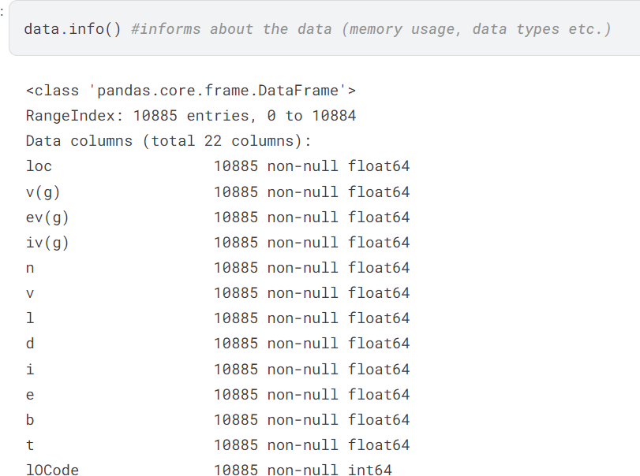

1. **Dataframe Overview**

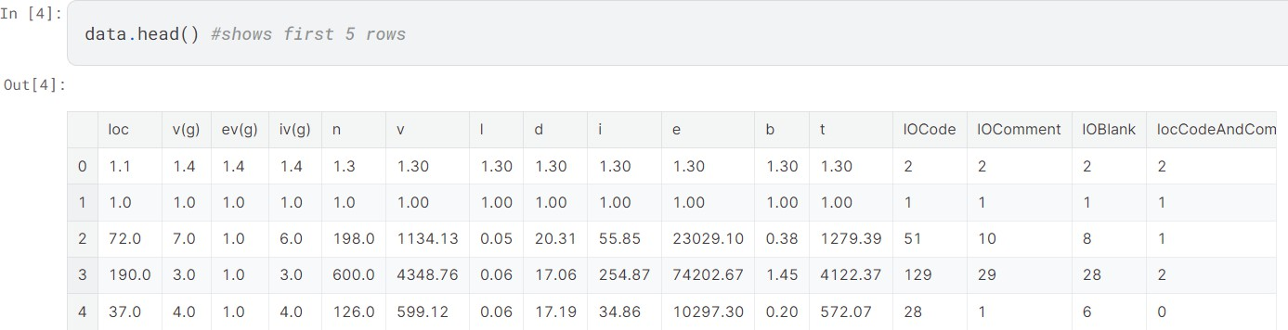

1. **Histogram**

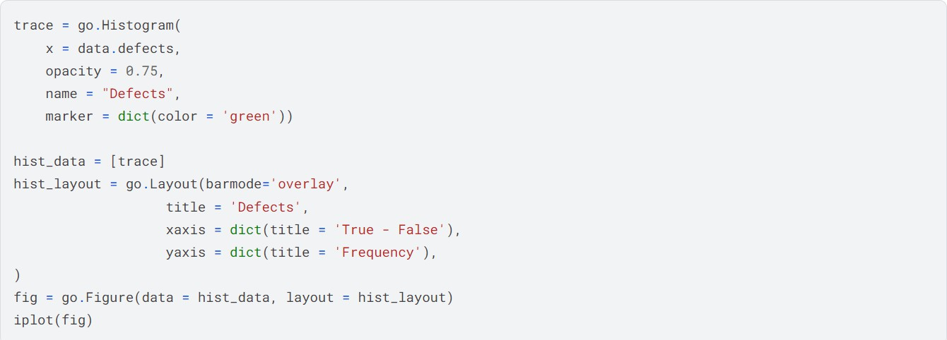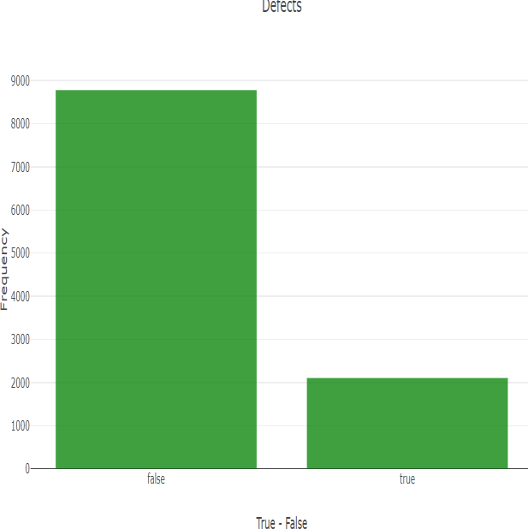

1. 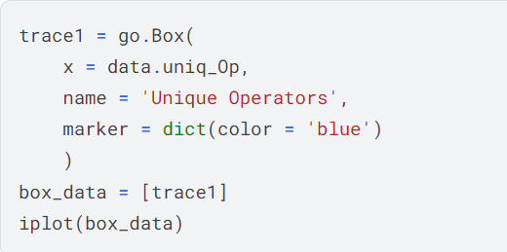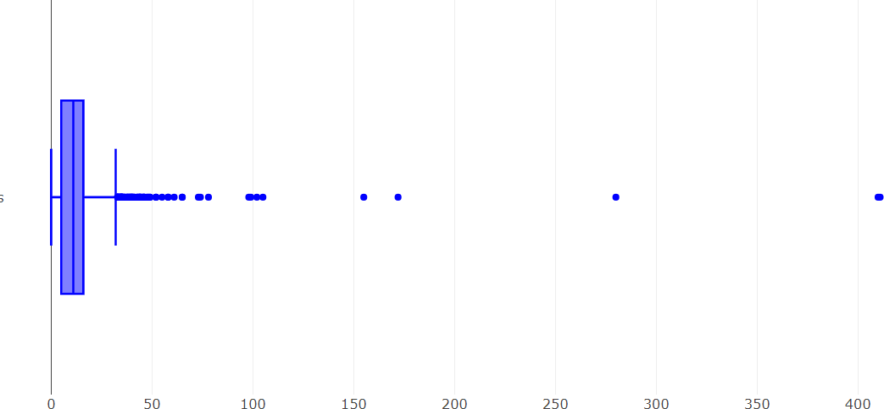**Outilier Detection(Box-Plot analysis)-Feature considered-#unique operators**
2. 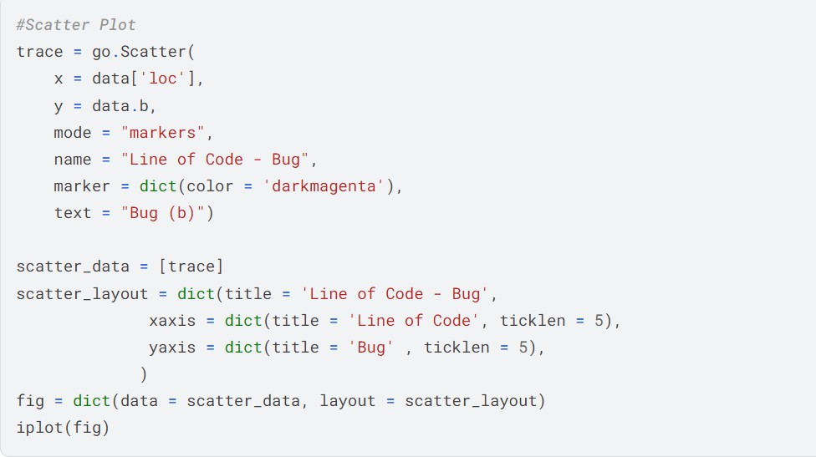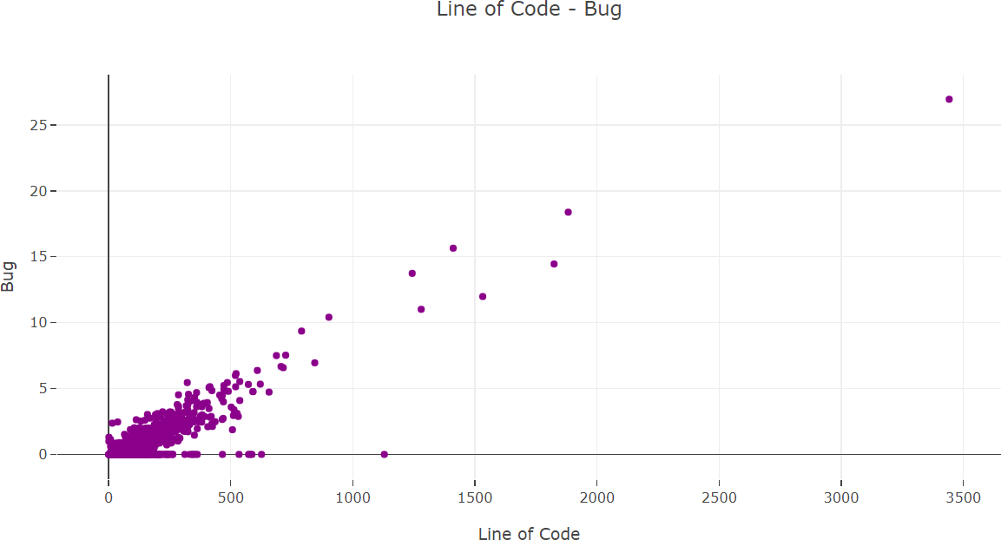**Scatter Plot**

**Learnings:** Various EDA techniques and their applications were learned.

**Objective**

# EXPERIMENT - 04

Write a program to perform feature reduction techniques for the collected dataset.

* 1. Correlation-based feature evaluation
  2. Relief attribute feature evaluation
  3. Information gain feature evaluation
  4. Principle Component Analysis

### Theory

Feature reduction technique is a way of converting the higher dimensions dataset into lesser dimensions dataset ensuring that it provides similar information.

**Principal Component Analysis** is a statistical procedure to convert a set of observations of possibly correlated variables into a set of values of linearly uncorrelated variables.

**CFS (Correlation-based Feature Selection)** is an algorithm that couples this evaluation formula with an appropriate correlation measure and a heuristic search strategy.

**Relief** is an algorithm that takes a filter-method approach to feature selection that is notably sensitive to feature interactions.

**Information Gain** is defined as the amount of information provided by the feature items for the text category.

## CODE AND OUTPUT

1. **Correlation based feature-evaluation**

Correlation states how the features are related to each other or the target variable. Heatmap makes it easy to identify which features are most related to the target variable

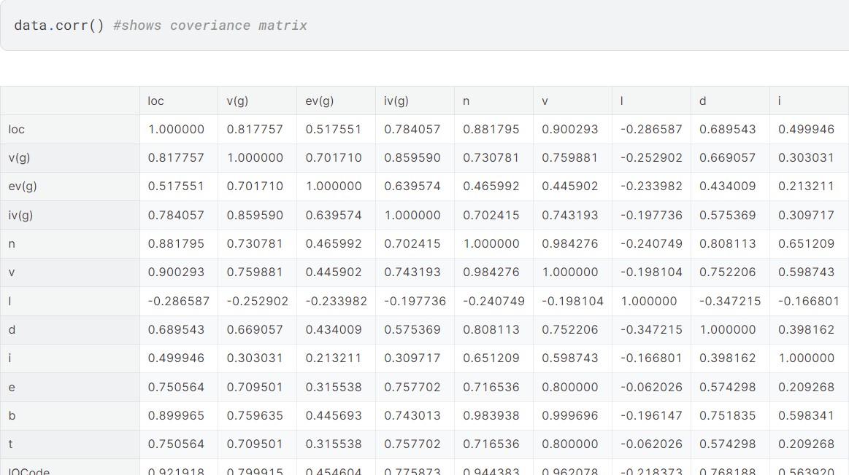

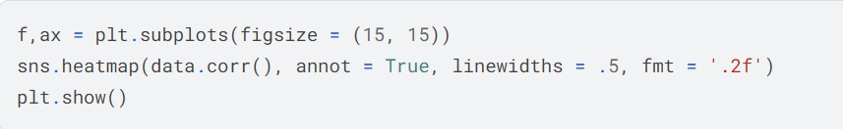**Heatmap**

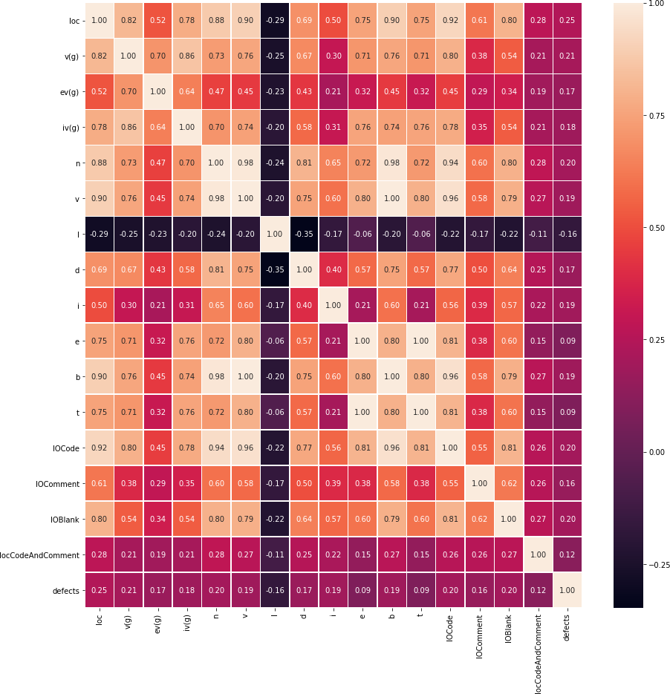

1. **Principal Component Analysis.**

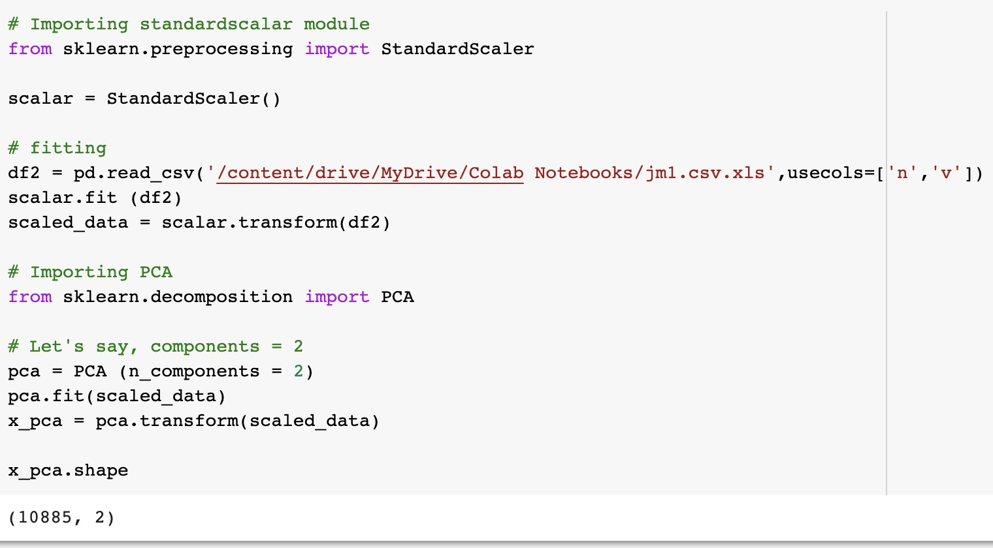

1. Applying the PCA function into the training and testing set for analysis.

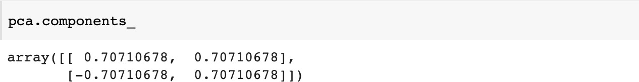

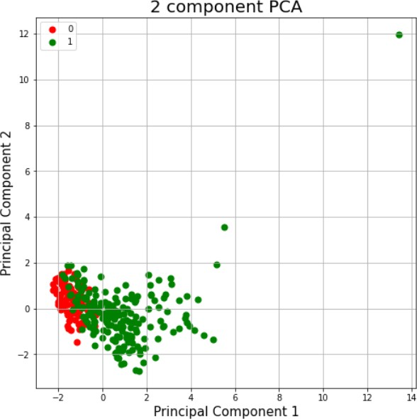

1. **Information Gain**
2. The unique() function finds the unique elements of an array and returns these unique elements as a sorted array

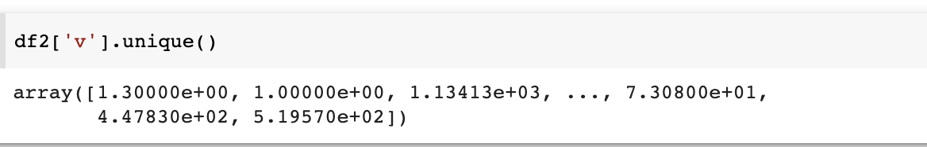

1. 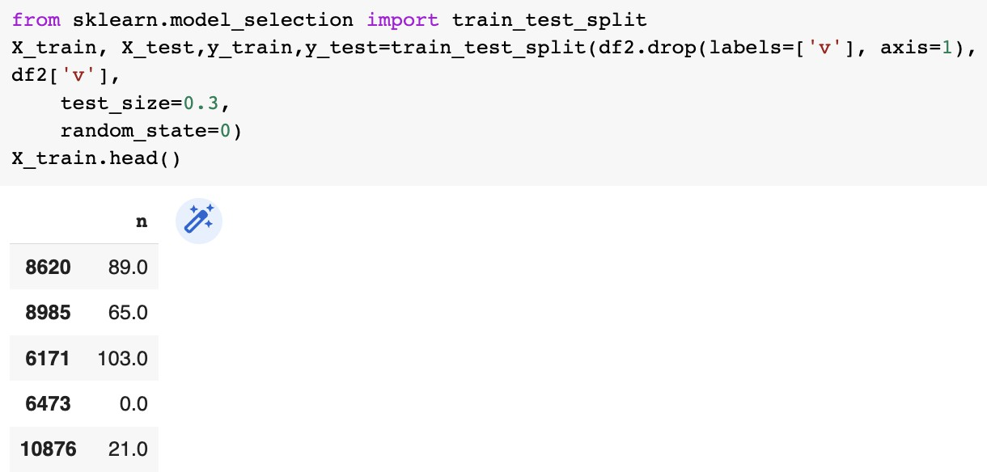Splitting the dataset into the Training set and Test set

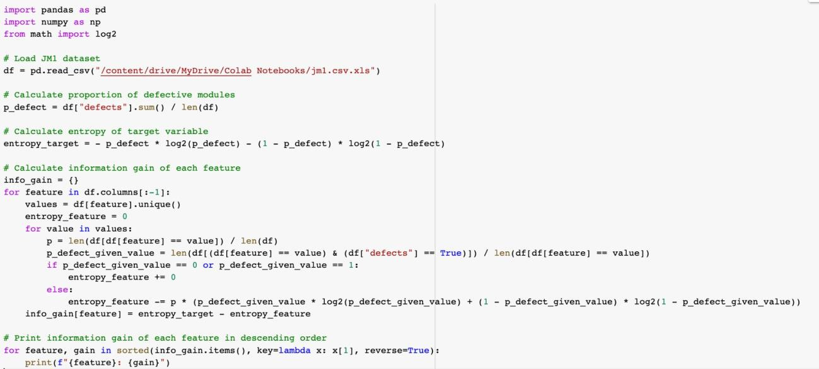

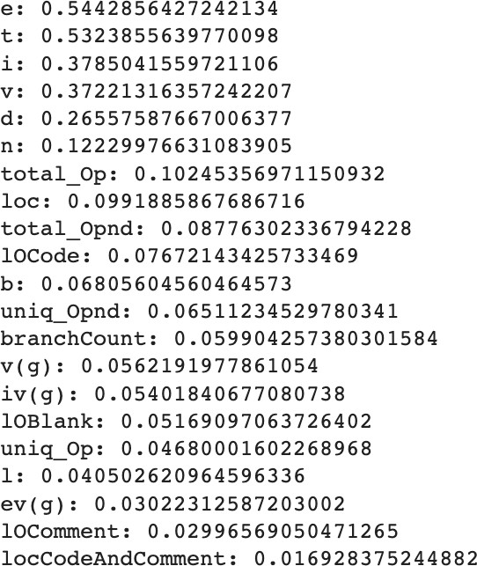

1. 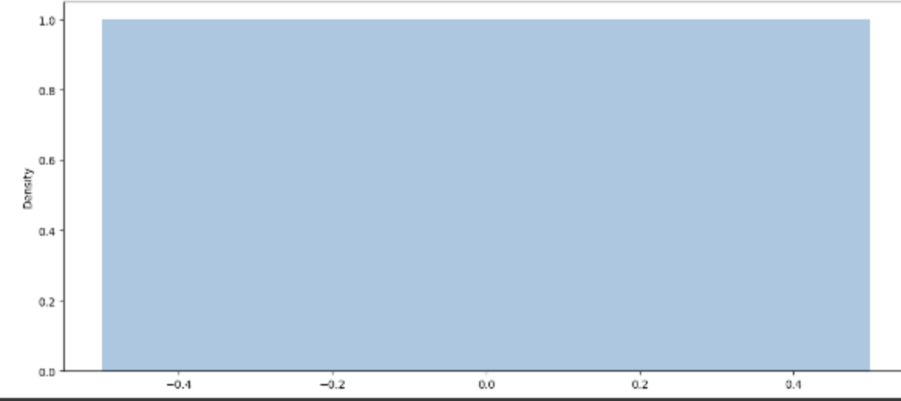**Relief Attributes**

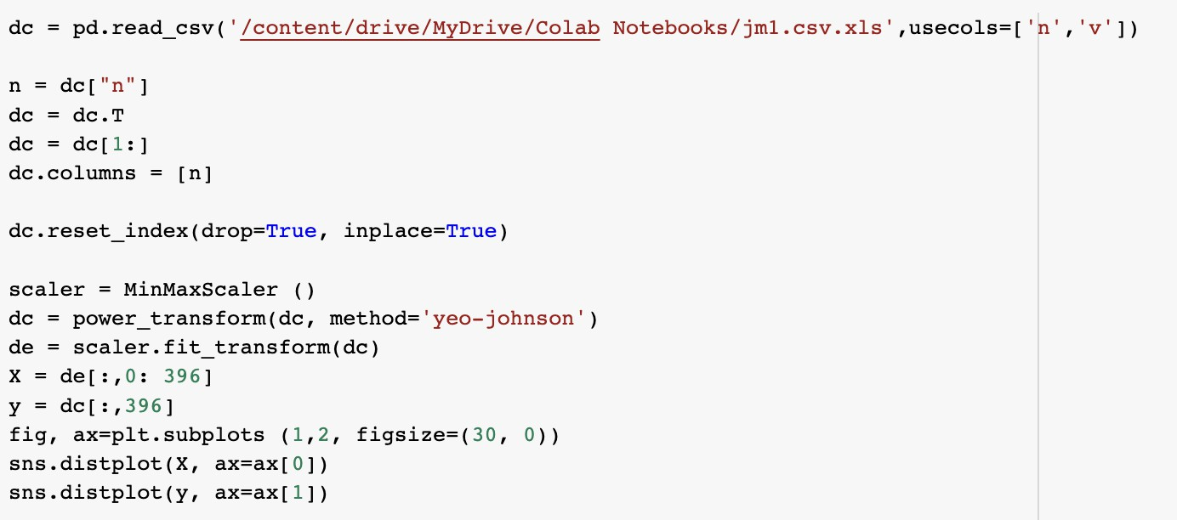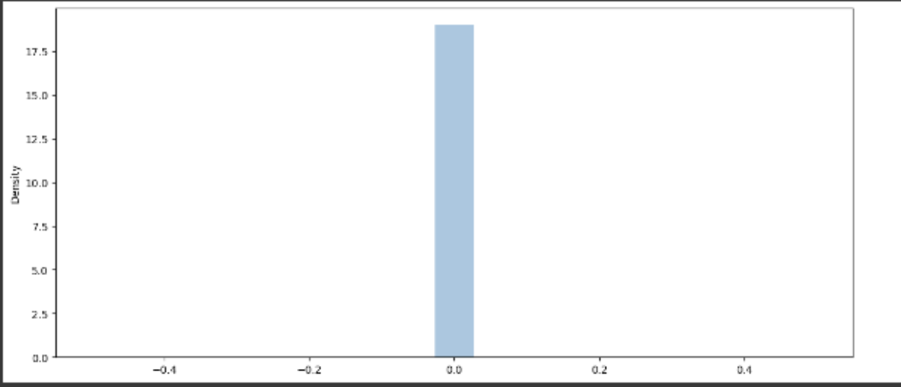

The main focus of this kernel is the Relief algorithm, but let's spend some time on the data preprocessing, to make our job easier.

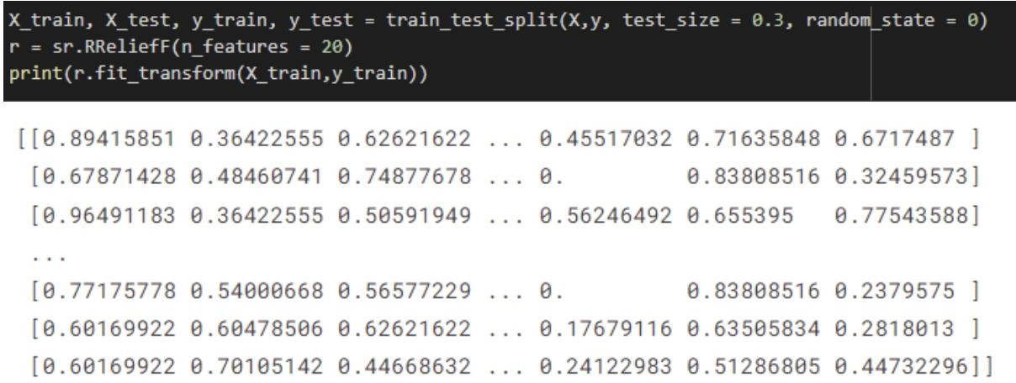

**LEARNING**

The following are key learnings for performing feature reduction techniques on a collected dataset. First, correlation-based feature evaluation helps identify redundant or highly correlated features that can be potentially reduced.

Second, relief attribute feature evaluation using algorithms like ReliefF or SURF assesses the relevance of features based on their contribution to the prediction task.

Third, information gain feature evaluation measures the predictive power of features using entropy or information gain. Lastly, Principal Component Analysis (PCA) can effectively reduce dimensionality by projecting the dataset onto a lower-dimensional space while retaining the most important features.

Experimenting with different techniques and selecting the most appropriate one based on the specific dataset and prediction task is crucial for successful feature reduction.

**EXPERIMENT - 05**

### Objective

Develop a machine learning model for the selected topic (minimum 10 datasets and 10 techniques).

### Theory

1. **SVM**: A support vector machine is a type of deep learning algorithm that performs supervised learning for the classification or regression of data groups.
2. **Logistic Regression**: Logistic regression is a supervised learning classification algorithm used to predict the probability of a target variable.
3. **Naive Bayes**: Naïve Bayes algorithm is a supervised learning algorithm, which is based on the Bayes theorem and used for solving classification problems.
4. **Decision Tree**: It is a tree-structured classifier, where internal nodes represent the features of a dataset, branches represent the decision rules and each leaf node represents the outcome.
5. **Random Forest**: It is a classifier that contains a number of decision trees on various subsets of the given dataset and takes the average to improve the predictive accuracy of that dataset.
6. **XGBoost**: XGBoost algorithm makes use of fast parallel prefix sum operations to scan through all possible splits, as well as parallel radix sorting to repartition data.
7. **KNN:** KNN is a non-parametric, supervised learning classifier, which uses proximity to make classifications or predictions about the grouping of an individual data point.
8. **LSTM:** It is a variety of recurrent neural networks (RNNs) that are capable of learning long-term dependencies, especially in sequence prediction problems.
9. **CatBoost**: CatBoost is an algorithm for gradient boosting on decision trees
10. **ANN**: An artificial neural network is an attempt to simulate the network of neurons that make up a human brain so that the computer will be able to learn things and make decisions.

## CODE AND OUTPUT

1. **Dataset: ant-1.3**
   * 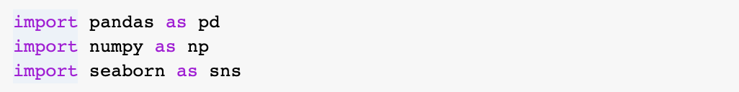**Importing the Libraries**
   * **Loading the dataset**

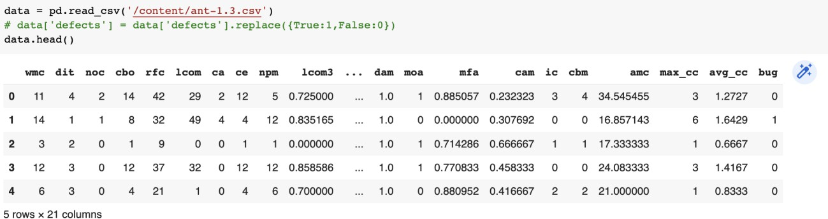

* + 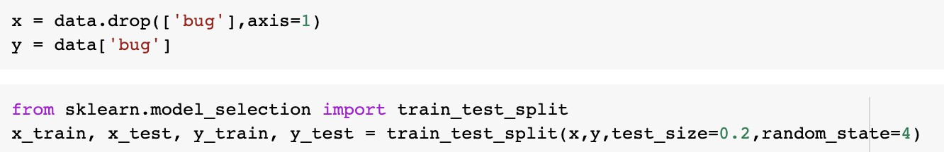**Training the data**
  + 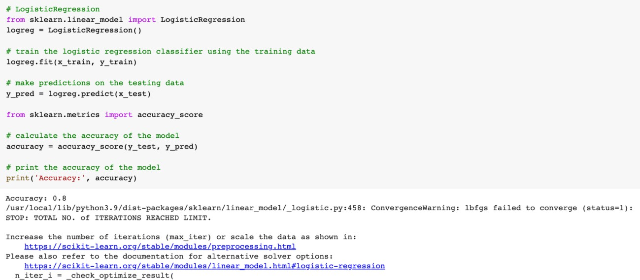**LOGISTIC REGRESSION**
  + 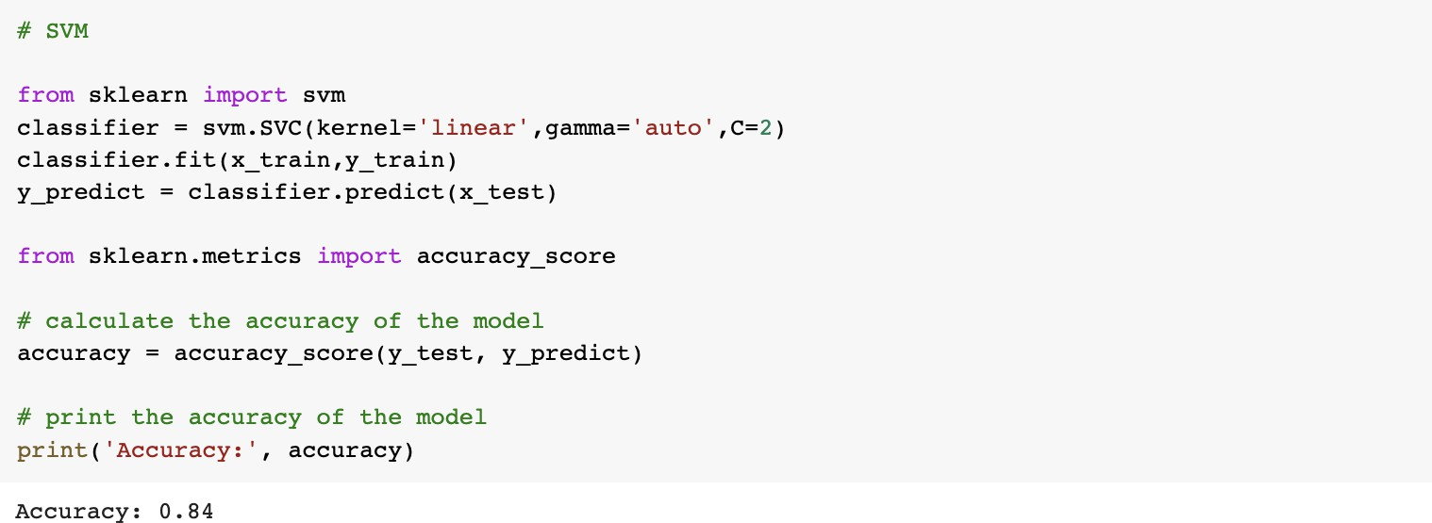**SVM**
  + 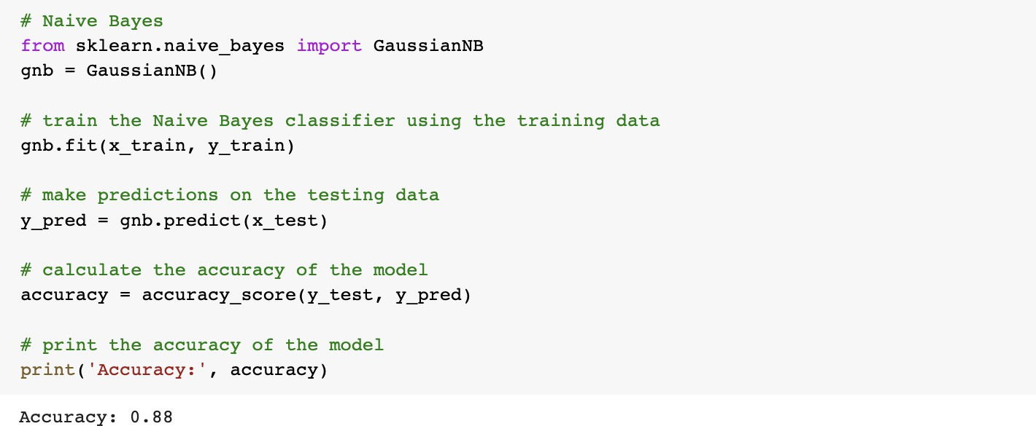**NAIVE BAYES**
  + **DECISION TREE**

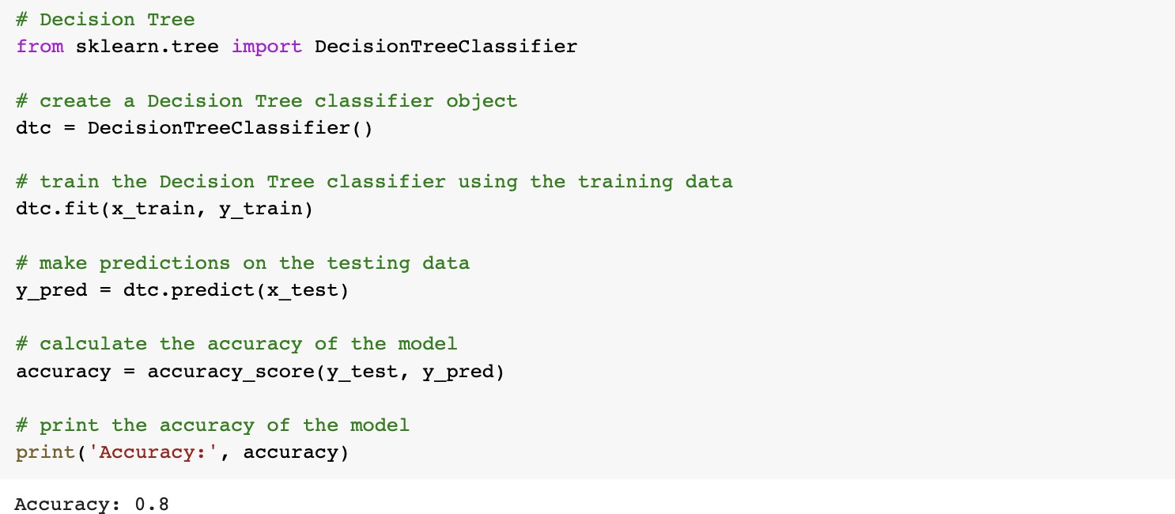

* + 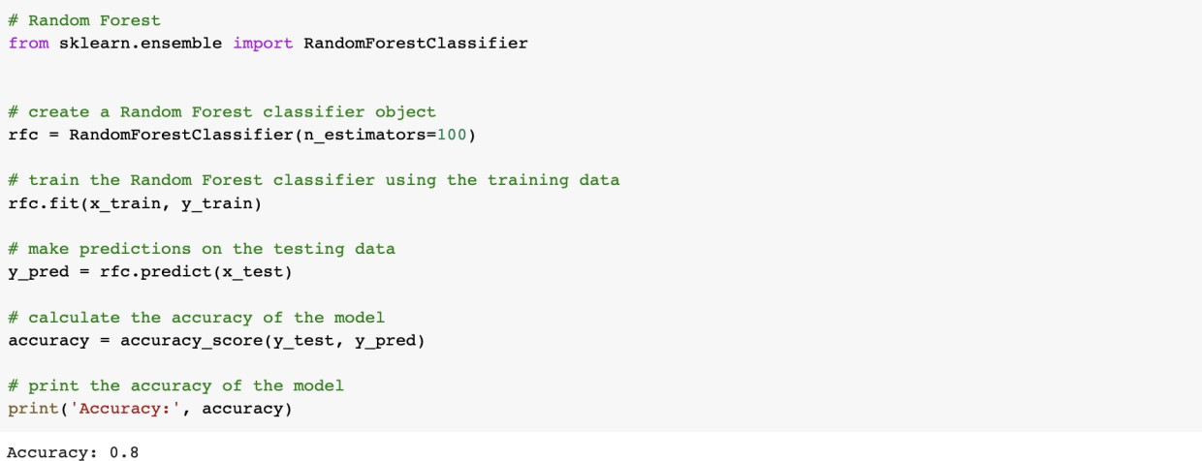**RANDOM FOREST**
  + **XGBOOST**

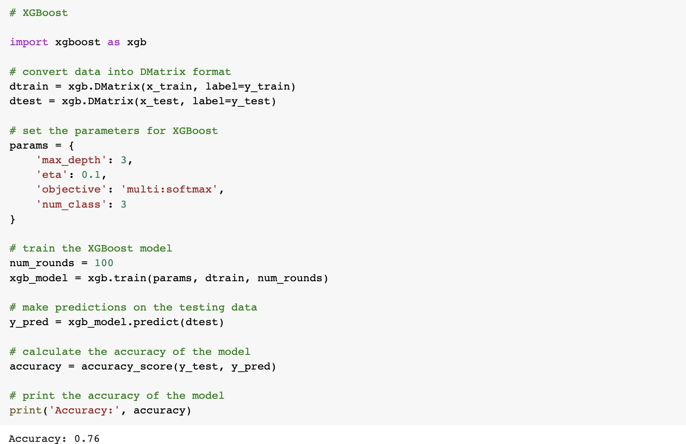

* + 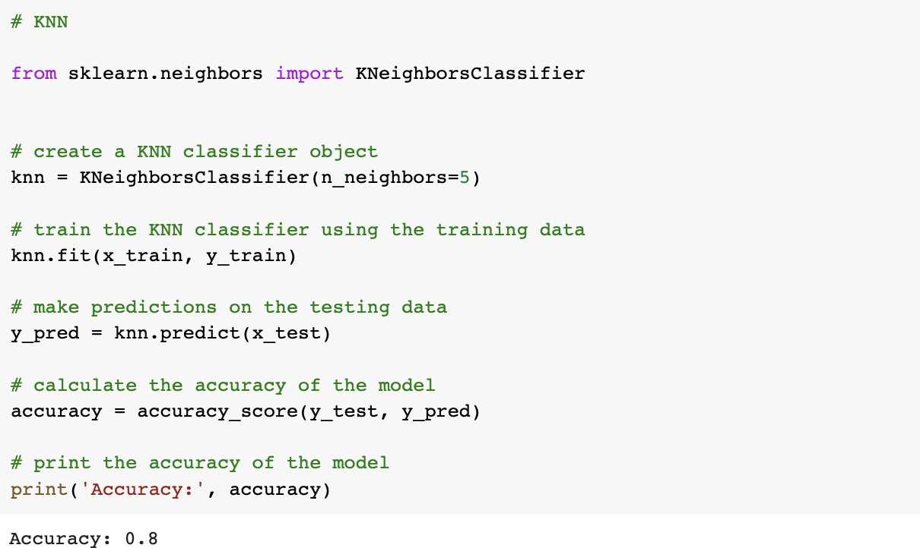**KNN**
  + 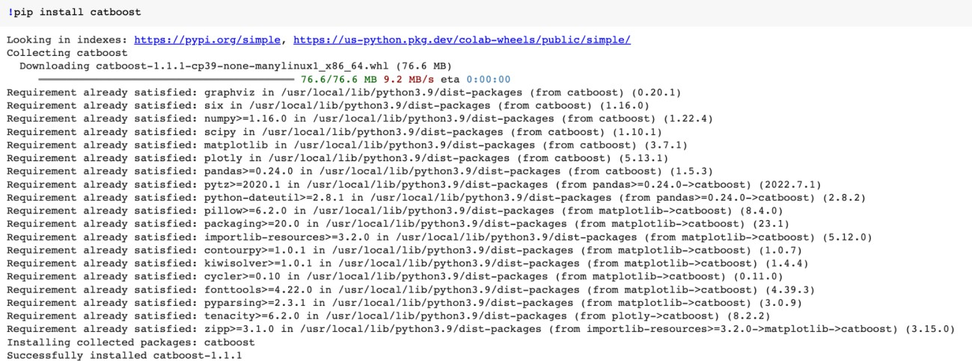**CATBOOST**

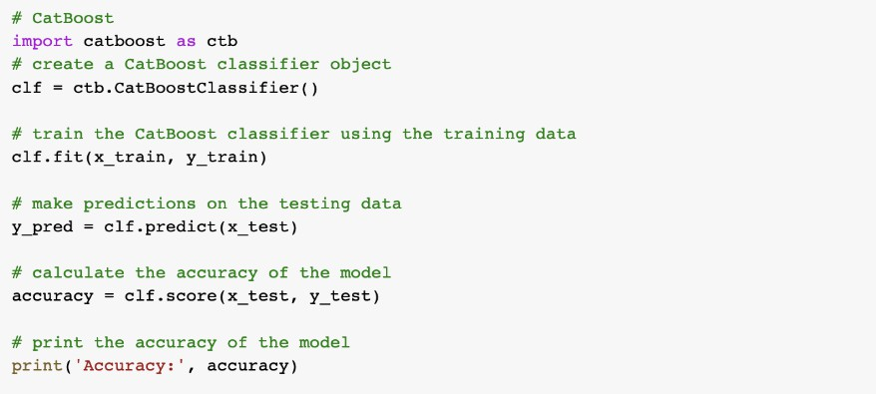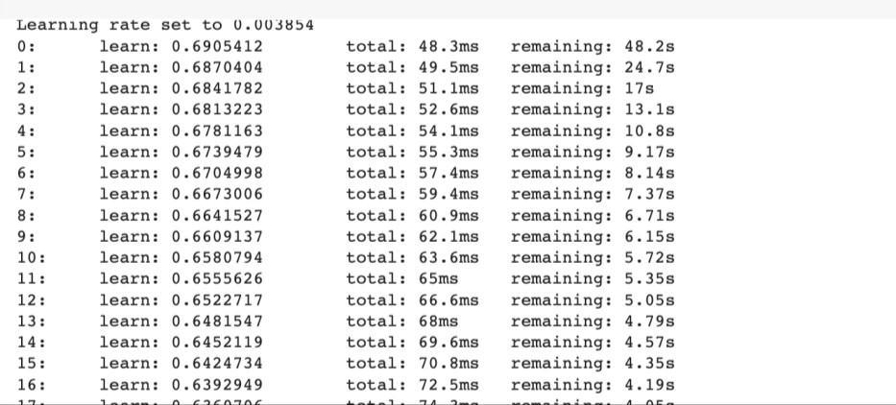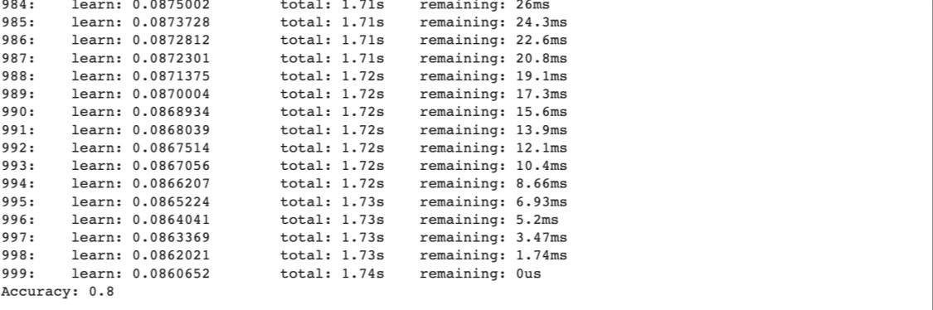

* + 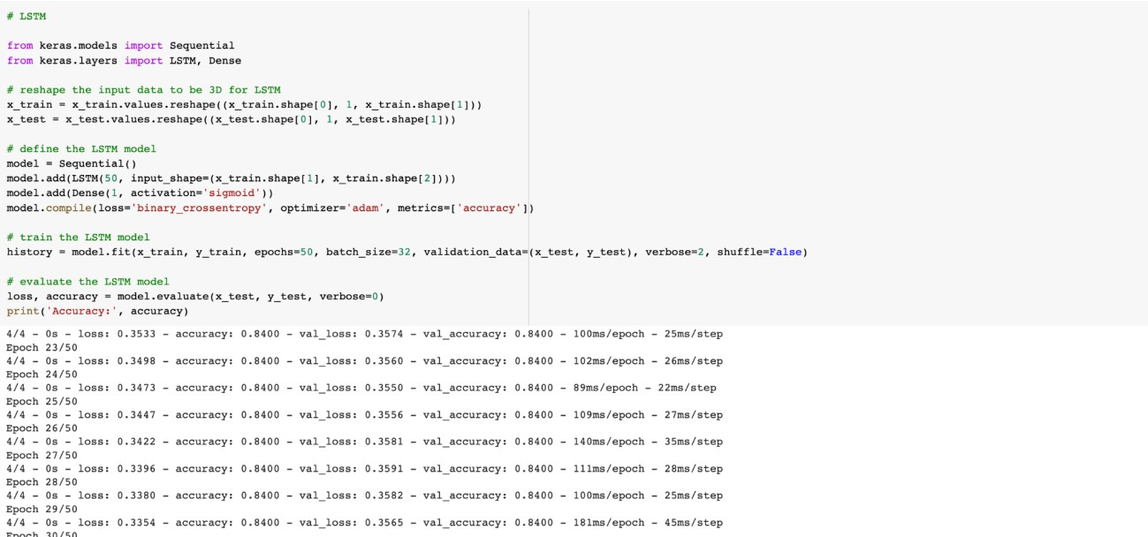**LSTM**
  + 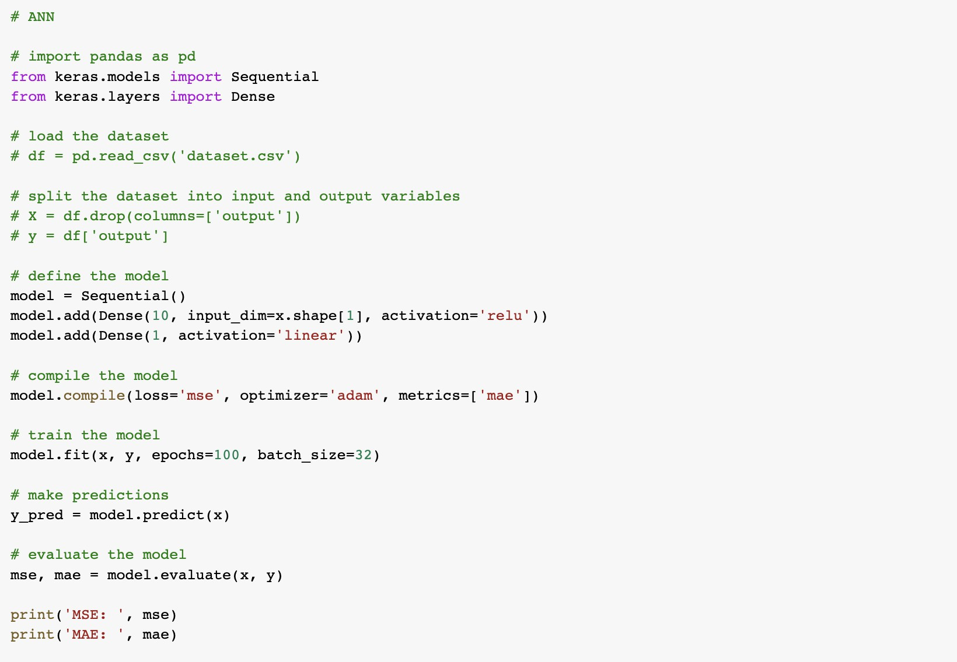**ANN**

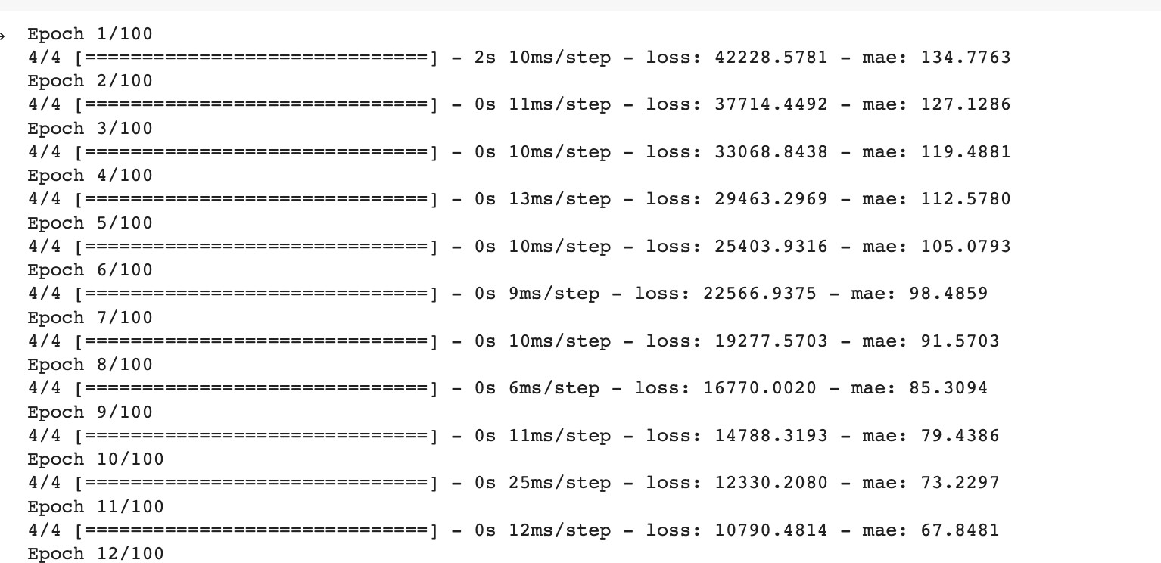

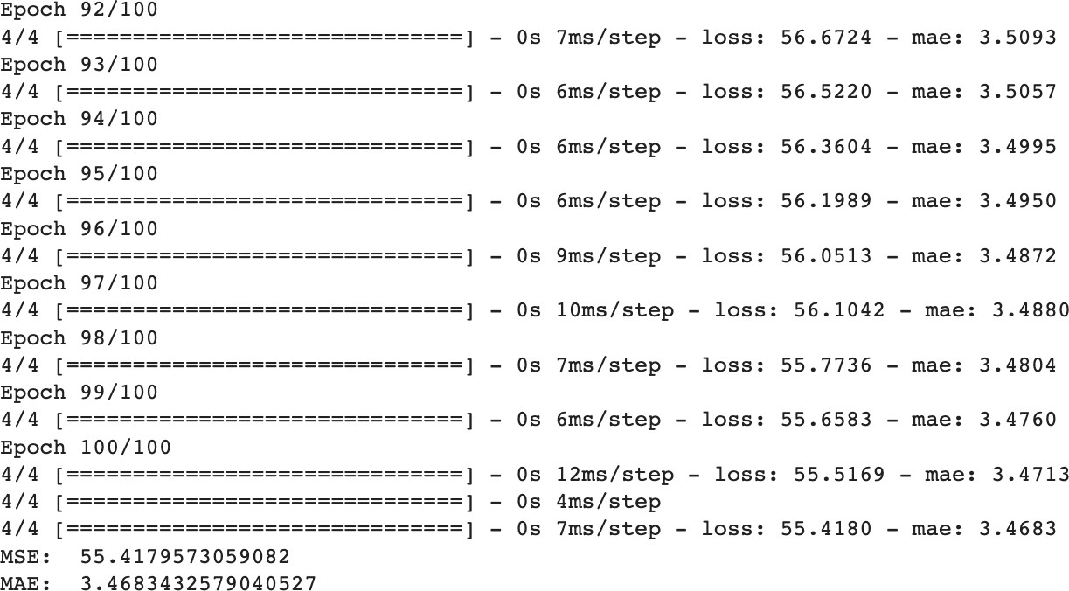

1. **Dataset: ant-1.4**
   * **Importing the Libraries**
   * 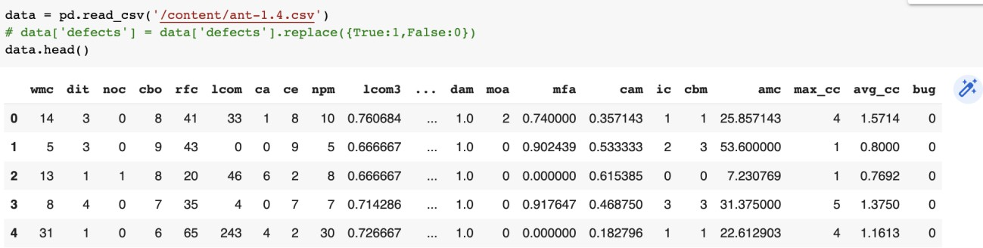**Loading the dataset**
   * **Training the data**



* + 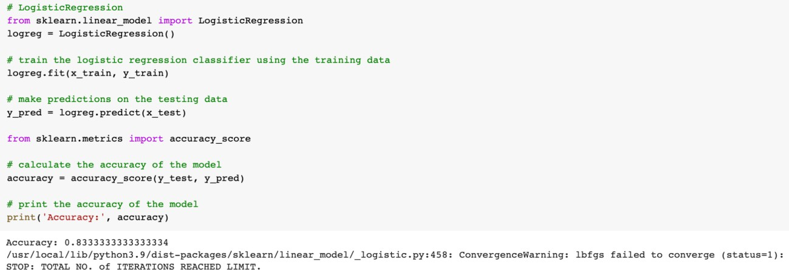**LOGISTIC REGRESSION**
  + **SVM**

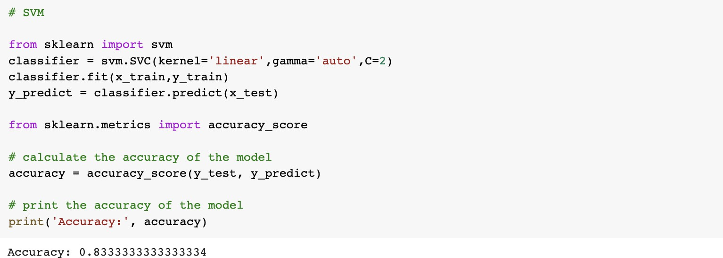

* + 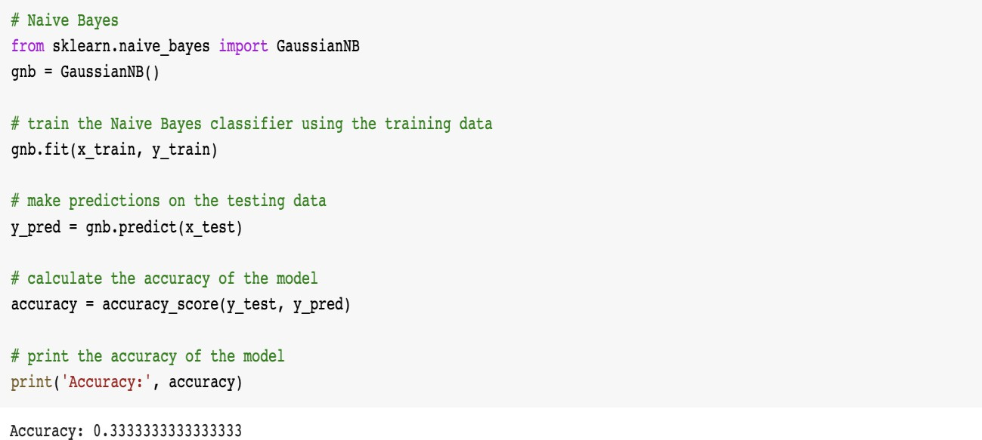**NAIVE BAYES**
  + **DECISION TREE**

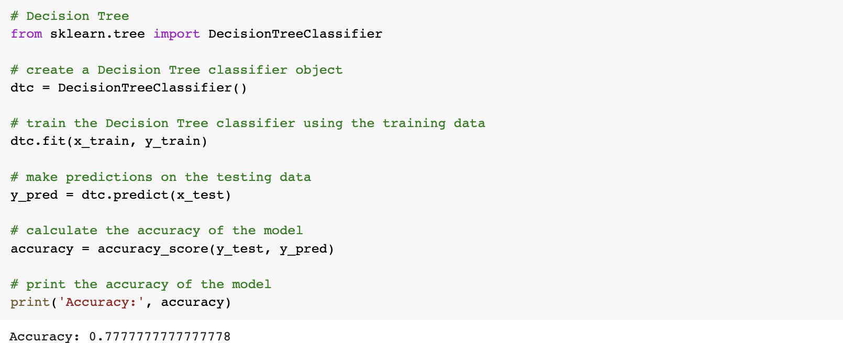

* + 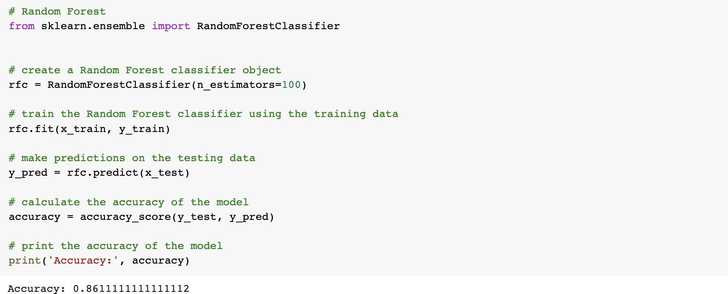**RANDOM FOREST**
  + 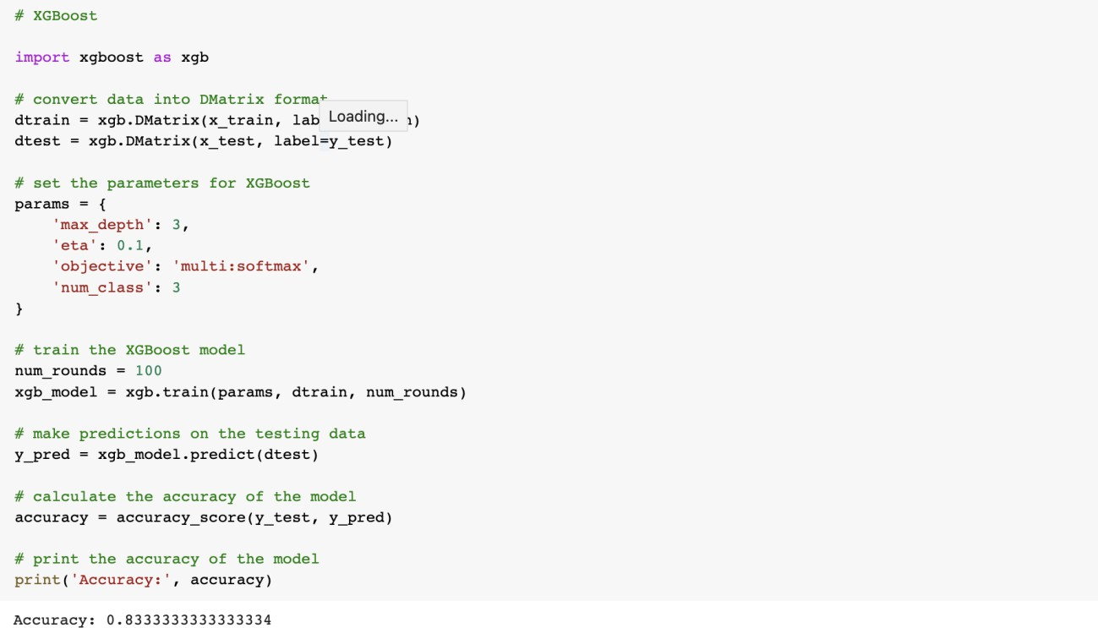**XGBOOST**
  + **KNN**

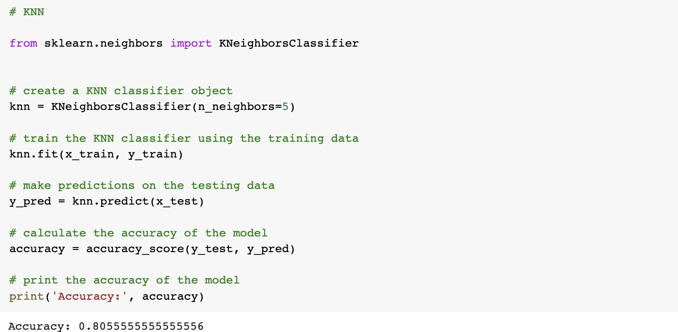

* + 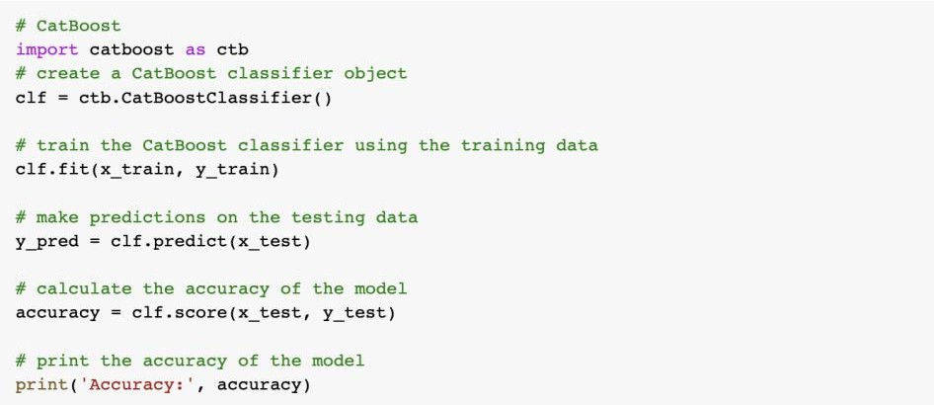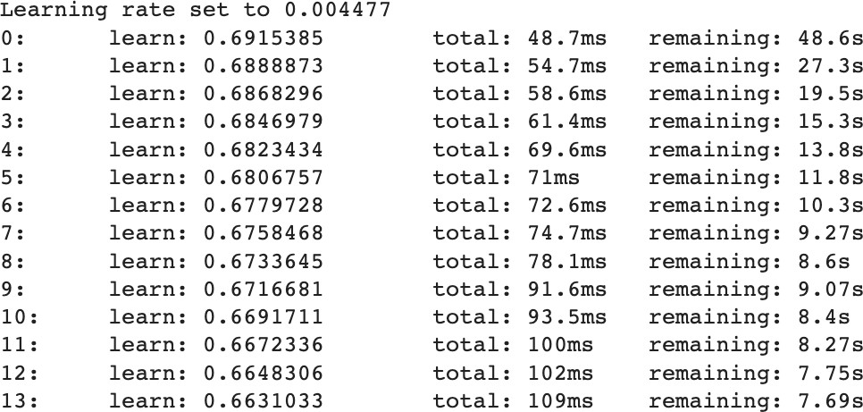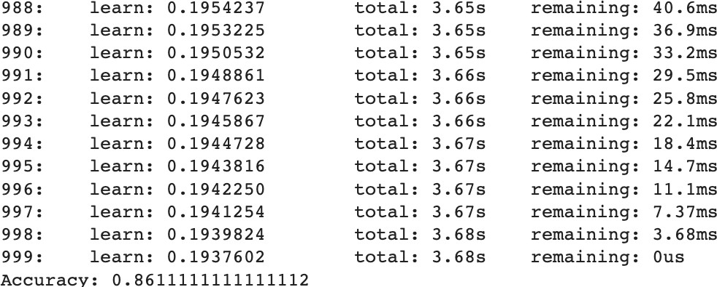**CATBOOST**
  + **LSTM**

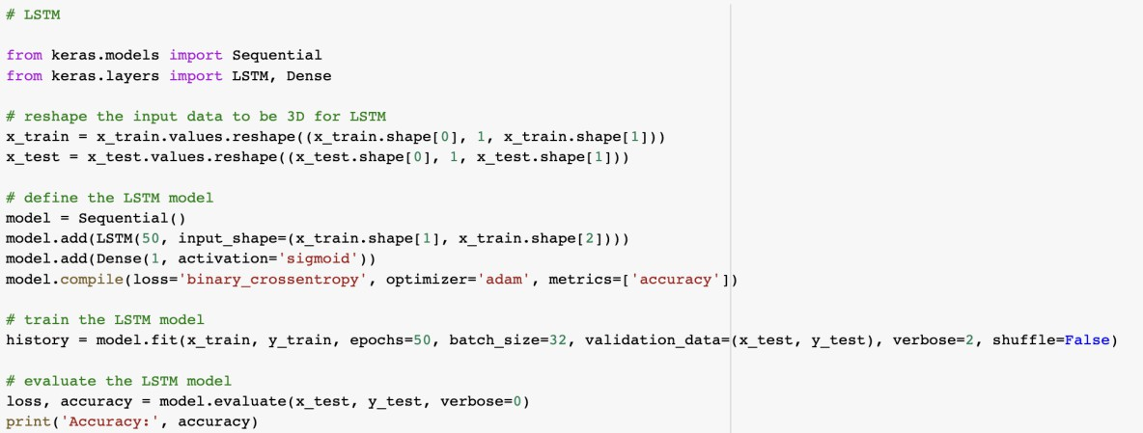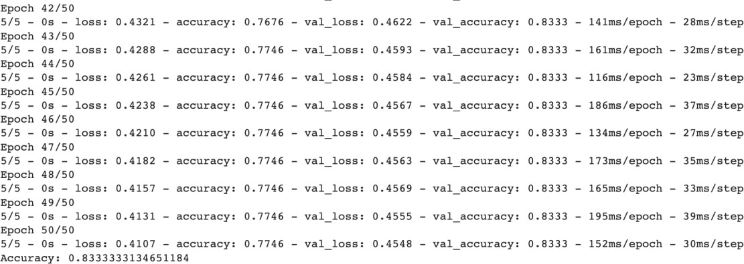

* + **ANN**

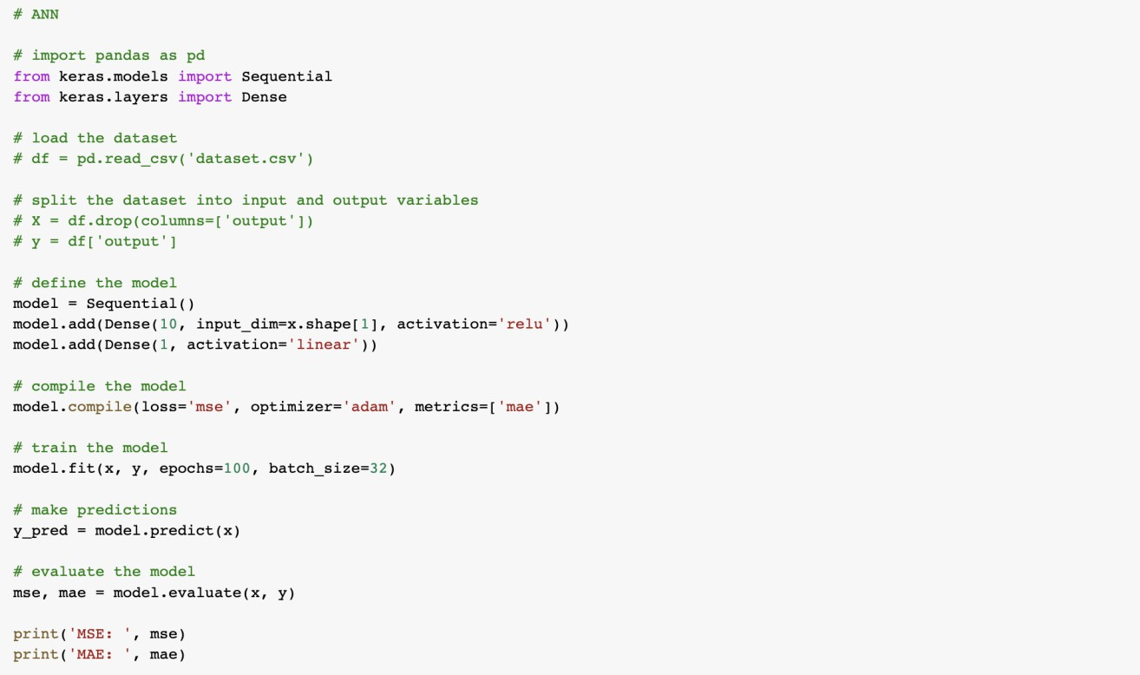

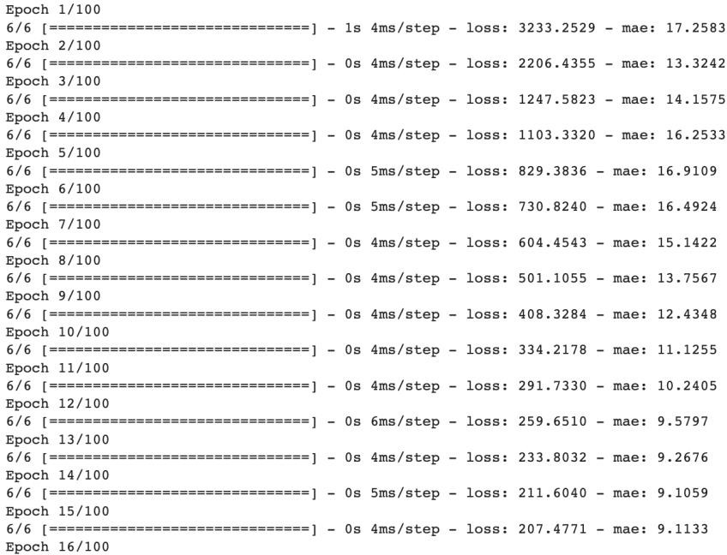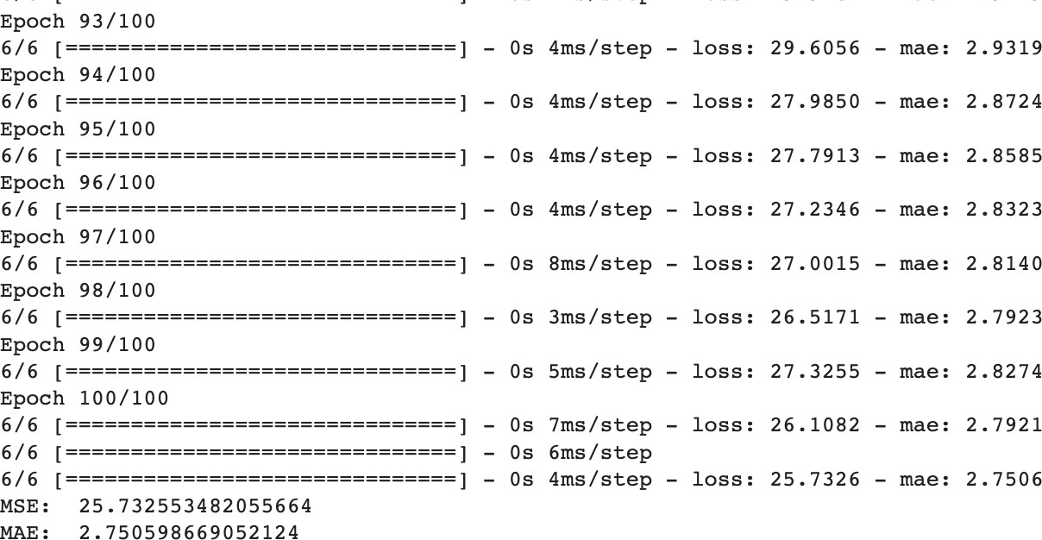

1. **Dataset : camel-1.0**
   * **Importing the Libraries**
   * **Loading the dataset**

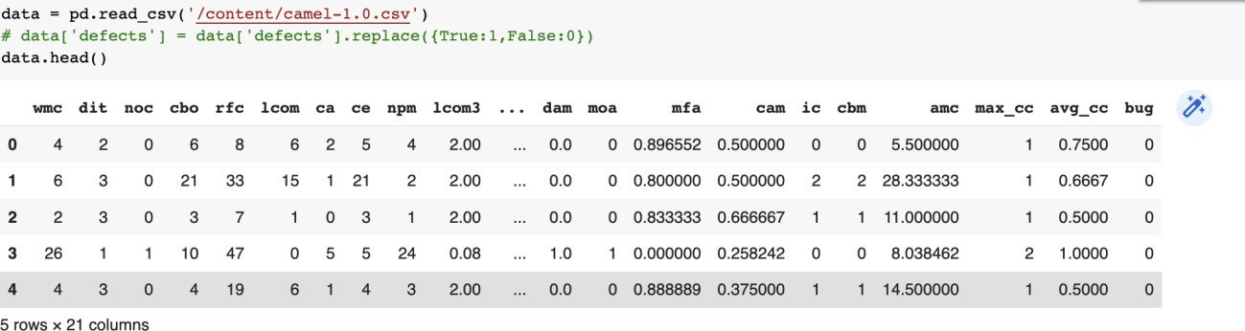

* + **Training the data**
  + 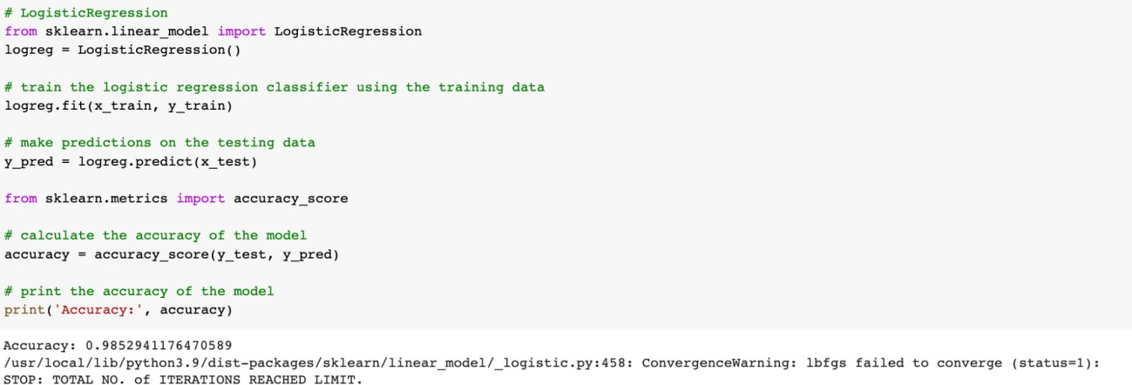**LOGISTIC REGRESSION**
  + **SVM**

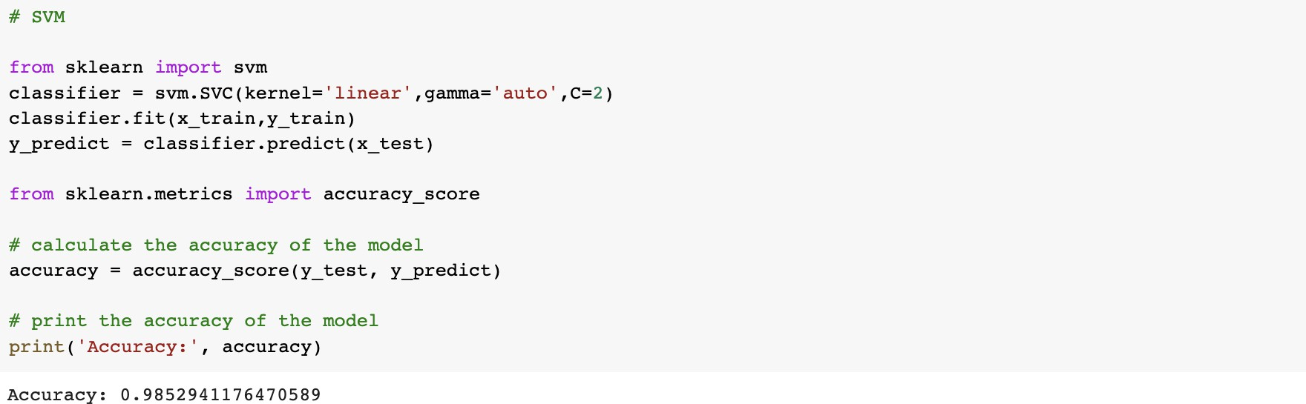

* + 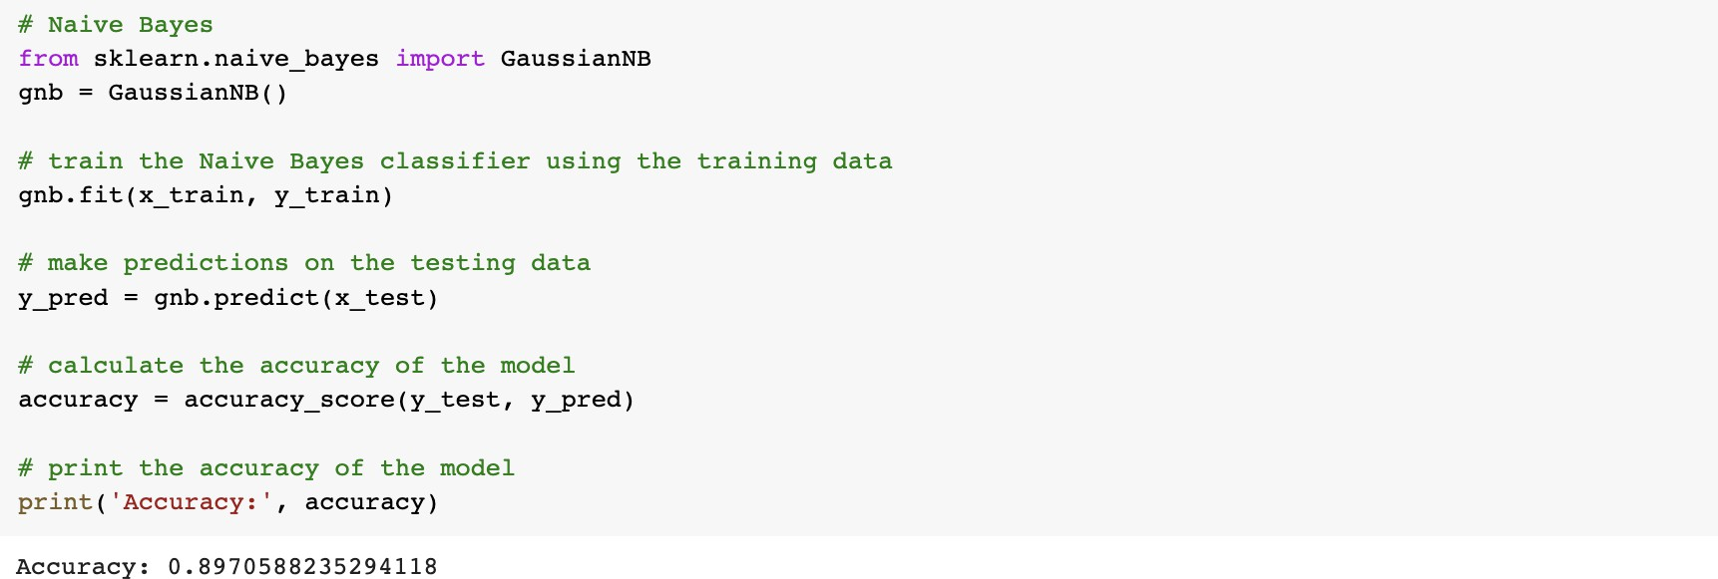**NAIVE BAYES**
  + 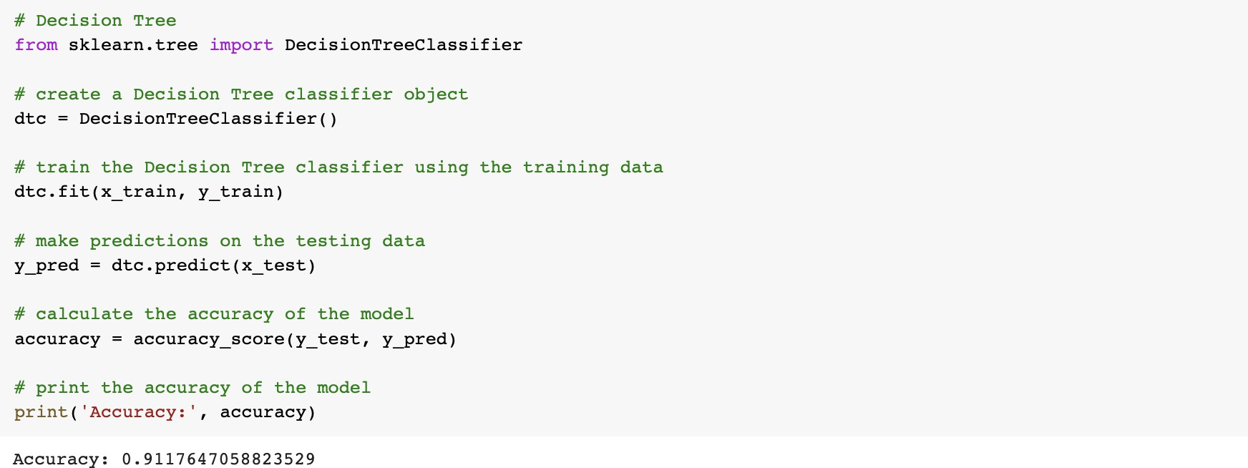**DECISION TREE**
  + **RANDOM FOREST**

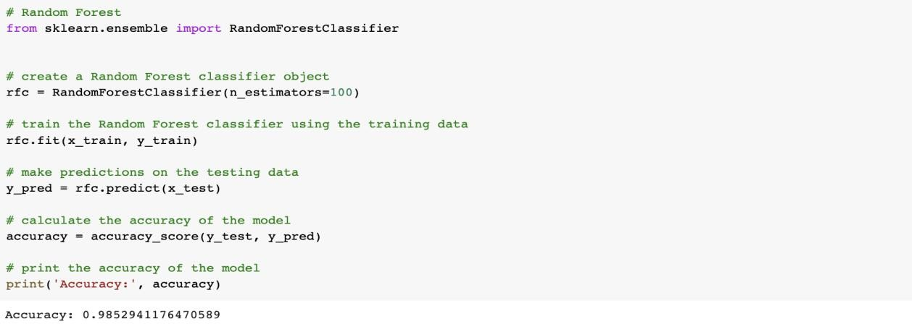

* + 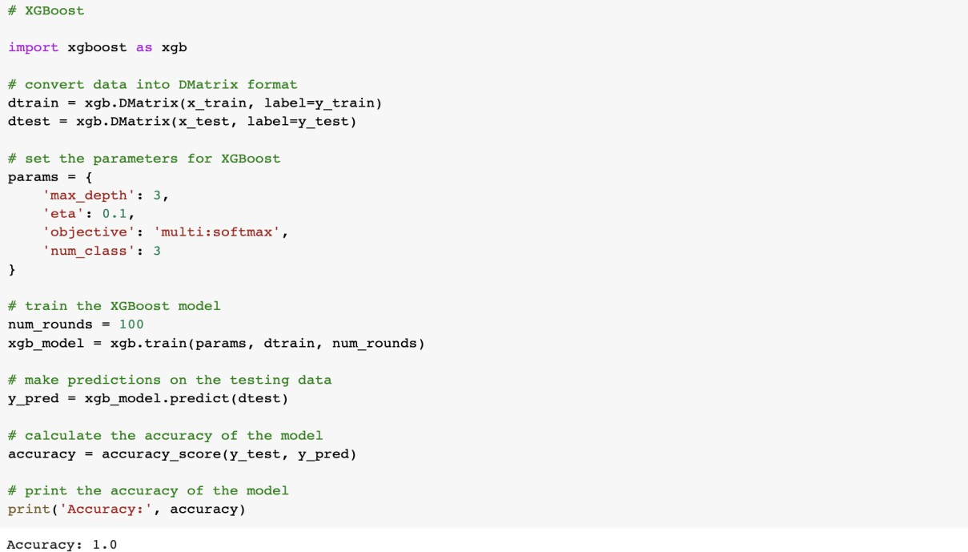**XGBOOST**
  + 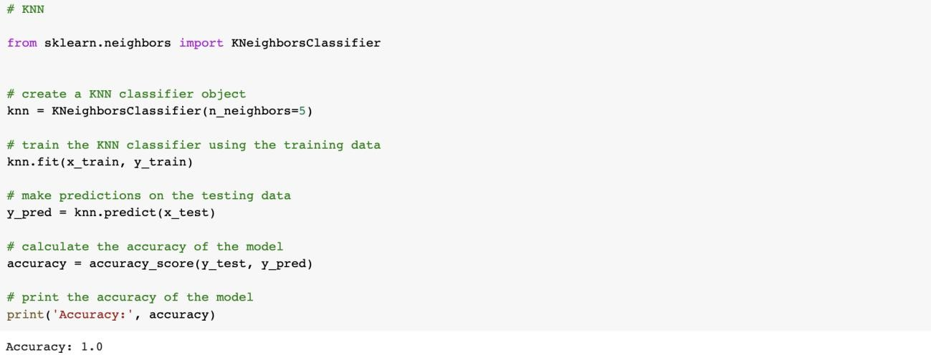**KNN**
  + 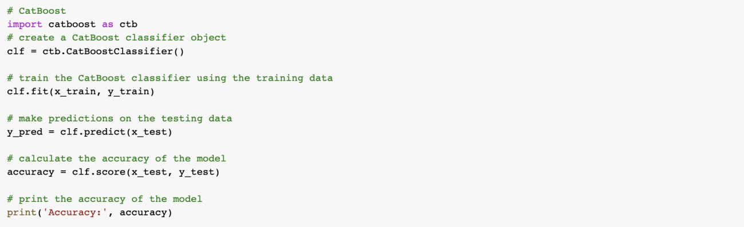**CATBOOST**

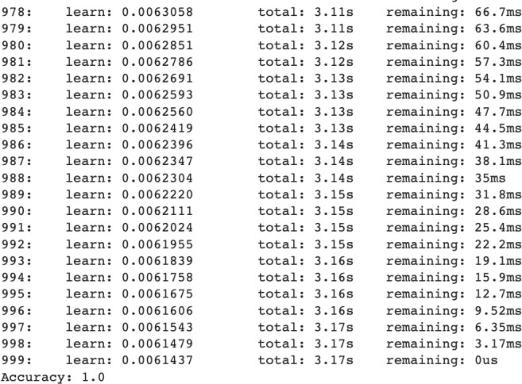

* + **LSTM**

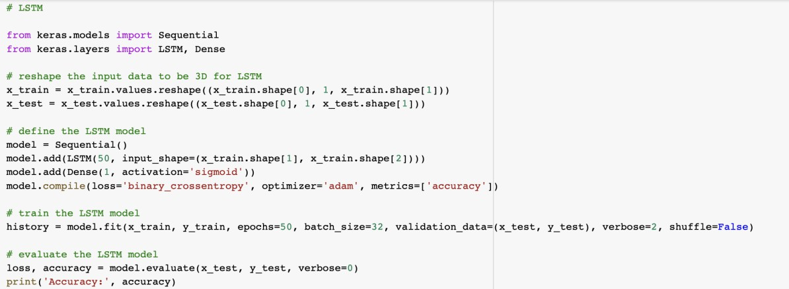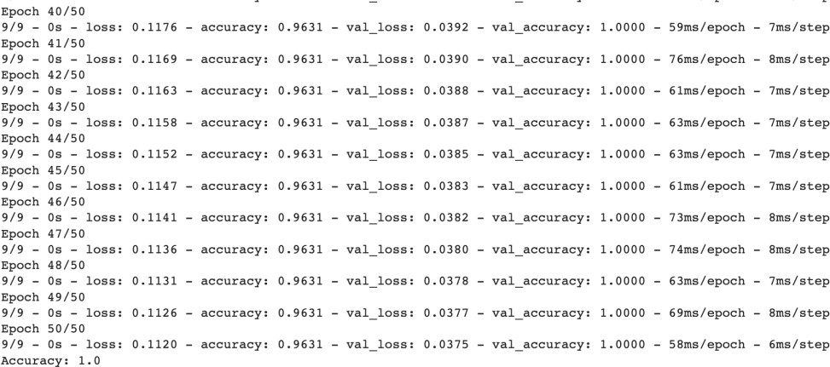

* + **ANN**

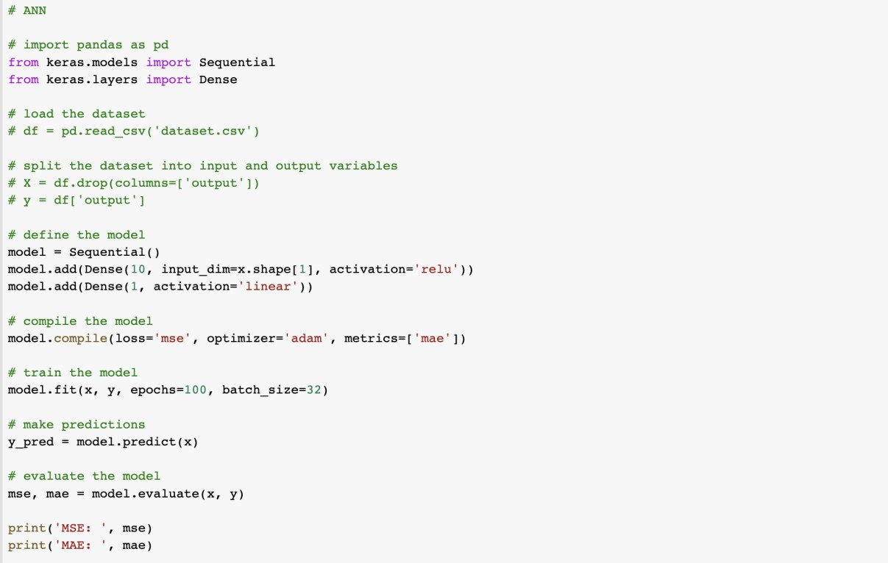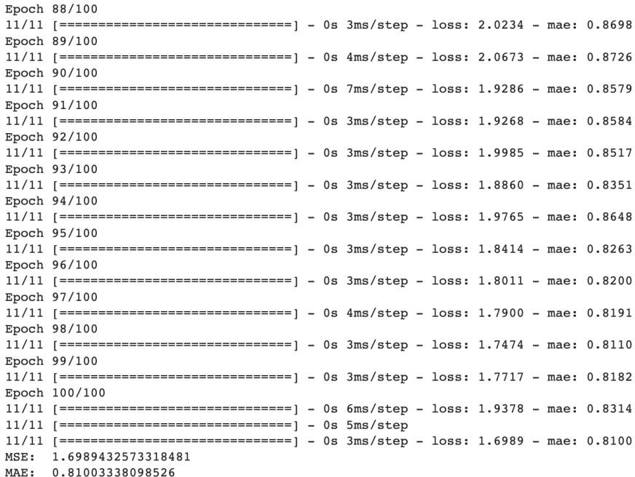

1. **Dataset : camel-1.2**
   * **Importing the Libraries**
   * 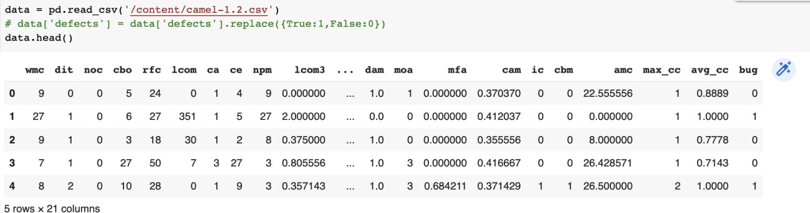**Loading the dataset**
   * **Training the data**



* + 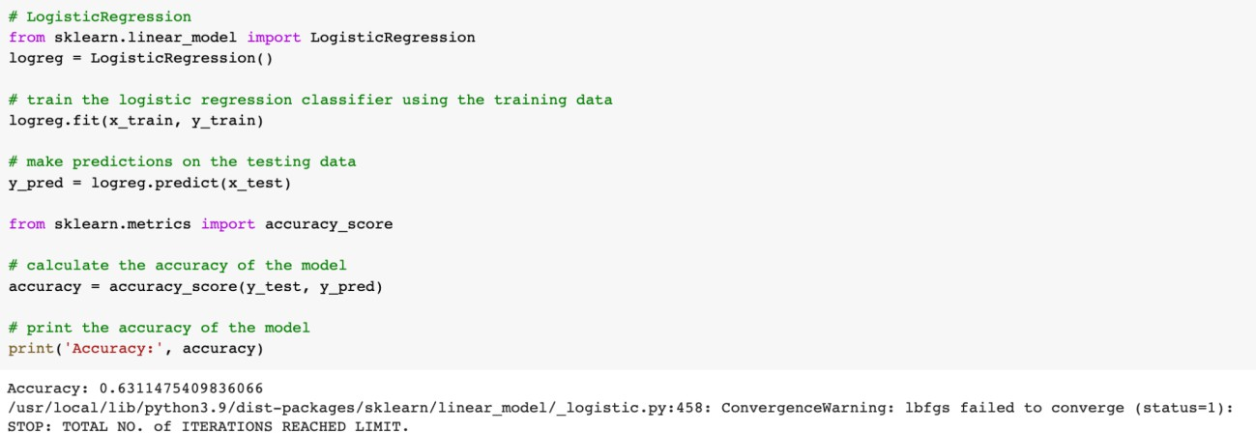**LOGISTIC REGRESSION**
  + **SVM**

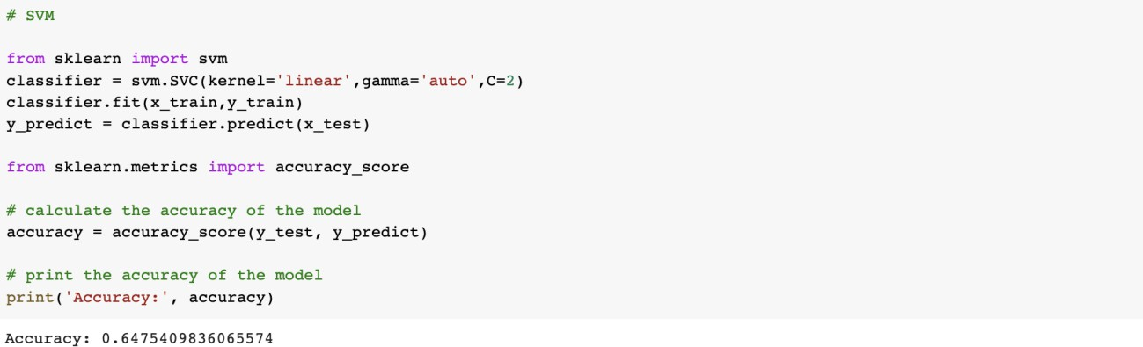

* + 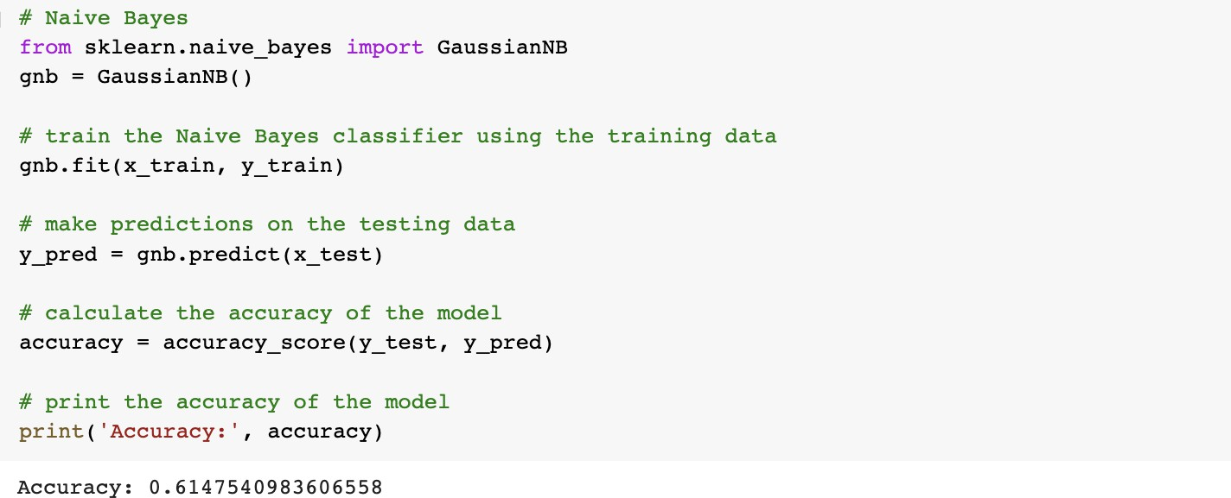**NAIVE BAYES**
  + 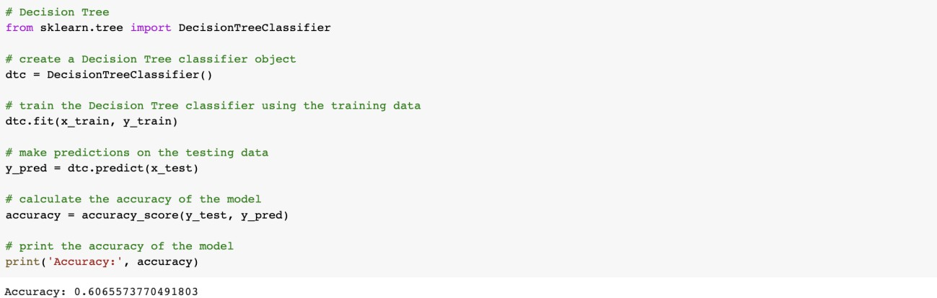**DECISION TREE**
  + **RANDOM FOREST**

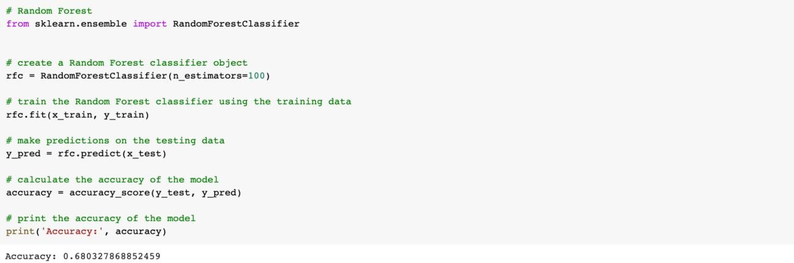

* + 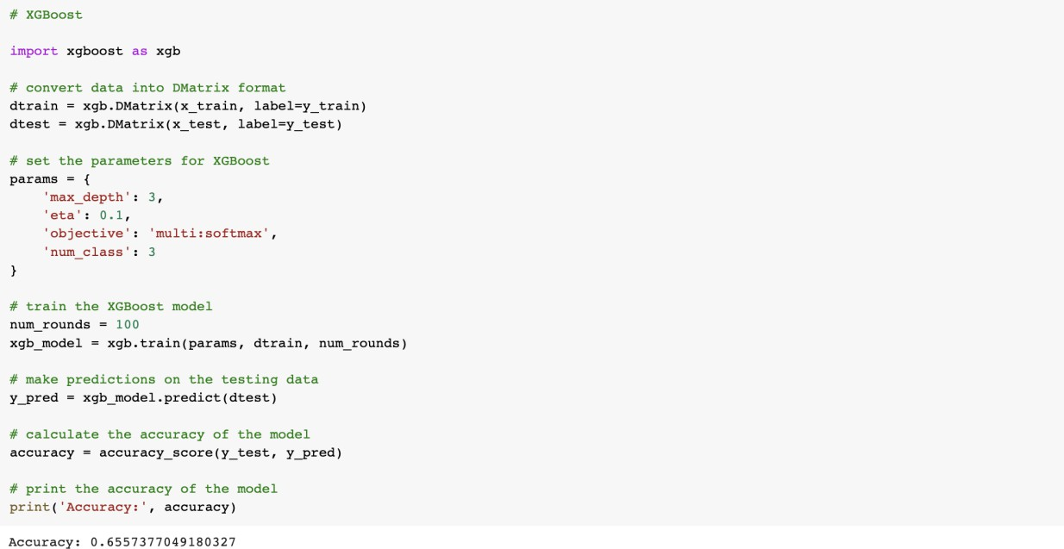**XGBOOST**
  + **KNN**

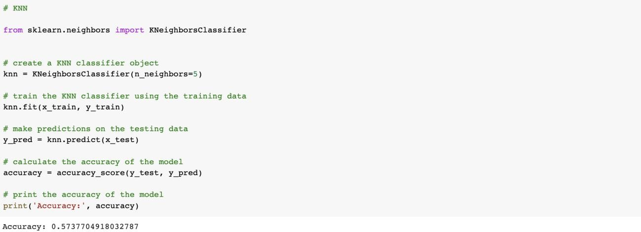

* + **CATBOOST**



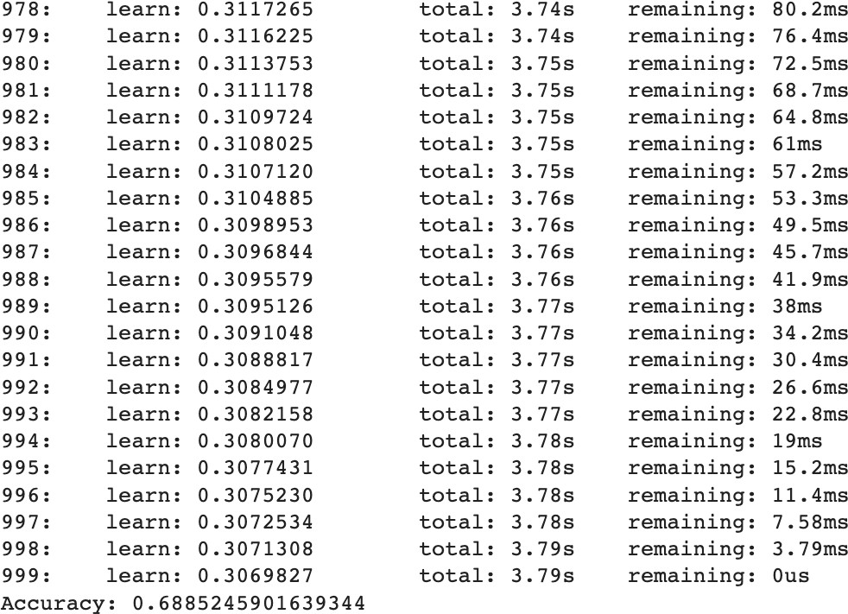

* + **LSTM**

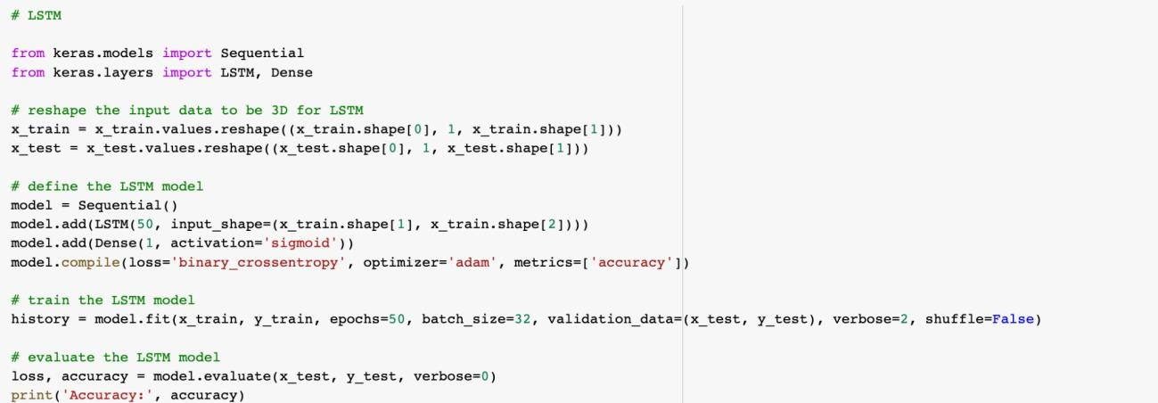

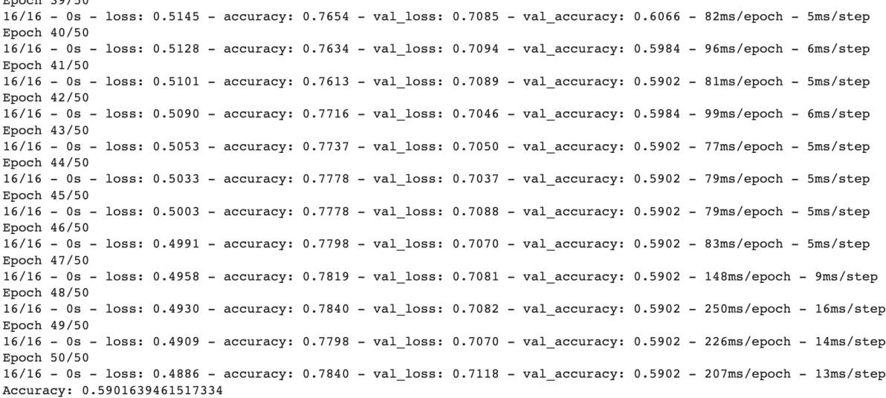

* + 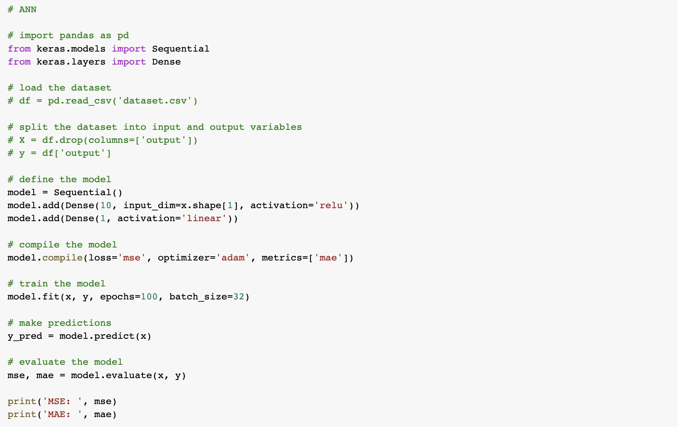**ANN**

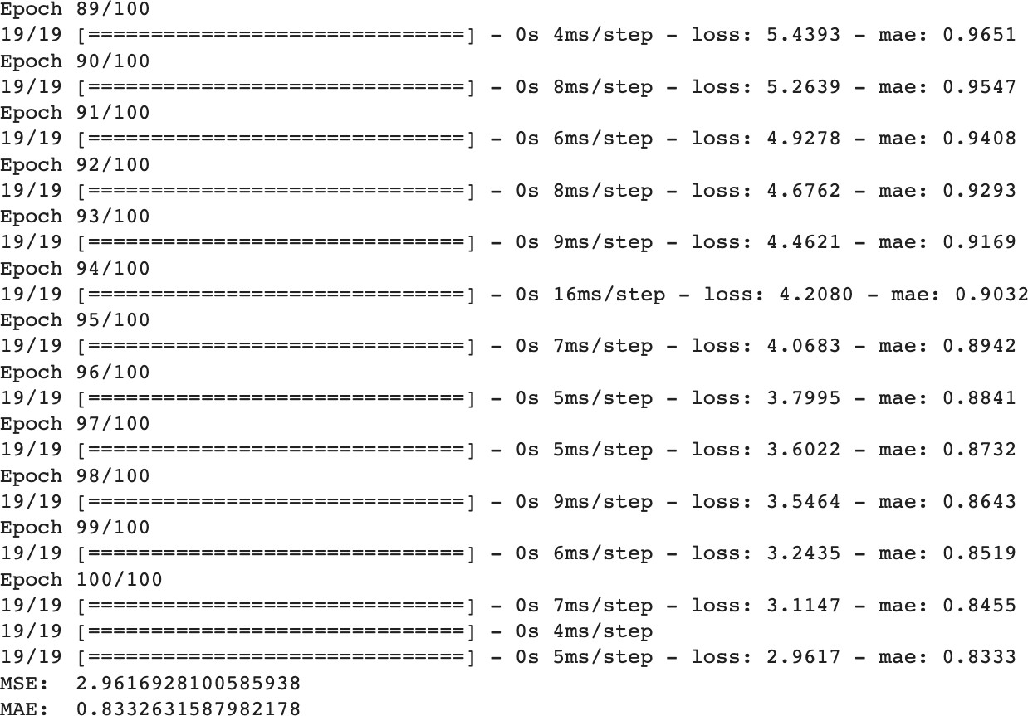

1. **Dataset : ivy-1.1**
   * **Importing the Libraries**
   * 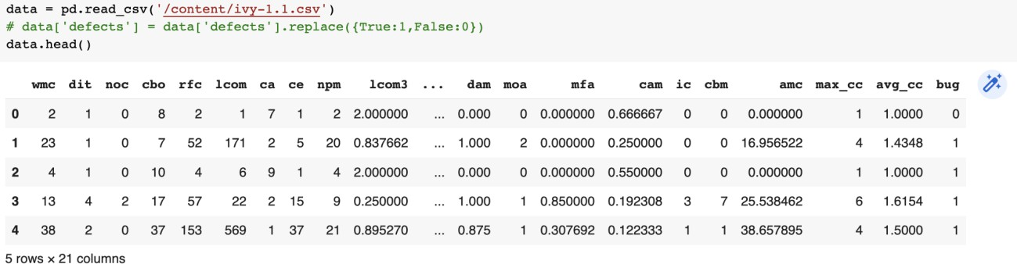**Loading the dataset**
   * **Training the data**
   * 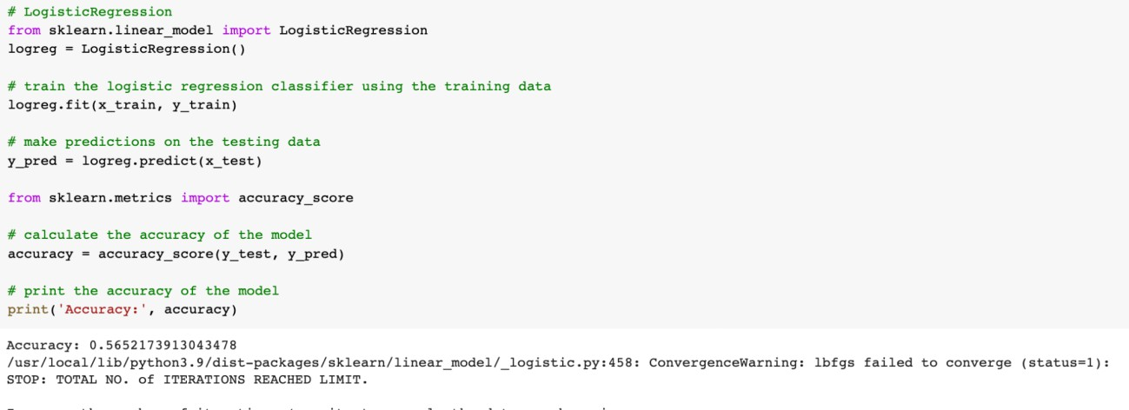**LOGISTIC REGRESSION**
   * **SVM**

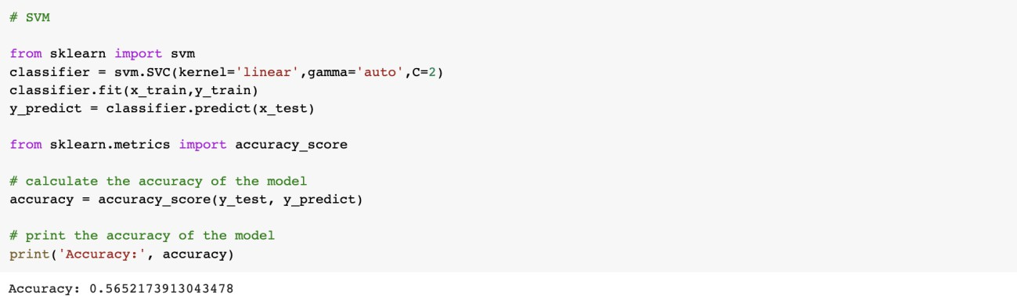

* + 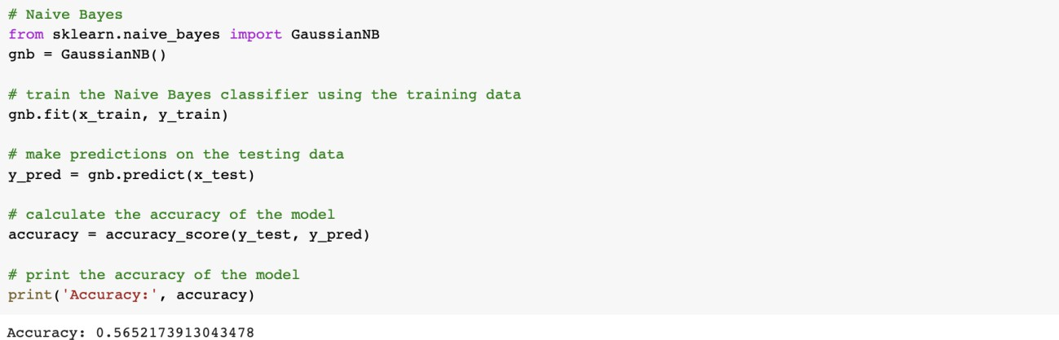**NAIVE BAYES**
  + 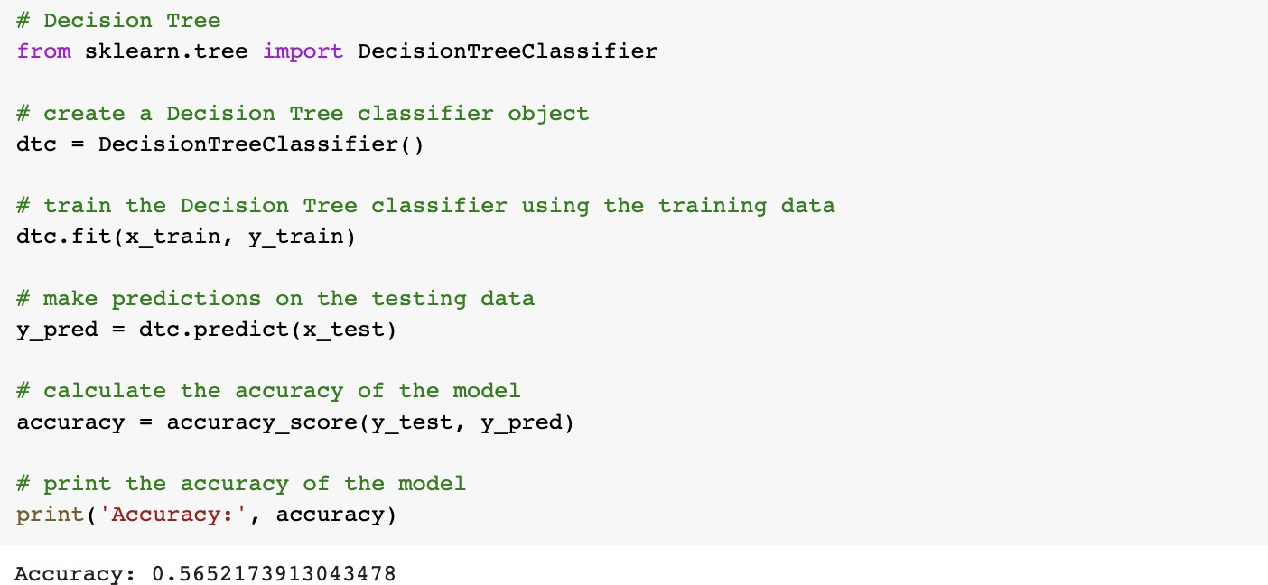**DECISION TREE**
  + **RANDOM FOREST**

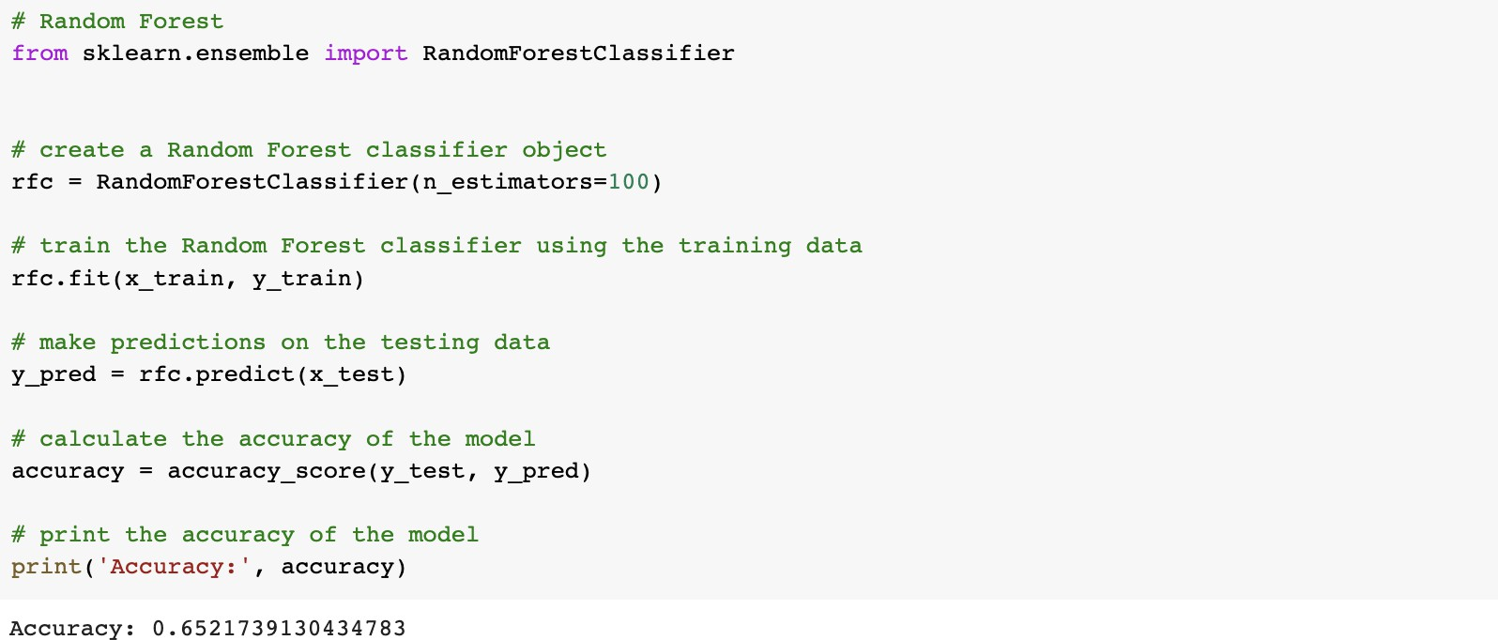

* + 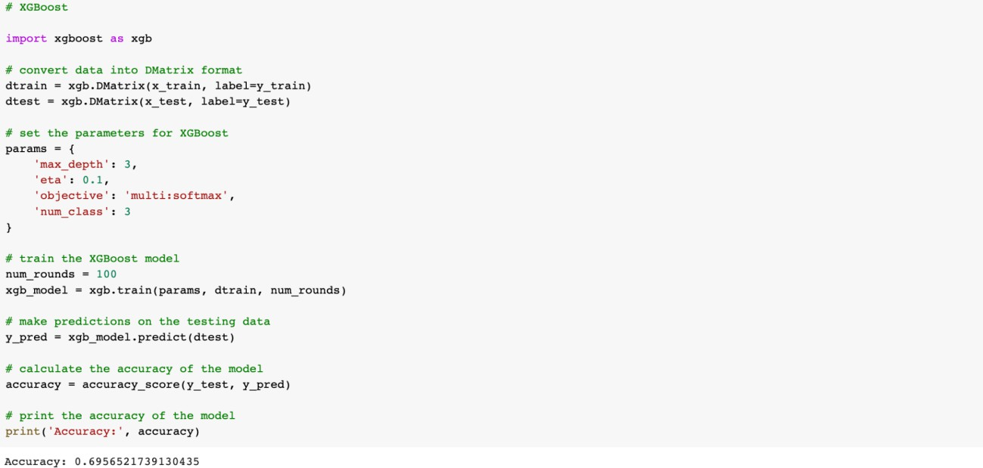**XGBOOST**
  + 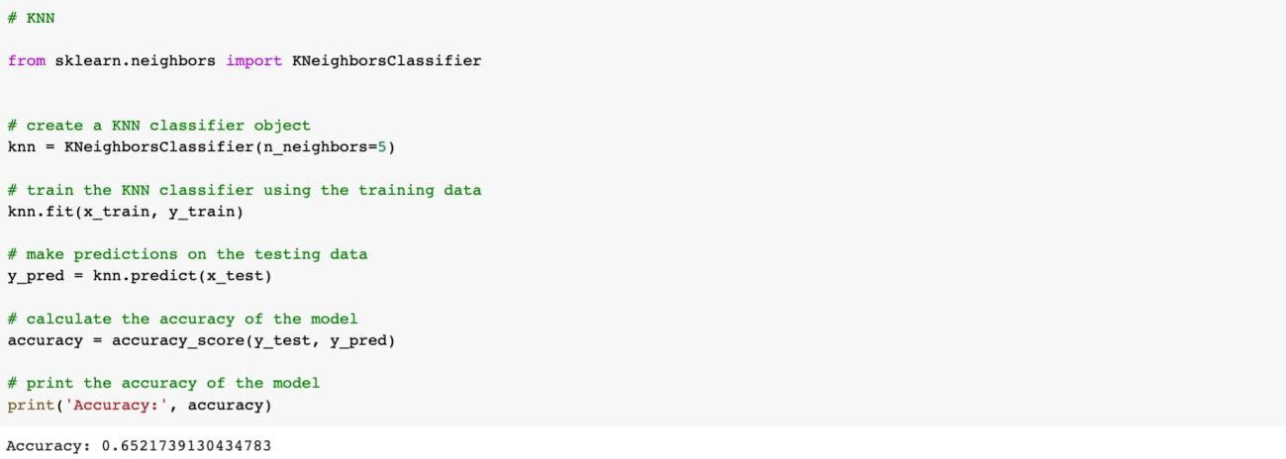**KNN**
  + **CATBOOST**



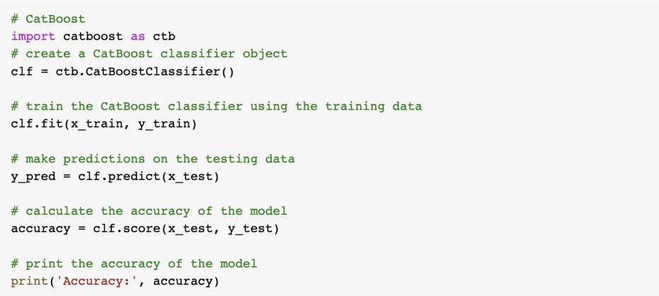

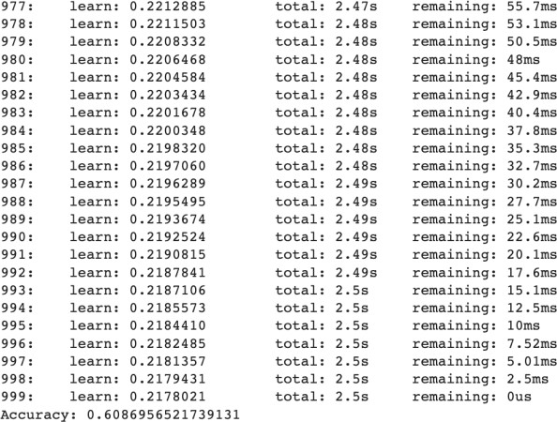

* + **LSTM**

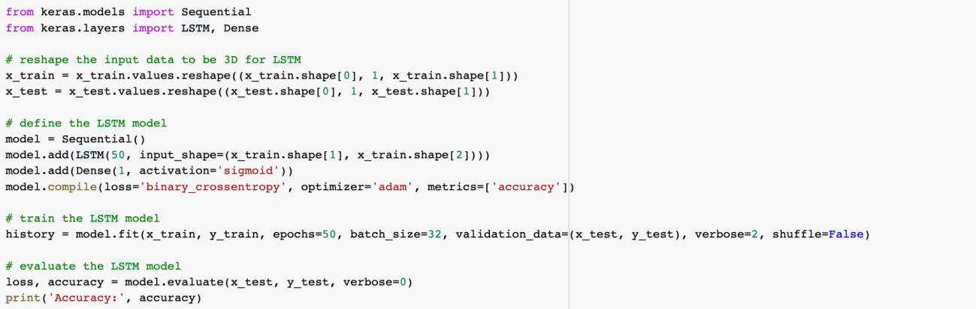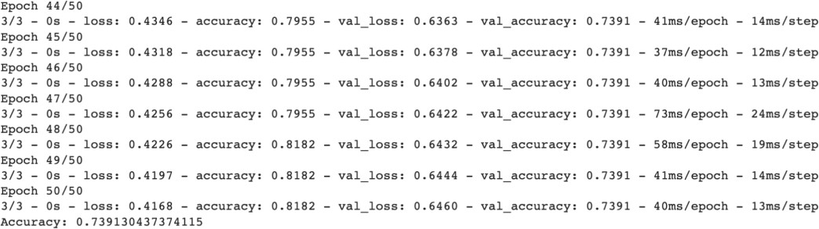

* + **ANN**

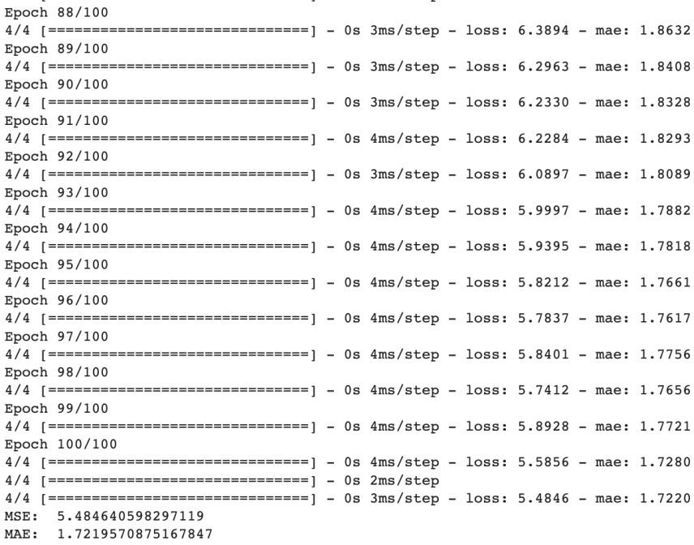

1. **Dataset : ivy-2.0**
   * **Importing the Libraries**
   * 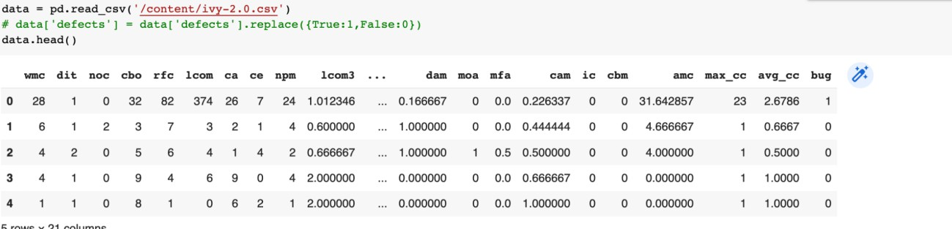**Loading the dataset**
   * **Training the data**



* + 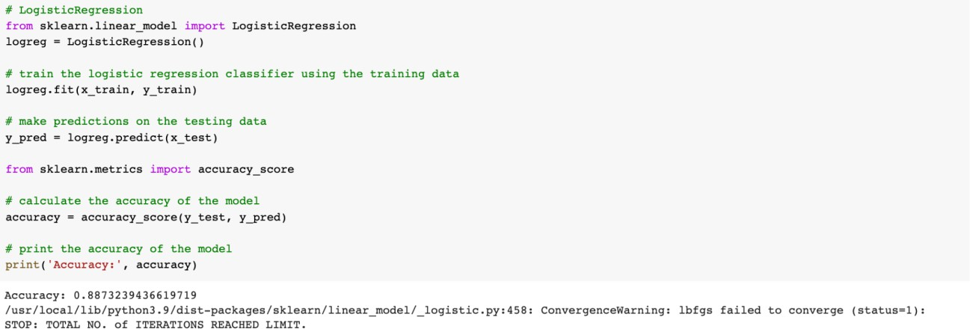**LOGISTIC REGRESSION**
  + **SVM**

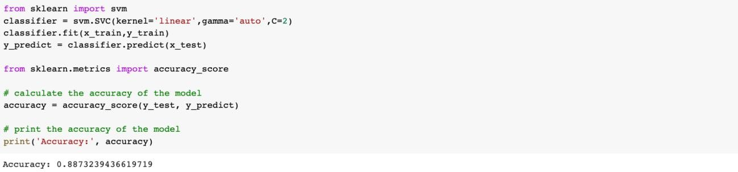

* + 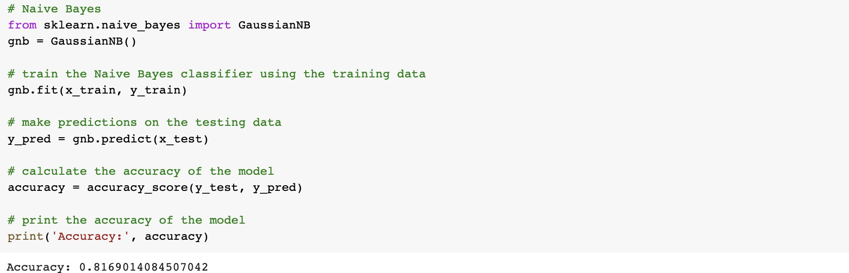**NAIVE BAYES**
  + 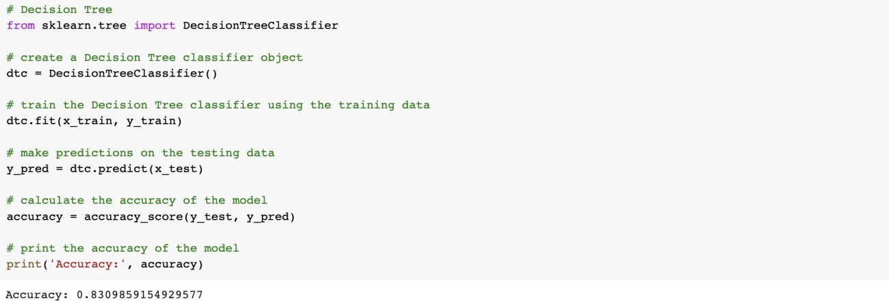**DECISION TREE**
  + 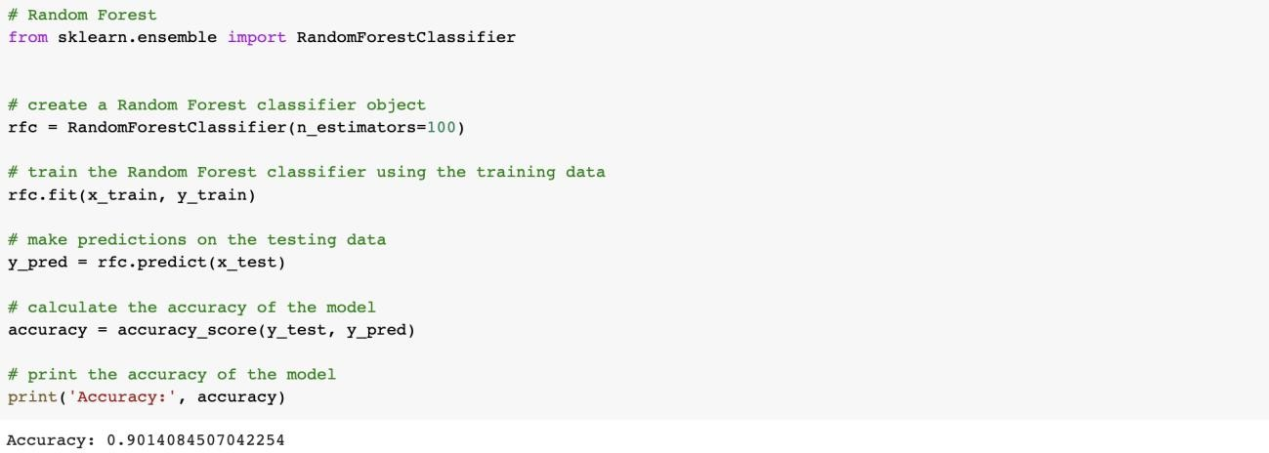**RANDOM FOREST**
  + 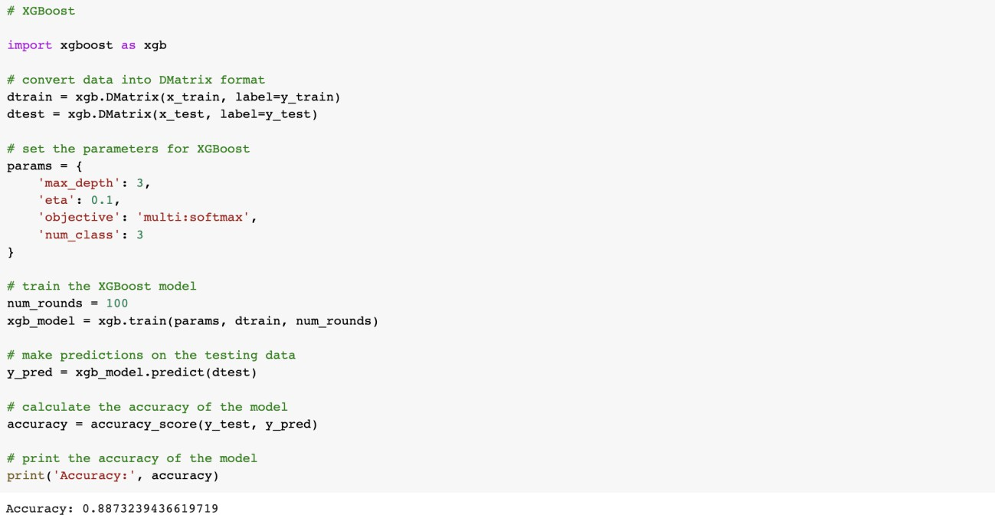**XGBOOST**
  + **KNN**

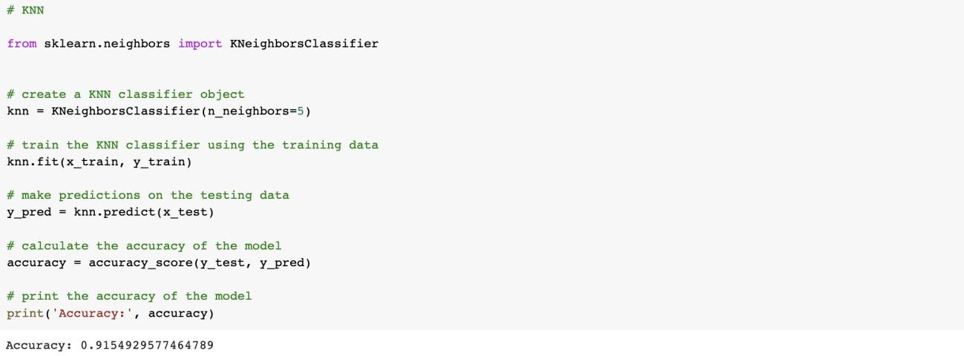

* + **CATBOOST**

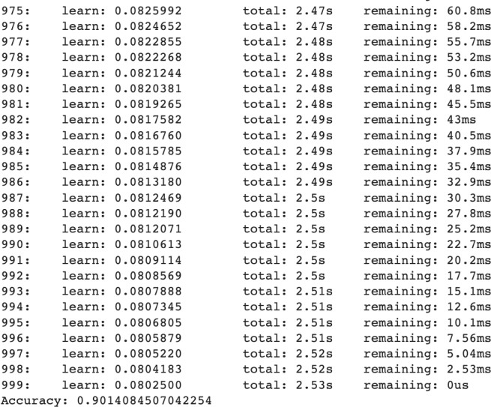

* + **LSTM**

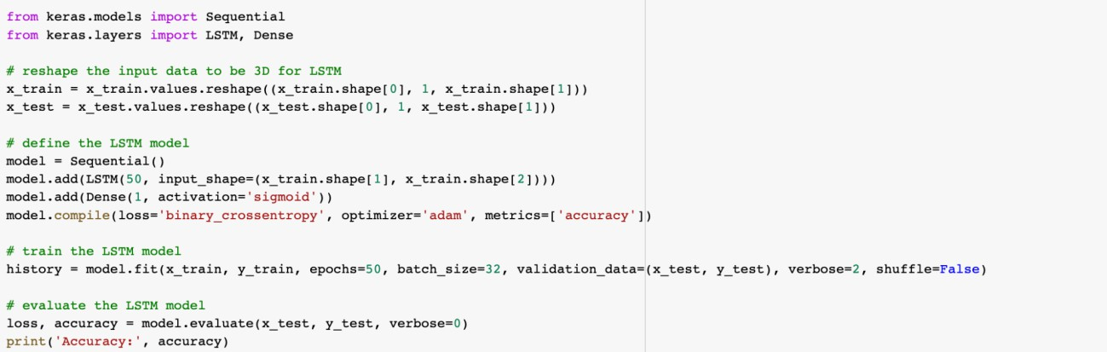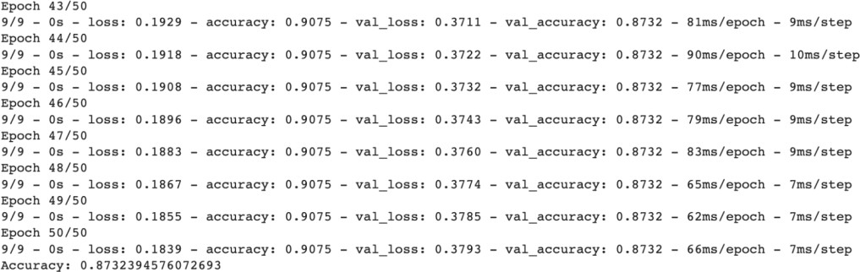

* + **ANN**

1. 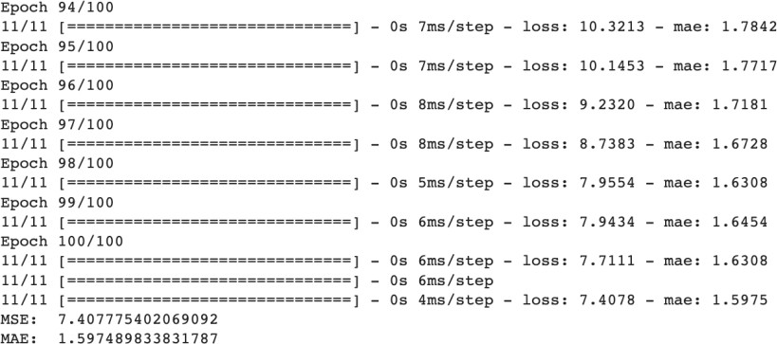**Dataset : jedit-3.2**
   * **Importing the Libraries**
   * **Loading the dataset**

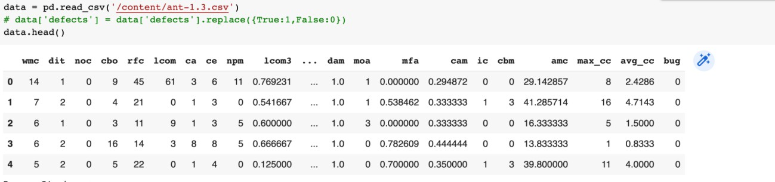

* + **Training the data**
  + 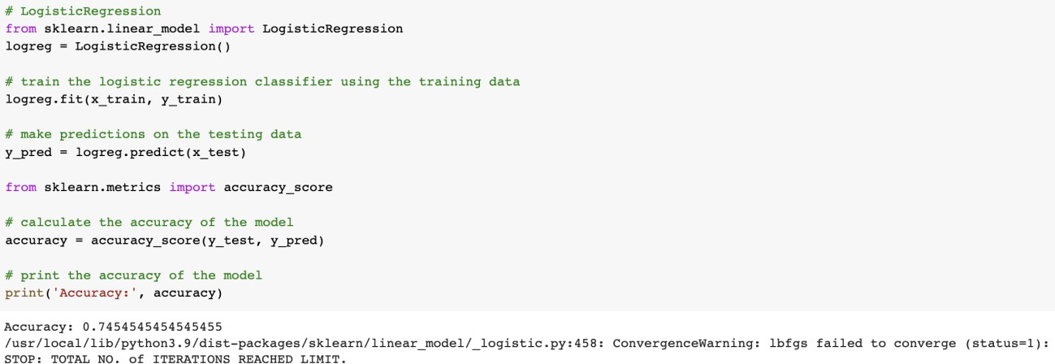**LOGISTIC REGRESSION**
  + **SVM**

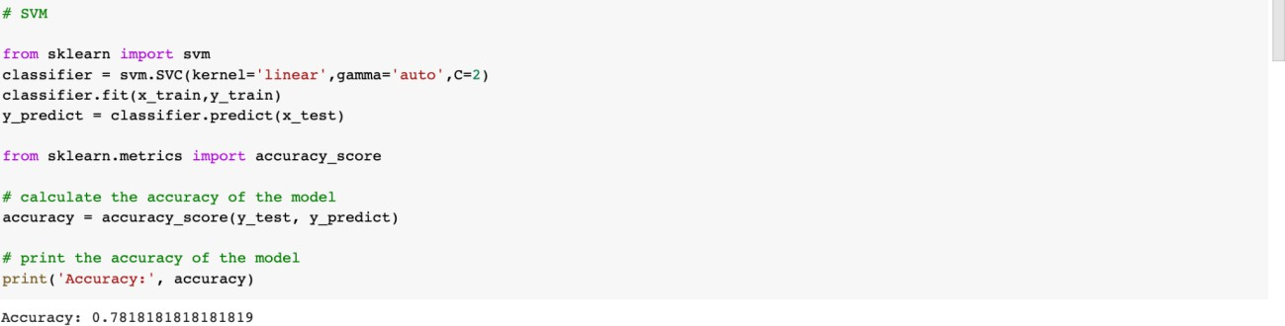

* + 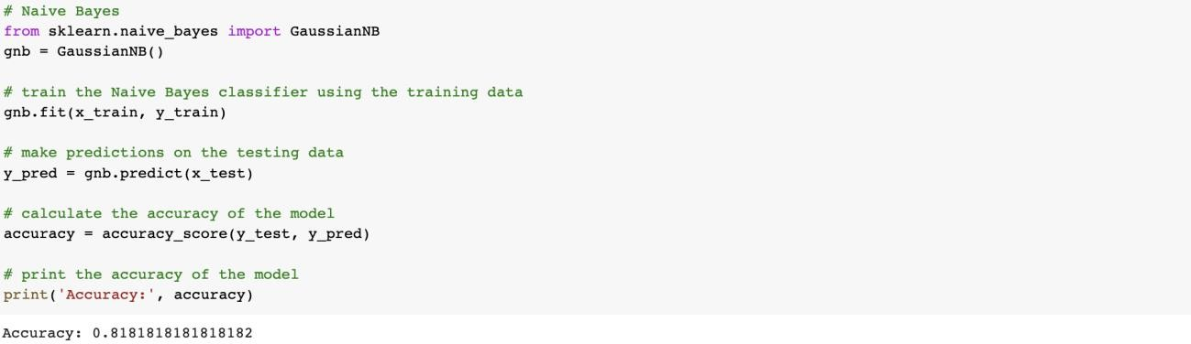**NAIVE BAYES**
  + 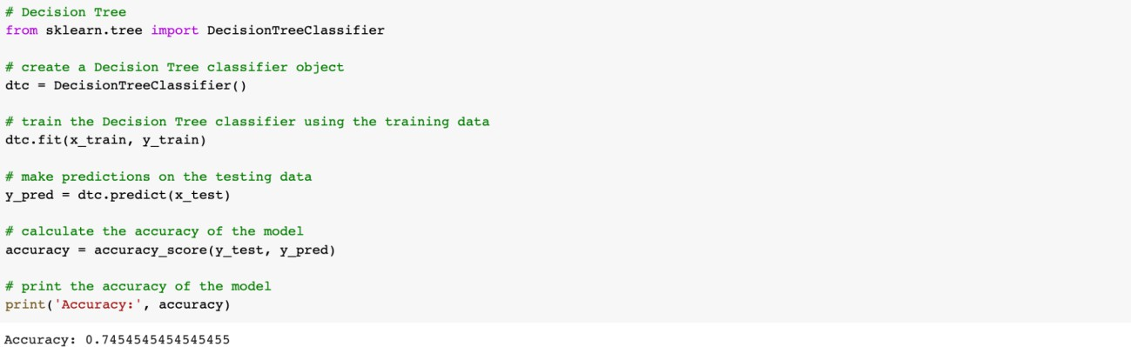**DECISION TREE**
  + **RANDOM FOREST**

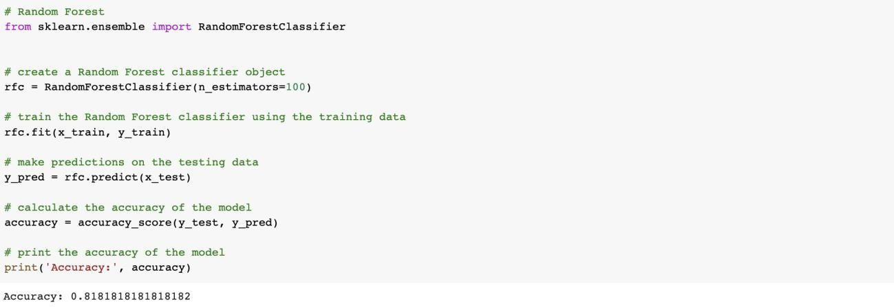

* + 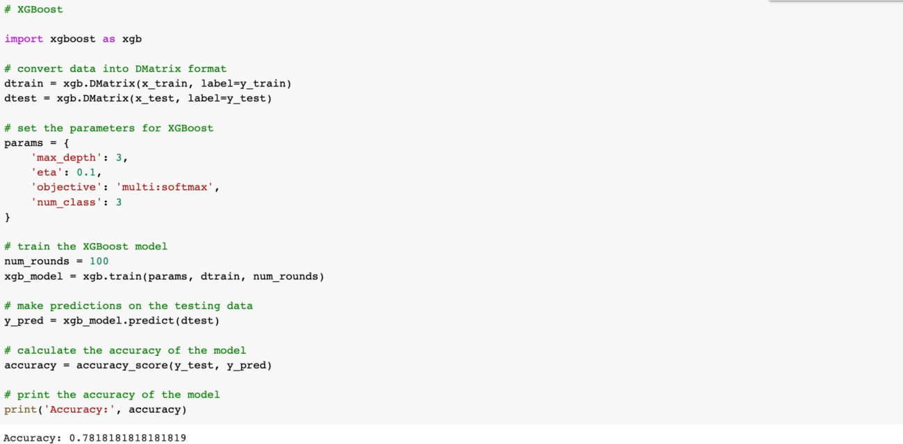**XGBOOST**
  + 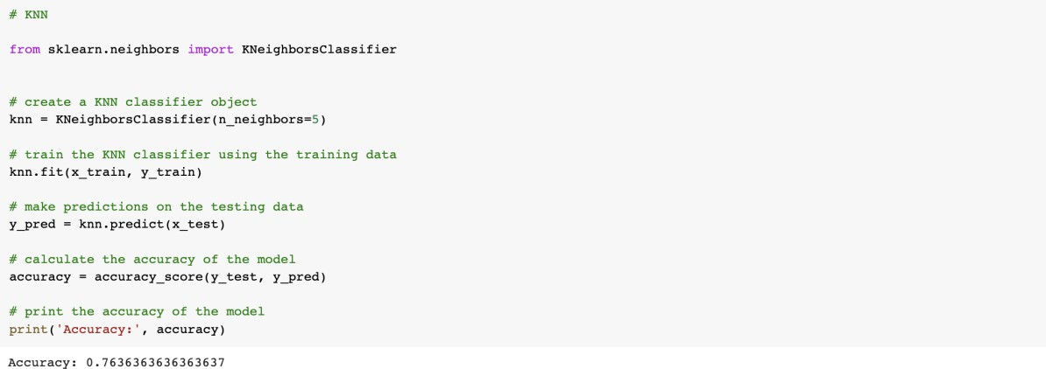**KNN**
  + **CATBOOST**



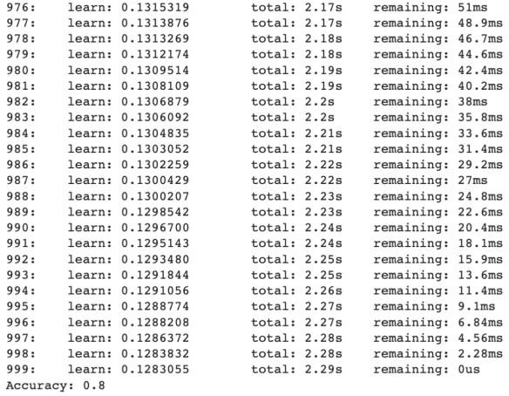

* + **LSTM**

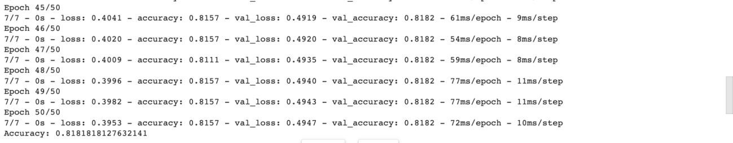

* + **ANN**

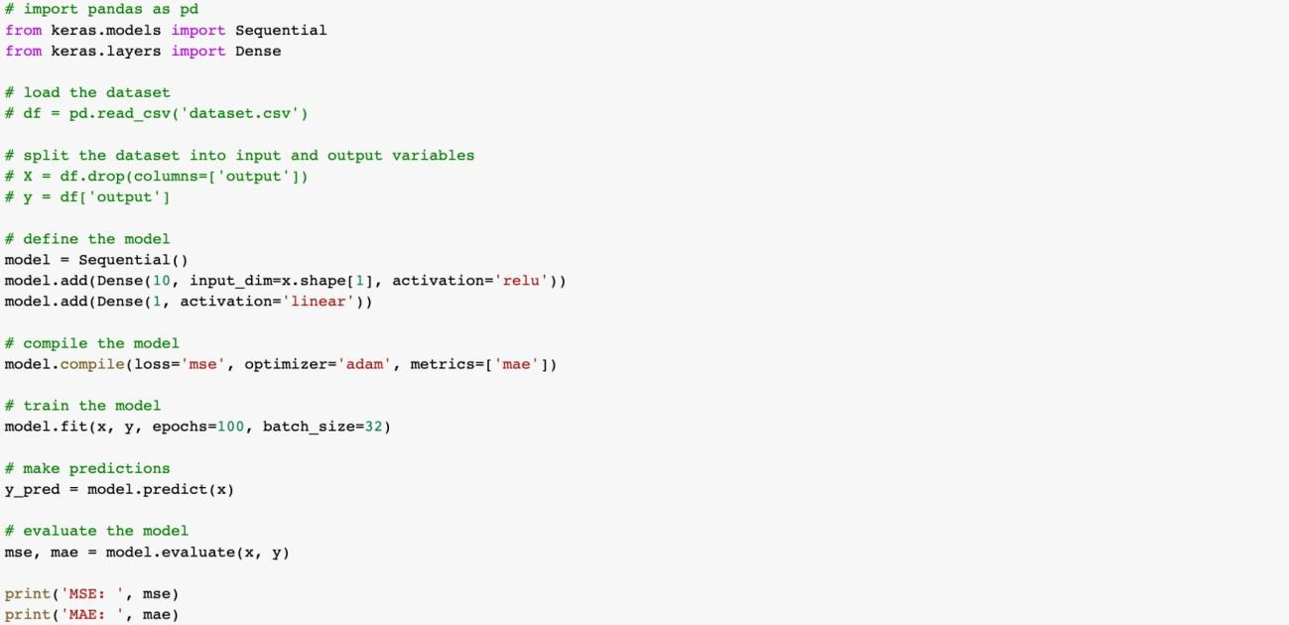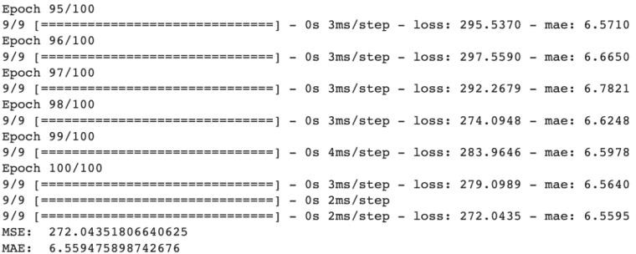

1. **Dataset : log4j-1.0**
   * **Importing the Libraries**
   * **Loading the dataset**

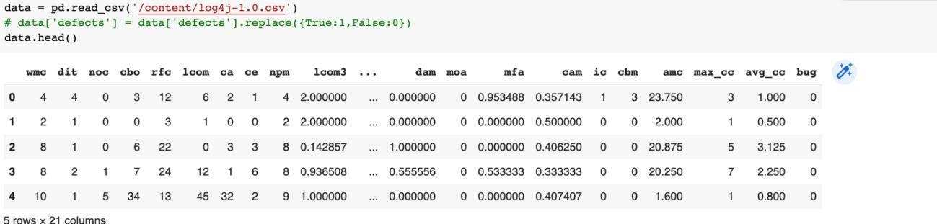

* + **Training the data**
  + **LOGISTIC REGRESSION**

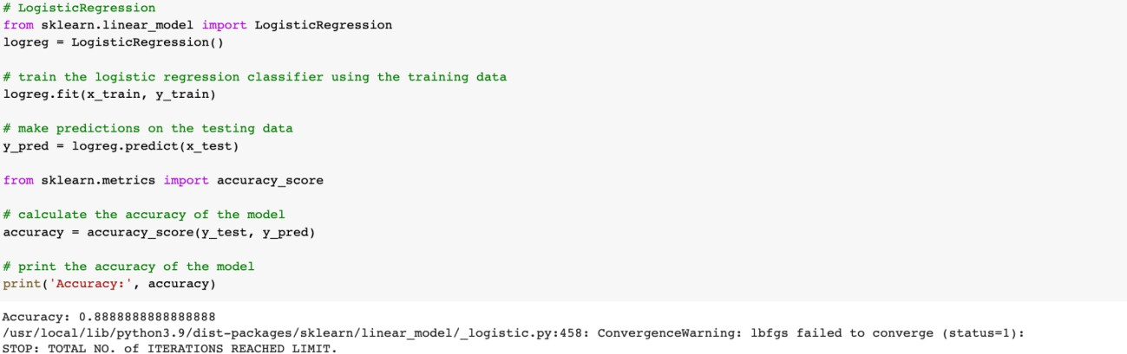

* + 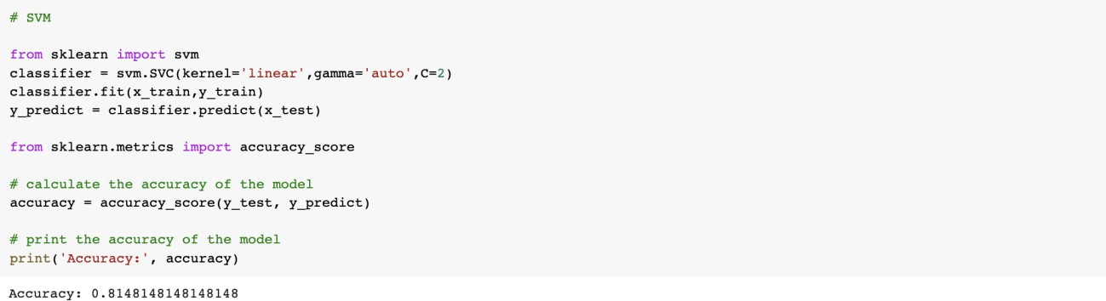**SVM**
  + 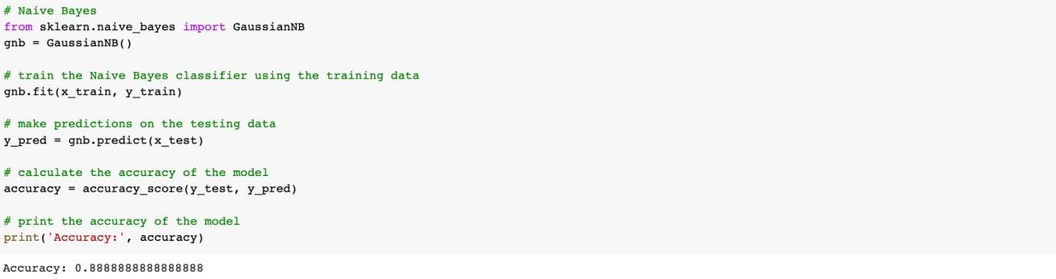**NAIVE BAYES**
  + **DECISION TREE**

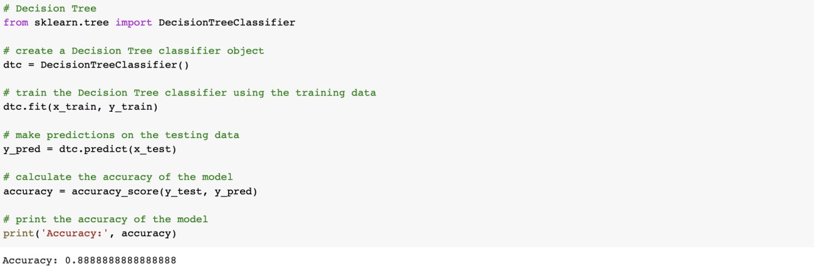

* + 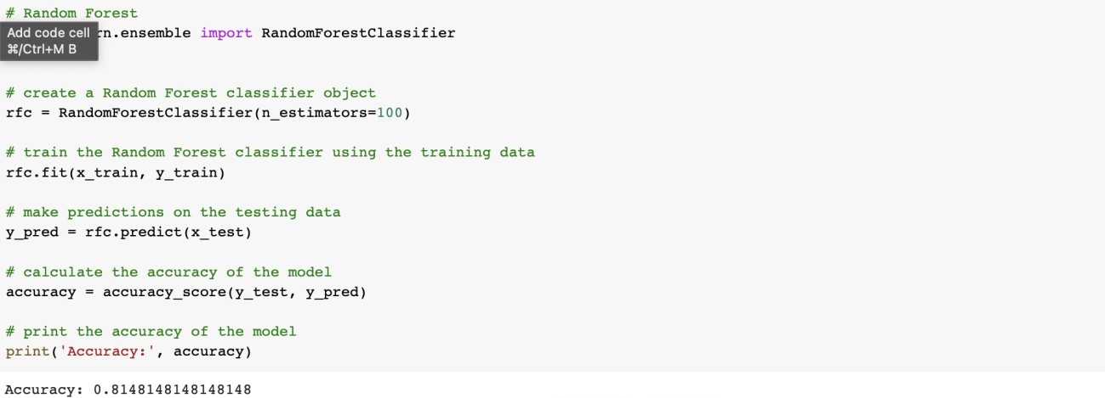**RANDOM FOREST**
  + 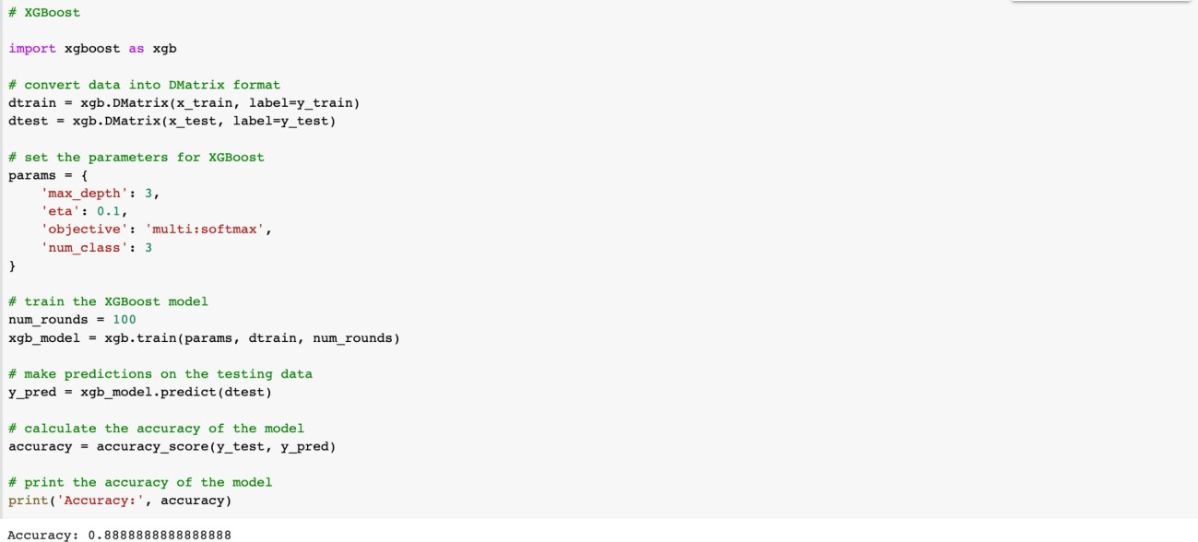**XGBOOST**
  + 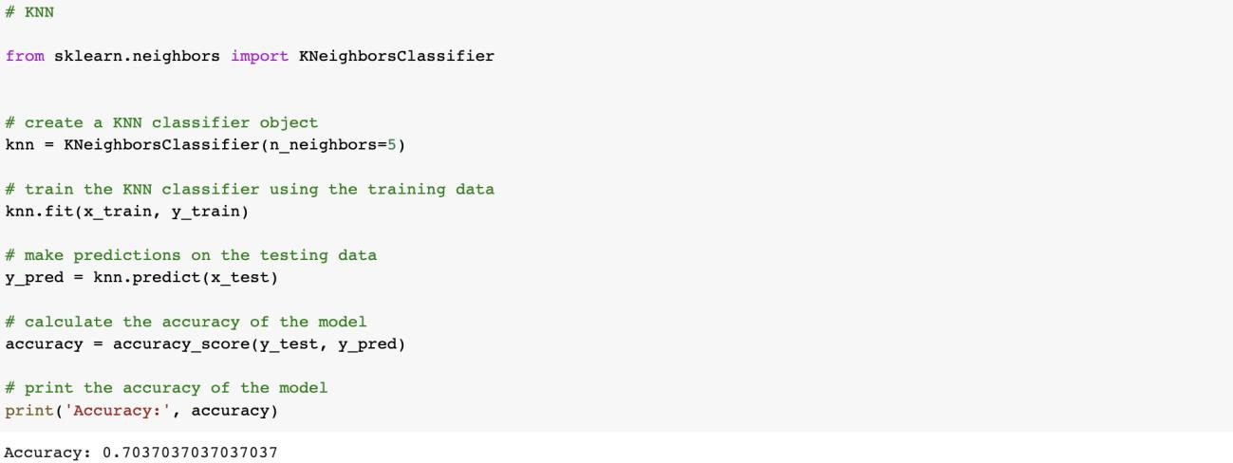**KNN**
  + **CATBOOST**



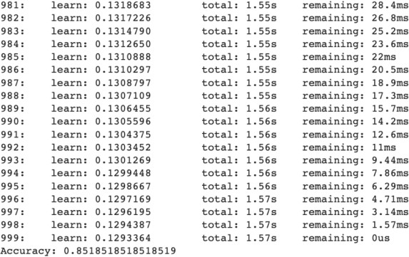

* + **LSTM**

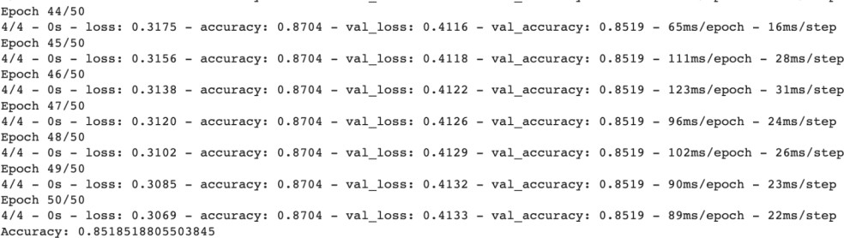

* + **ANN**

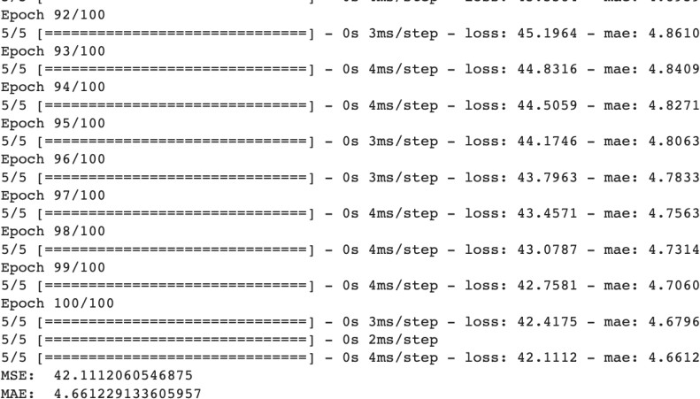

1. **Dataset : lucene-2.0**
   * **Importing the Libraries**
   * **Loading the dataset**

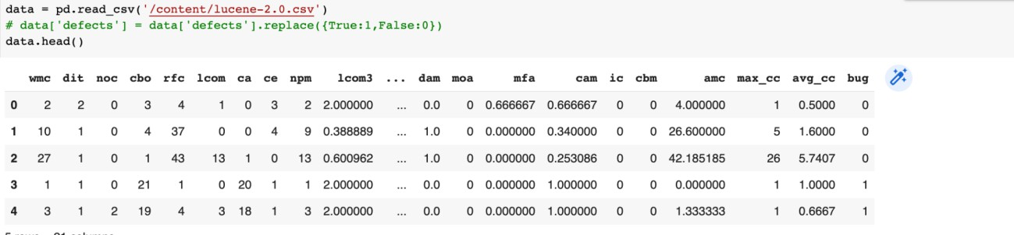

* + **Training the data**
  + **LOGISTIC REGRESSION**

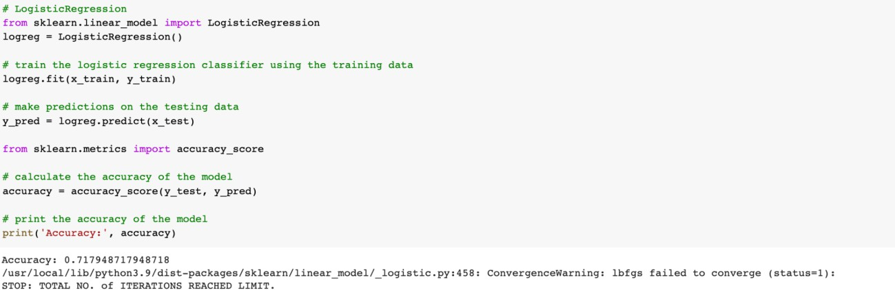

* + 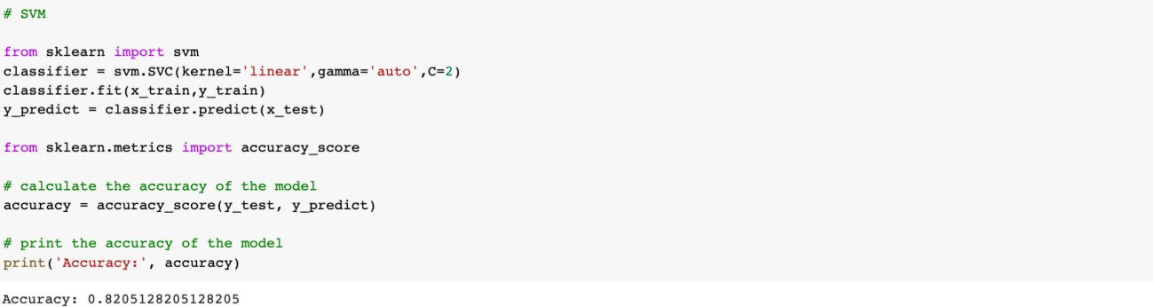**SVM**
  + 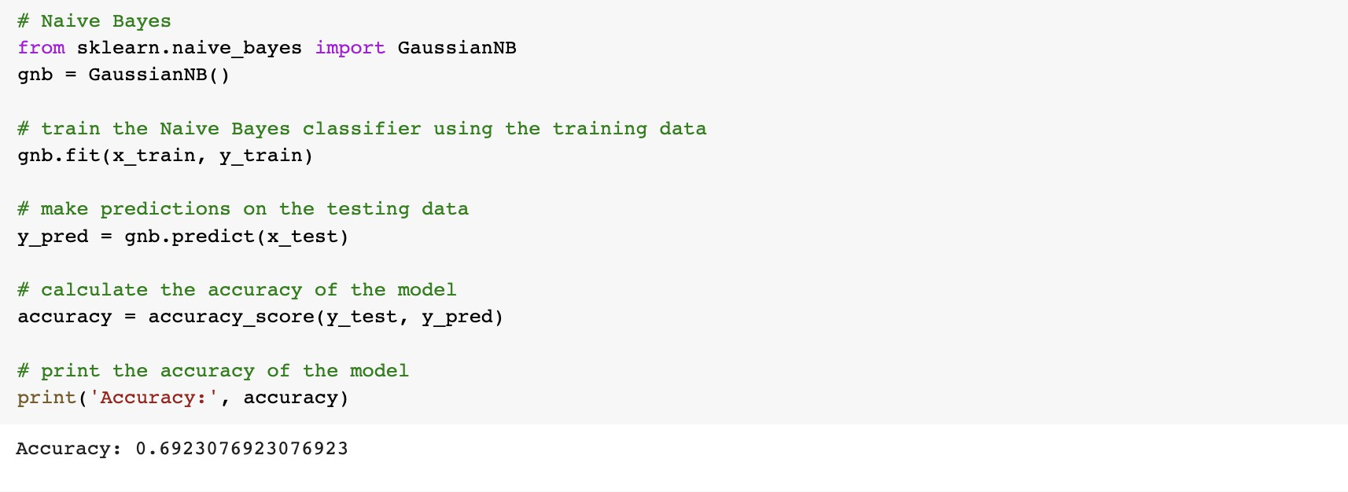**NAIVE BAYES**
  + 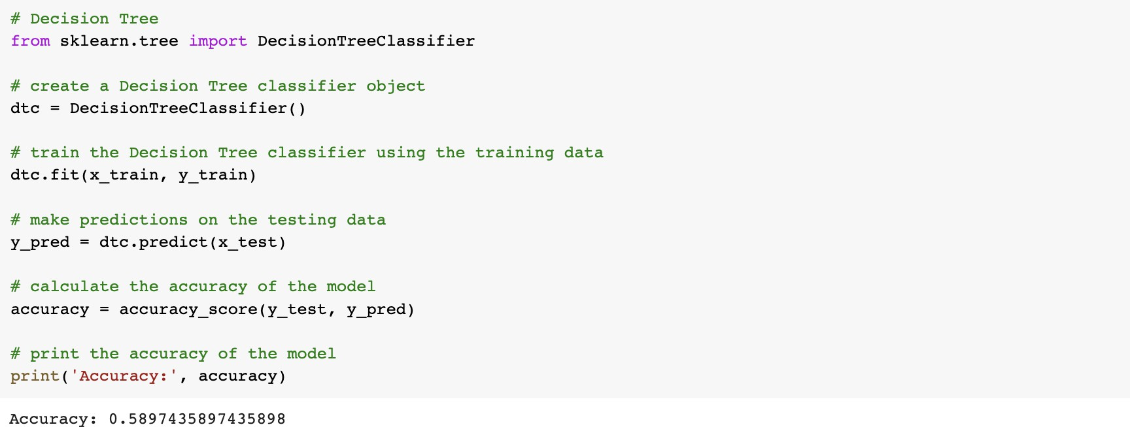**DECISION TREE**
  + **RANDOM FOREST**

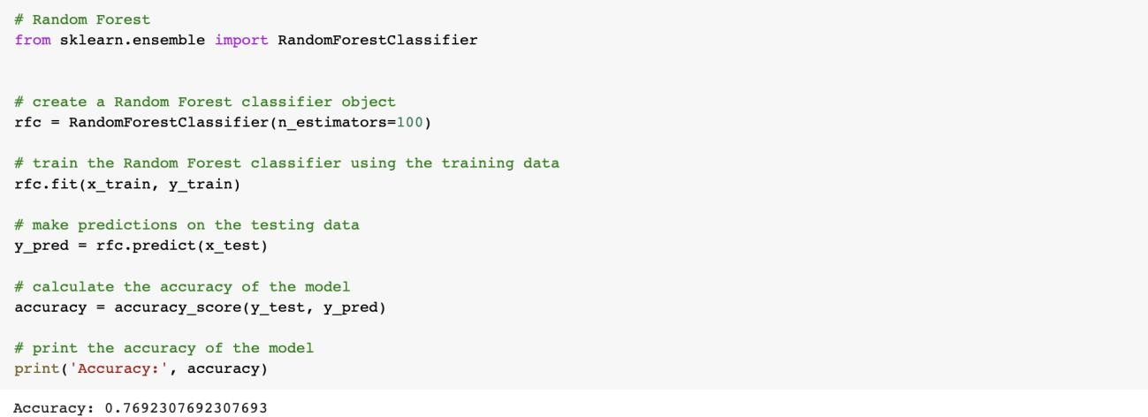

* + 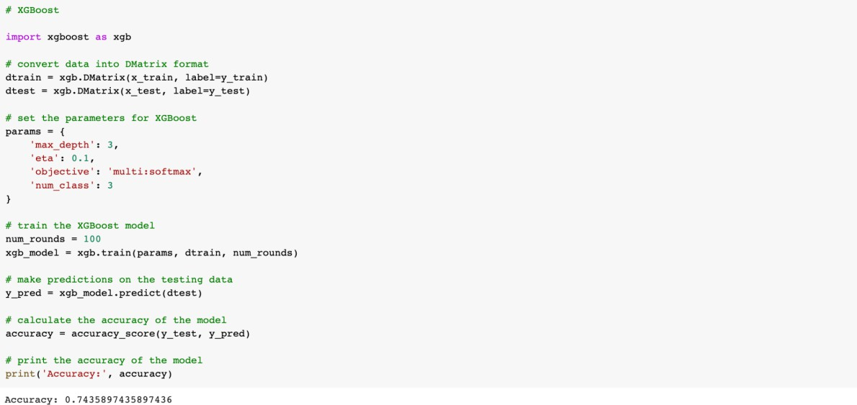**XGBOOST**
  + 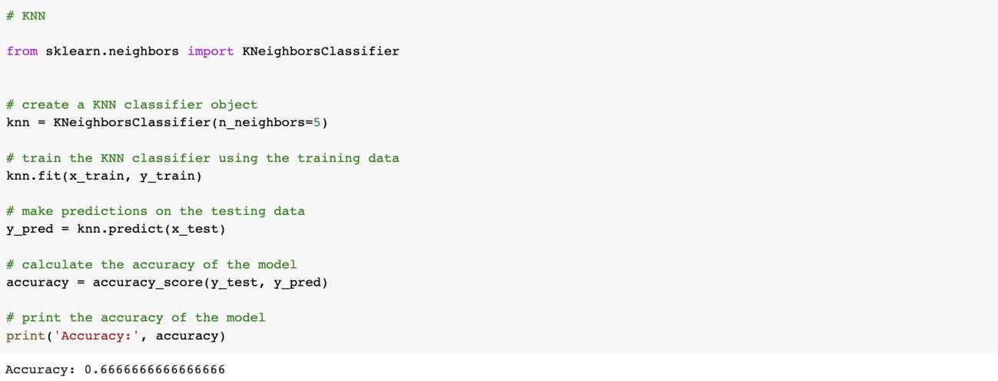**KNN**
  + **CATBOOST**



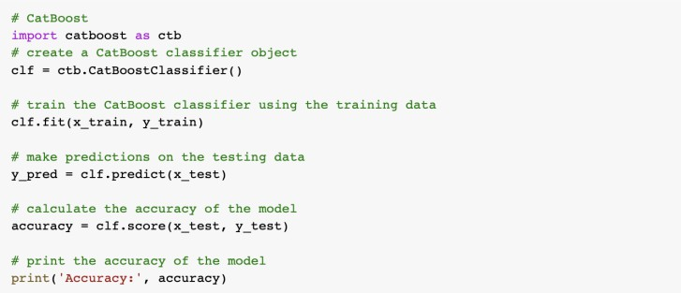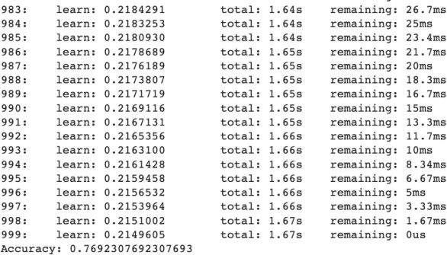

* + **LSTM**

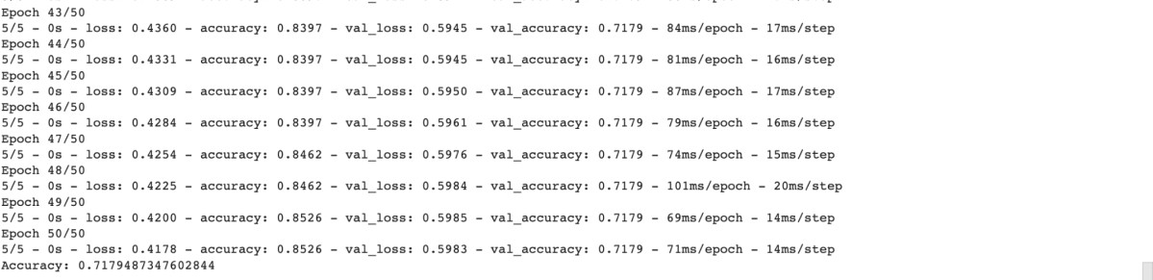

* + **ANN**

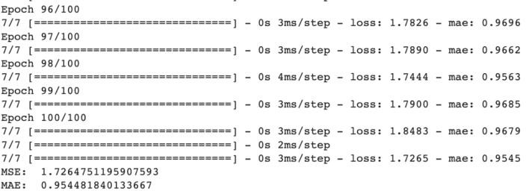

1. **Dataset : synapse-1.0**
   * **Importing the Libraries**
   * **Loading the dataset**

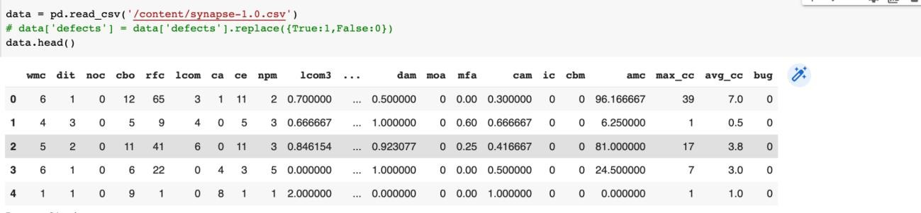

* + **Training the data**
  + **LOGISTIC REGRESSION**

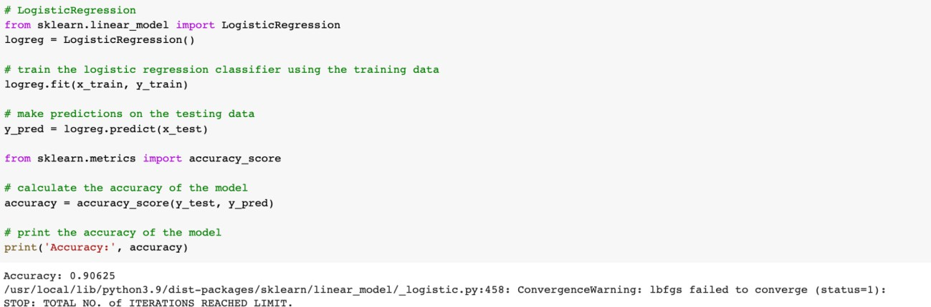

* + 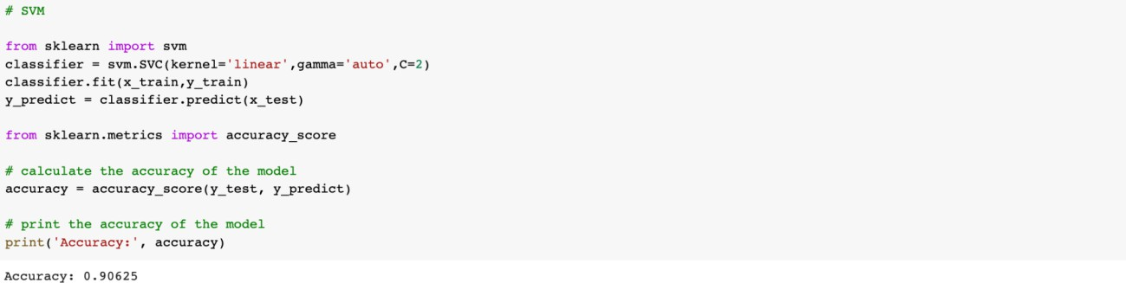**SVM**
  + 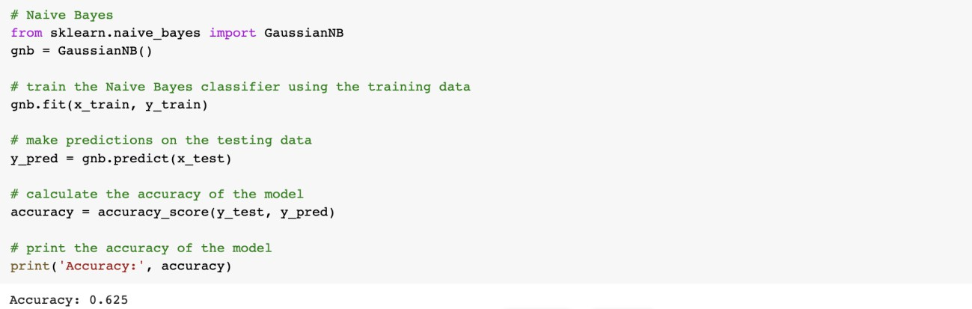**NAIVE BAYES**
  + **DECISION TREE**

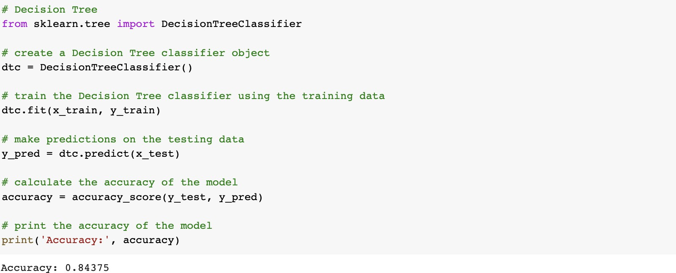

* + 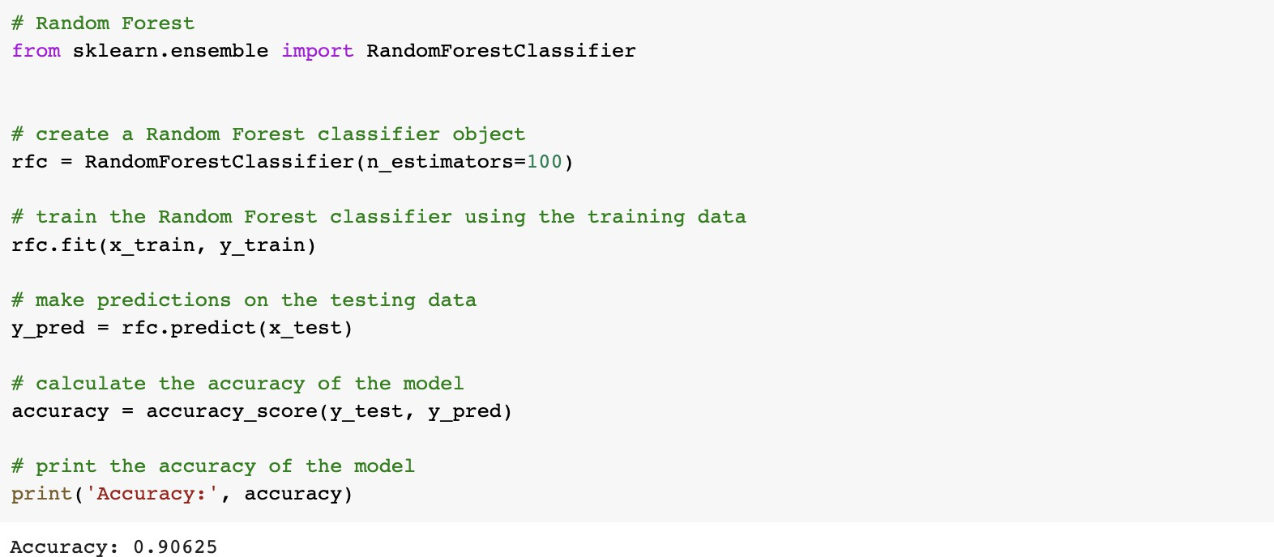**RANDOM FOREST**
  + 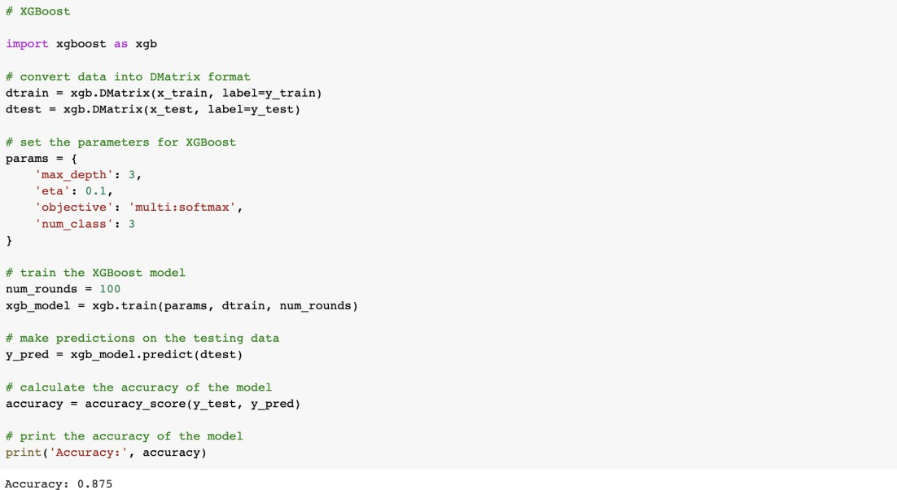**XGBOOST**
  + **KNN**

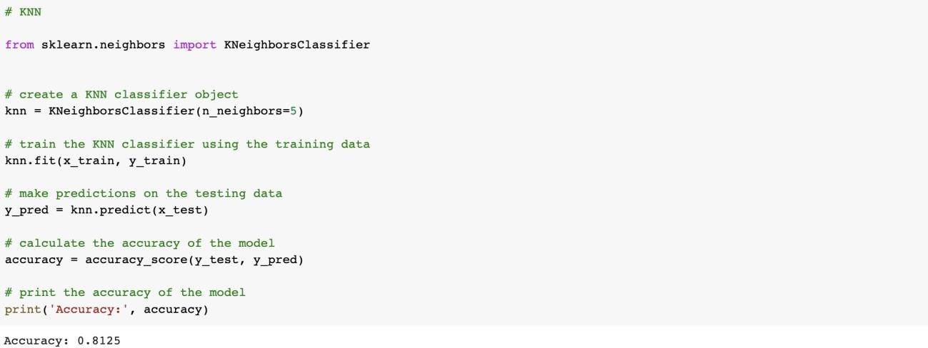

* + **CATBOOST**



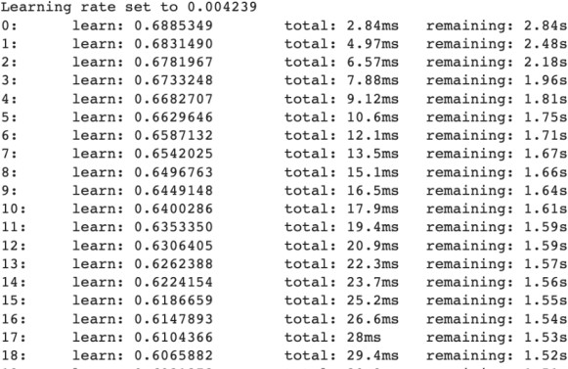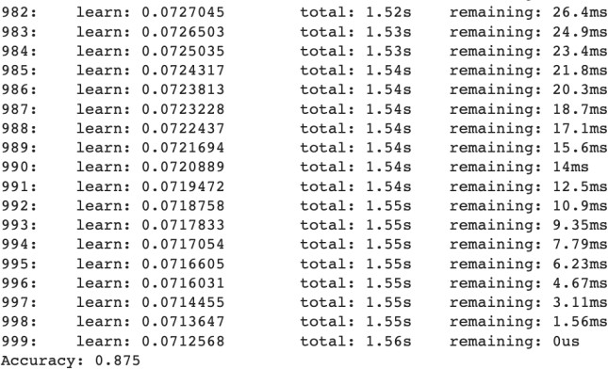

* + **LSTM**

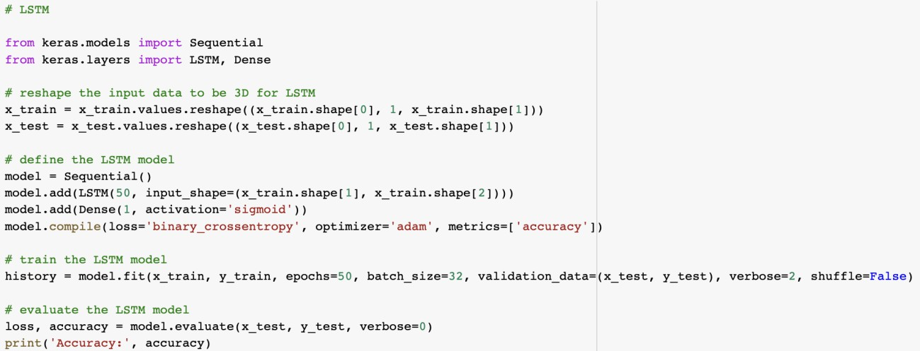

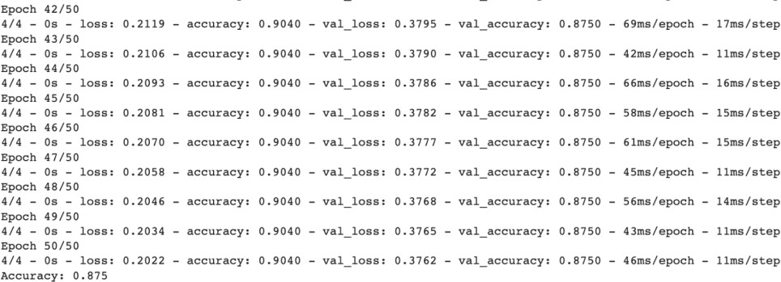

* + **ANN**

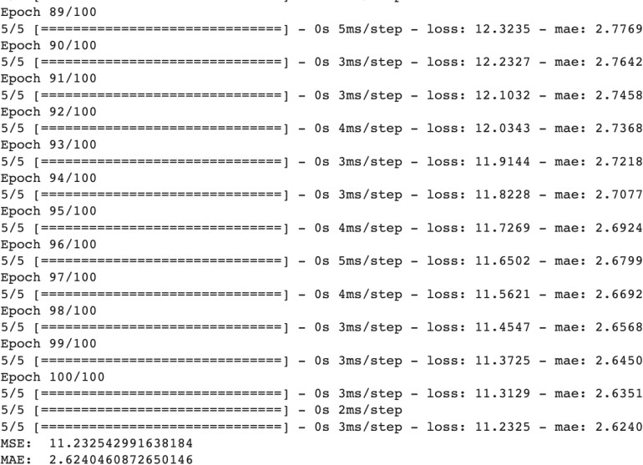

**AIM**

# Experiment - 06

Consider the model developed in experiment no. 5 identify:

1. State the hypothesis.
2. Formulate an analysis plan.
3. Analyze the sample data.
4. Interpret results.
5. Estimate type-I and type-II error

## INTRODUCTION

**State the hypothesis**: The hypothesis is a statement or assumption that is being tested using a machine learning model. In machine learning, the hypothesis is usually framed as a predictive model that maps input variables to output variables.

**Formulate an analysis plan**: The analysis plan outlines the steps that will be taken to test the hypothesis. This includes selecting a suitable machine learning algorithm, collecting and preparing the data, training and testing the model, and evaluating its performance. The plan should also specify any statistical tests or metrics that will be used to assess the model's accuracy.

**Analyze the sample data**: The sample data is used to train and test the machine learning model. This involves feeding the input variables into the model and comparing the predicted output to the actual output.

**Interpret results**: The results of the analysis are used to draw conclusions about the hypothesis being tested. If the model performs well on the sample data, it may be considered a good predictor of the outcome variable.

**Estimate type-I and type-II error:** Type-I error, also known as a false positive, occurs when the model incorrectly predicts a positive outcome when the actual outcome is negative. Type-II error, also known as a false negative, occurs when the model incorrectly predicts a negative outcome when the actual outcome is positive.

## OUTPUT

1. **State the hypothesis.**
   * The linguistic and contextual features of news articles can be used to predict whether an article is likely to contain false information.
   * Machine learning models trained on this dataset can accurately classify news articles as true or false based on their content and metadata.
   * Supervised learning approach that utilizes multiple types of features, such as linguistic features (e.g., sentiment analysis, part-of-speech tagging) and contextual features (e.g., source credibility, temporal and social signals), can lead to an accurate and robust fake news detection system.
2. **Formulate an analysis plan.**

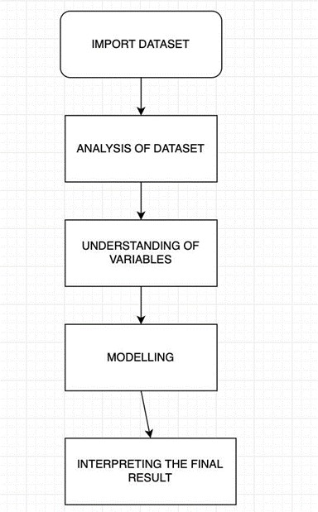The analysis plan can be described by below flow chart:

1. Importing dataset: The data analysis pipeline begins with the import or creation of a working dataset. The exploratory analysis phase begins immediately after. Importing a dataset is simple with Pandas through functions dedicated to reading the data.
2. Analysis of dataset: An especially important activity in the routine of a data analyst or scientist. It enables an in-depth understanding of the dataset, defines or discards hypotheses and creates predictive models on a solid basis. It uses data manipulation techniques and several statistical tools to describe and understand the relationship between variables and how these can impact business.
3. Understanding the variables: While in the previous point, we are describing the dataset in its entirety, now we try to accurately describe all the variables that interest us. For this reason, this step can also be called bivariate analysis.
4. Modelling: At the end of the process, we will be able to consolidate a business report or continue with the data modelling phase. We would be using Logistic Regression, Decision Tree Classifier, Random Forest Classifier, Gradient Boosting, and Support Vector Machine for modelling the dataset.
5. Interpreting the results: The results of the analysis are used to draw conclusions about the hypothesis being tested. If the model performs well on the sample data, it may be

considered a good predictor of the outcome variable. However, the model's accuracy may need to be validated on new, unseen data to ensure that it is generalizable.

1. **Analyze the sample data**. Importing working datasets

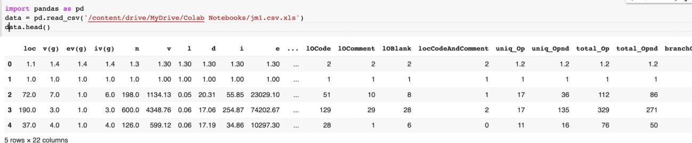

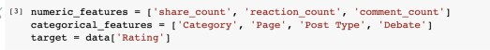Data Cleaning

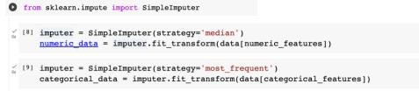Missing values

1. **Interpreting the results.**

For dataset,

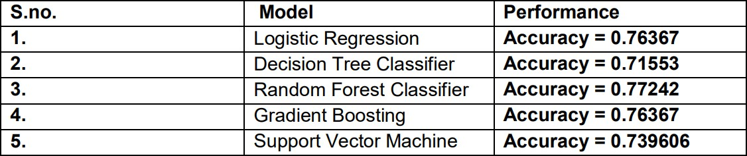

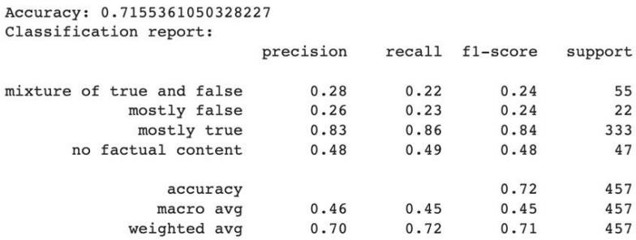**Decision Tree Classifier**

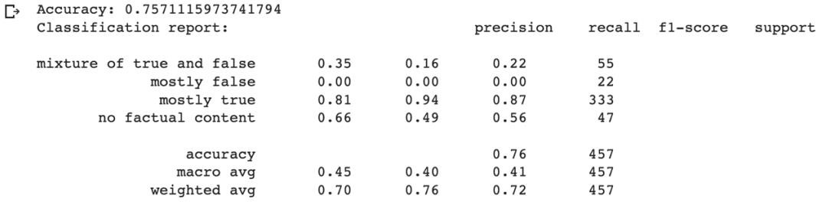**Random Forest Classifier**

**Gradient Boosting**

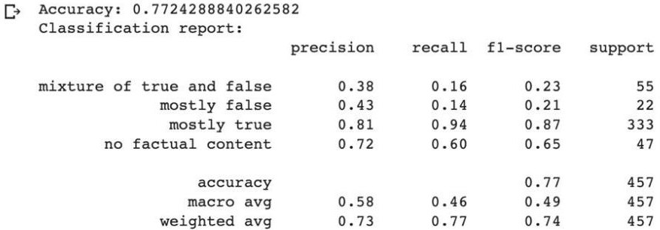

## LEARNING

A Type I error is a false positive conclusion, while a Type II error is a false negative conclusion.

# EXPERIMENT – 07

## AIM

Write a program to implement the t-test.

## THEORY

A t-test is a type of inferential statistic used to determine if there is a significant difference between the means of two groups, which may be related to certain features.

There are three types of t-tests, and they are categorized as dependent and independent t-tests.

1. Independent samples t-test: compares the means for two groups.
2. Paired sample t-test: compares means from the same group at different times (say, one year apart).
3. One sample t-test test: the mean of a single group against a known mean.

## CODE AND OUTPUTS

1. 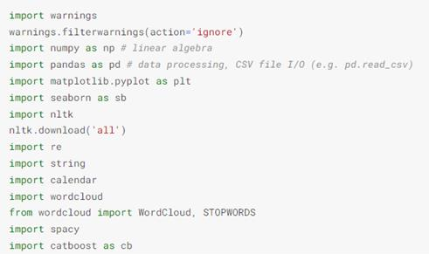Importing required Libraries
2. Loading the dataset

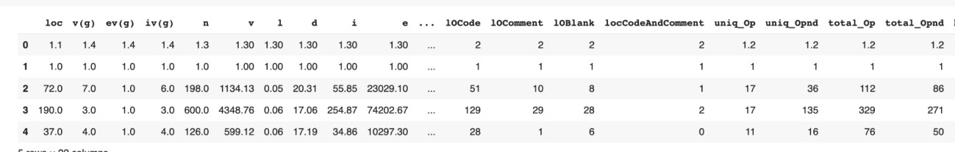

1. Dataset information

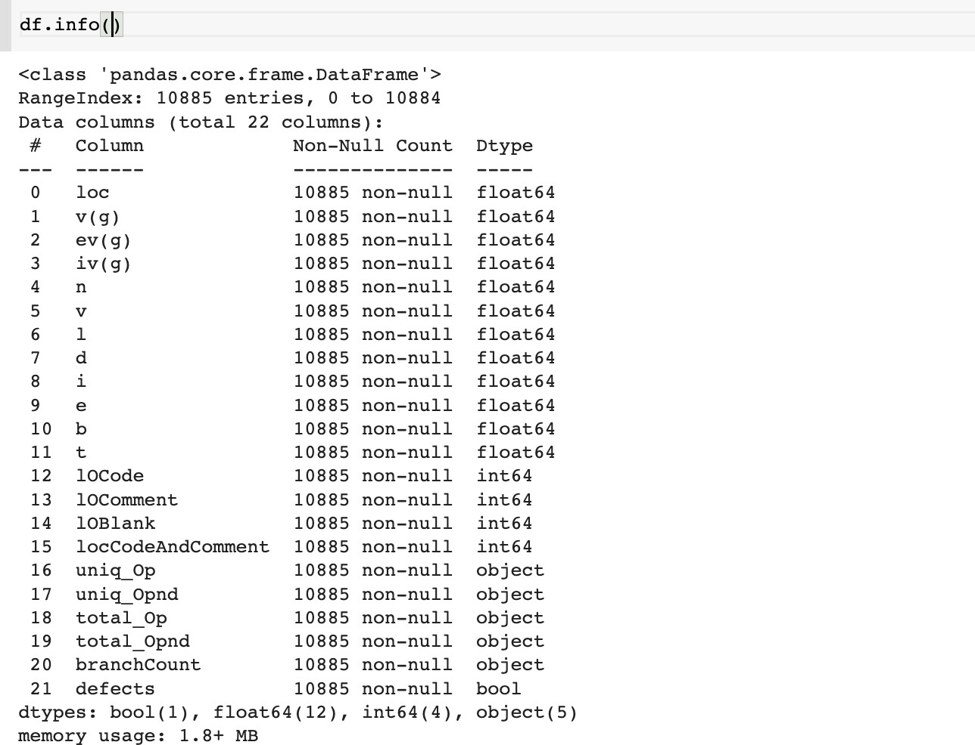

1. Selecting Features
2. Performing the test

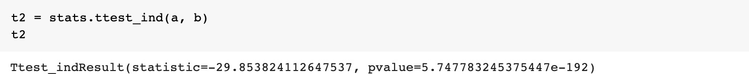

Observation: P value is small (less than 0.05) for all the features. hence null hypothesis is rejected, which implies group mean is not the same for all categories.

Null Hypothesis: The difference in mean values of title length of fake news and title length of real news is 0.

Alternate Hypothesis: The difference in mean values of the title length of fake news and the title length of real news is not 0.

**OBSERVATION**

We observe a statistically significant difference (p-value = 0.01583) between the length of news titles of real and fake news. The title length of fake news is slightly larger than that of real news. Fake news title length distribution is cantered with a mean of 7.83, while the centre of distribution of title length of real news is slightly skewed towards the right with a mean of 7.02. The t-test gives us evidence that the length of a real news title is significantly shorter than the a fake news title.

**LEARNING**

Key learnings for implementing the T-Test in a program include understanding its applications in statistical hypothesis testing, considering assumptions such as normality and homogeneity of variances, implementing the T-Test in a programming language or statistical software, interpreting results including p-values and confidence intervals, and considering sample size, power analysis, and effect size for appropriate interpretation and decision-making.

**AIM**

# EXPERIMENT – 08

Write a program to implement the chi-square test.

## THEORY

One of the primary tasks involved in any supervised Machine Learning venture is to select the best features from the given dataset to obtain the best results. One way to select these features is the Chi-Square Test. Mathematically, a Chi-Square test is done on two distributions two determine the level of similarity of their respective variances. In its null hypothesis, it assumes that the given distributions are independent. This test thus can be used to determine the best features for a given dataset by determining the features on which the output class label is most dependent.

It involves the use of a contingency table. A Contingency table (also called crosstab) is used in statistics to summarise the relationship between several categorical variables.

## CODE AND OUTPUTS

* Null Hypothesis: There is no relation between News_Type and Article_Subject
* Alternate Hypothesis: There is a significant relation between News_Type and Article_Subject

1. ****Importing required Libraries
2. Loading the dataset



1. Information about the dataset
2. 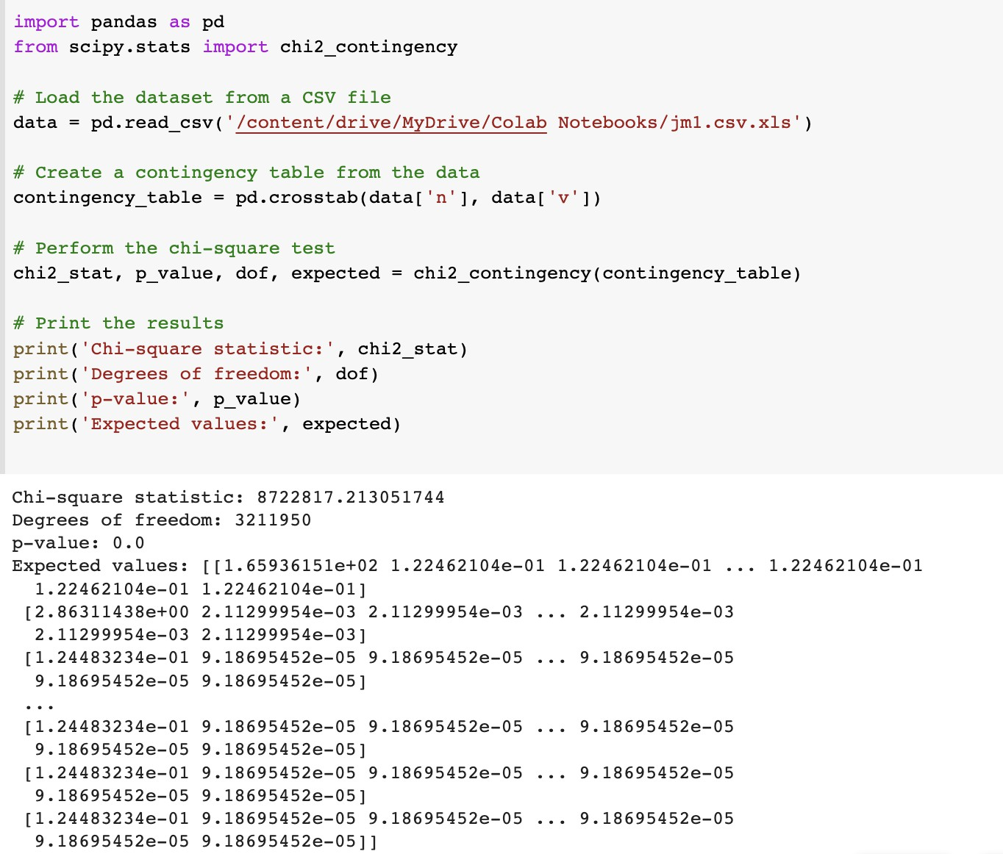Performing Chi-square test

## LEARNING

Key learnings for implementing the Chi-Square test in a program include understanding its applications in analyzing categorical data, familiarity with different types of Chi-Square tests, implementation in a programming language or statistical software, interpretation of results including chi-square statistic, degrees of freedom, and p-values, and consideration of limitations and assumptions for appropriate application and interpretation of the Chi-Square test.

**AIM**

# EXPERIMENT – 09

Write a program to implement the Friedman test.

## THEORY

Friedman Test is a non-parametric test alternative to the one-way ANOVA with repeated measures. It tries to determine if subjects changed significantly across occasions/conditions. For example:- Problem-solving ability of a set of people is the same or different in the Morning, Afternoon, and Evening.

## CODE AND OUTPUTS

* Null Hypothesis: There is no significant difference in the score values
* Alternate Hypothesis: At least 2 values differ from one another.

1. ****Importing required Libraries
2. Loading the dataset



1. Information about the dataset



1. 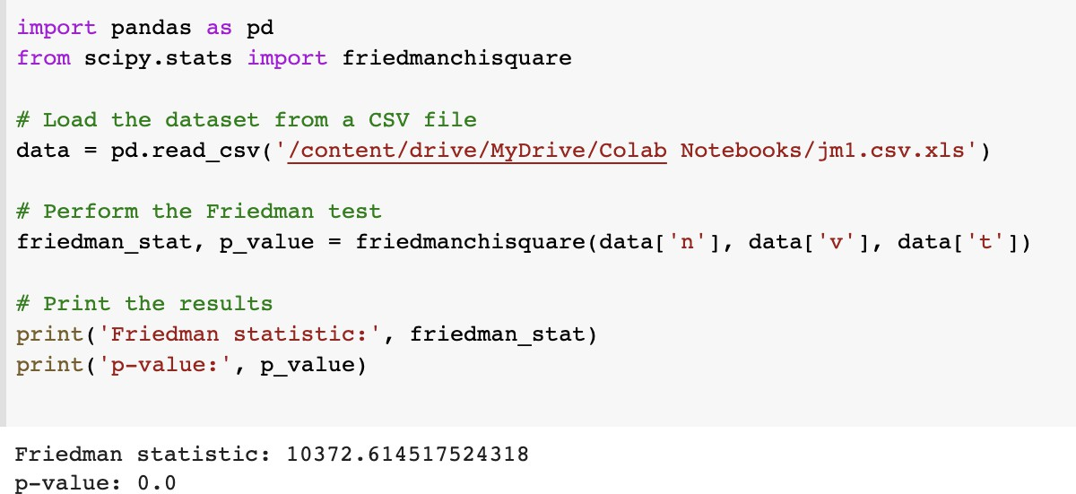Friedman Test

**LEARNING**

Key learnings for implementing the Friedman test in a program include understanding its applications in non-parametric statistical analysis, familiarity with assumptions and requirements such as repeated measures and ranked data, implementation in a programming language or statistical software, interpretation of results including Friedman statistic, degrees of freedom, and p-values, and consideration of appropriate use and limitations of the Friedman test for comparison of multiple related samples and valid interpretation of results.

**AIM**

# EXPERIMENT – 10

Write a program to implement Wilcoxon Signed Rank Test.

## THEORY

Wilcoxon signed-rank test, also known as Wilcoxon matched pair test is a non-parametric hypothesis test that compares the median of two paired groups and tells if they are identically distributed or not.

We can use this when:

* Differences between the pairs of data are non-normally distributed.
* Independent pairs of data are identical. (or matched)

## CODE AND OUTPUTS

* Null Hypothesis: The groups - title length of fake news and title length of real news are identically distributed.
* Alternate Hypothesis: The groups - title length of fake news and title length of real news are not identically distributed.

1. 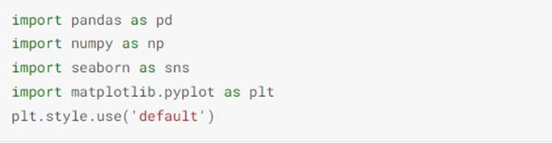Importing required Libraries
2. Loading the dataset



1. Information about the dataset



1. 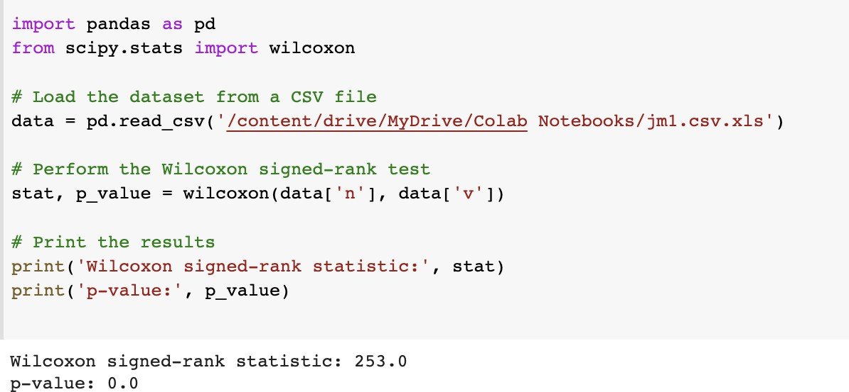Wilcoxon Signed Rank Test

## LEARNING

Key learnings for implementing the Wilcoxon Signed Rank test in a program include understanding its applications in non-parametric statistical analysis, familiarity with assumptions and requirements such as paired data and ordinal or continuous variables, implementation in a programming language or statistical software, interpretation of results including test statistic, p- values, and confidence intervals, and consideration of appropriate use and limitations of the Wilcoxon Signed Rank test for comparing paired data and valid interpretation of results.

**AIM**

# EXPERIMENT – 11

Write a program to implement the Nemenyi test.

## THEORY

The Friedman Test is used to find whether there exists a significant difference between the means of more than two groups. In such groups, the same subjects show up in each group. If the p-value of the Friedman test turns out to be statistically significant then we can conduct the Nemenyi test to find exactly which groups are different. This test is also known as Nemenyi posthoc test.

## CODE AND OUTPUTS

* Null Hypothesis: There is no significant difference in the score values
* Alternate Hypothesis: At least 2 values differ from one another.

1. Importing required Libraries
2. Loading the dataset



1. Information about the dataset
2. Friedman Test
3. Nemenyi Test

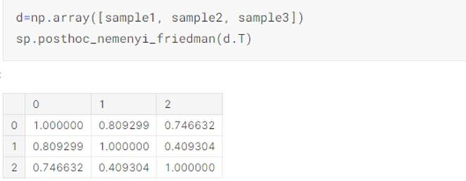

## OBSERVATION

* + From the outputs received, we reject the Null hypothesis
  + From the output table we can clearly conclude that the 2 groups to have statistically significantly different means are Group 1 and Group 2.

## LEARNING

Key learnings for implementing the Nemenyi test in a program include understanding its applications in posthoc analysis of multiple comparison tests, familiarity with requirements and assumptions such as ranked or continuous data and multiple group comparisons, implementation in a programming language or statistical software, interpretation of results including critical difference values and significance levels, and consideration of appropriate use and limitations of the Nemenyi test for posthoc analysis and valid interpretation of results in the context of statistical hypothesis testing.

# EXPERIMENT – 12

### Objective

Conduct ANNOVA test

### Theory

ANOVA stands for ANalysis Of VAriance. It is an excellent statistical test to compare group means across different levels of one categorical variable. In case there are just two levels of a categorical variable then two sample t-test can be used, but in case number of levels in categorical variable increases from two then ANOVA is preferred approach. Alternatively, one can run two-sample t-test for all possible combinition of groups but that is a cumbersome task to execute.

Here we will explore one-way ANOVA only. One way ANOVA compares three or more levels for a categorical variable to establish if there is difference between sample means or not. Sample means will always be different but is the difference statstically significant or not? This is the main goal of ANOVA. It is called one-way ANOVA because groups are under one categorical variable. If there are two factors then it is called two-way ANOVA or ANCOVA if one variable is continious.

Assumptions for running ANOVA tests are:

* Normal distribution of populations
* Equal variances
* Samples are independent

Here null hypothesis for one-way ANOVA is that group means are same and there is no statistical differences between group means:

**Code and Output**

1.Dataframe overview

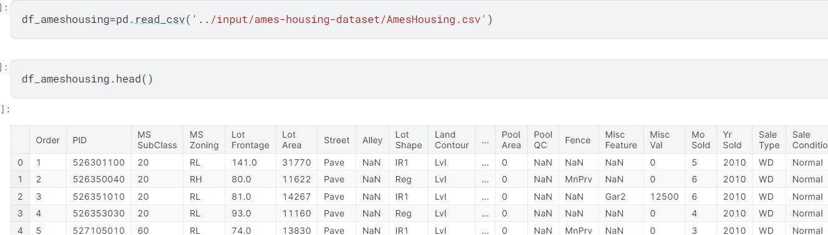

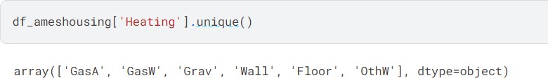

Null hypothesis for this test is that variance for all groups is same.

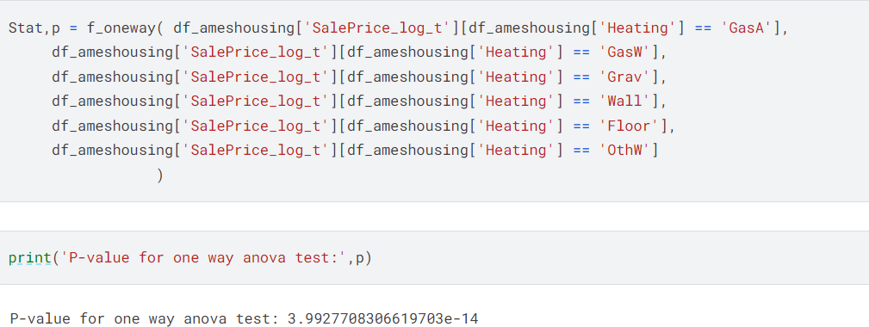

### Findings and Learnings

As p-value for one-way ANOVA is less than 0.05 so we can conclude that atleast one group mean is different from others. One-way ANOVA only tell us that atleast one group mean is different, it doesn't tell which one is different

**AIM**

# EXPERIMENT – 13

To analyze the performance of the model developed.

## THEORY

The performance analysis of a model for software defect prediction encompasses several crucial steps to ensure its effectiveness. Beginning with meticulous data preparation, including dataset splitting for training and testing, the process progresses to selecting suitable machine learning algorithms and relevant features. Model training involves optimization through hyperparameter tuning while monitoring for overfitting. Performance evaluation entails assessing metrics such as accuracy, precision, recall, and F1-score, along with techniques like ROC analysis and confusion matrices. Error analysis aids in understanding misclassifications, while cross-validation ensures consistency and generalization. Comparison with baselines provides context, and interpretability enhances the model's utility. Documenting the entire process comprehensively facilitates clear communication of results and insights, empowering informed decision-making in software quality assurance endeavors**.**

### CODE AND OUTPUTS( considering Naïve Bayes Model)

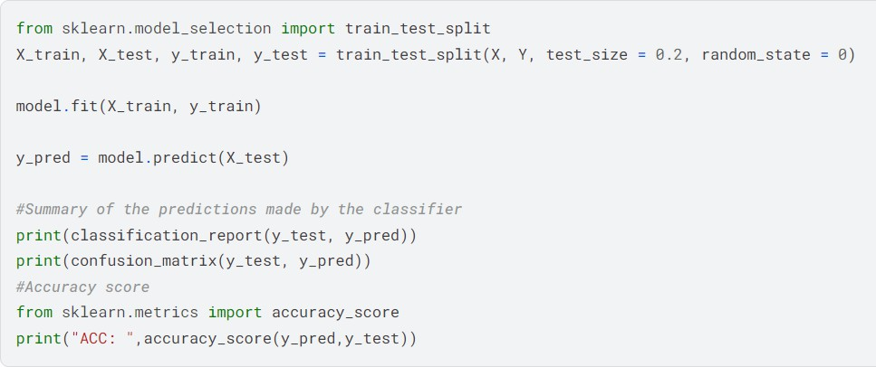

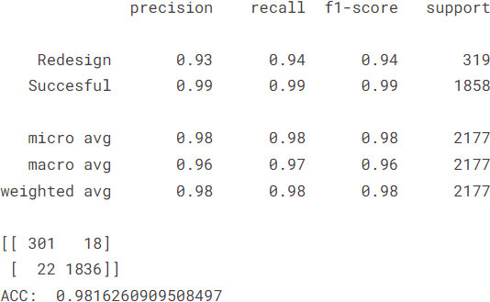

**Learnings:**The overall accuray of the Naïve Bayes model for cross-project defect prediction was 98 percent with recall and f1 scores as shown above.